SWE202 - Software Modeling and Design
Project

Topic:Property Rental System

Members:Kevin Muho(Leader) Ledio Tafciu
Desard Lybeshari Matias Bali
Haidi Toto Ornelt Lemellari
Anisa Domi

Instructors: M.Sc. Ari Gjerazi
M.Sc. Edlira Cani

Date: 31/05/2026

Property Rental System

Requirements Specification Version 3.0
March 8th, 2025

Use this Requirements Specification template to document the requirements for your product or service, including priority and approval. Tailor the specification to suit your project, organizing the applicable sections in a way that works best, and use the checklist to record the decisions about what is applicable and what isn't.
The format of the requirements depends on what works best for your project.
This document contains instructions and examples which are for the benefit of the person writing the document and should be removed before the document is finalized.
To regenerate the TOC, select all (CTL-A) and press F9.

Table of Contents
- Executive Summary 4
  - Project Overview 4
- Product/Service Description 5
  - Product Context 6
  - User Characteristics 8
  - Assumptions 8
  - Constraints Dependencies 9
- Requirements 10
  - Functional Requirements 10
  - Non-Functional Requirements 15
    - Product Requirements 15
      - Usability Requirements 15
      - Performance Requirements 16
      - Availability 16
      - Security 17
    - Organizational Requirements 18
    - External Requirements 18
- User Case Tables 19
- Diagrams 35
5.1 ERD 35
5.2 Use Case Diagram 36
5.3 Activity Diagrams 37
5.4 Class Diagram 64
5.5 State Diagrams 65
5.6 Sequence Diagrams 71
5.7 Collaboration Diagrams 112
5.8 IOD 130
5.9 BPMN 133
- Design Patterns 136

Executive Summary

Project Overview
The Property Rentals System is a software platform designed to simplify and manage the process of renting properties between tenants, property owners, and administrative staff. The system provides a centralized environment where property owners can list rental properties, tenants can search and book accommodations, and administrators can monitor and manage overall system operations.
The platform supports several core services including:
- Property listing and management
- Property search and filtering
- Rental request and booking management
- Online payment processing
- Messaging and notifications
- Complaint and dispute management
- Reporting and administrative monitoring
The intended audience of the system includes:
- Tenants searching for rental accommodations
- Property Owners managing rental properties
- Administrators and Managers supervising operations and disputes
- Financiers handling transactions and refunds
- HR Staff managing complaints and user support
The main goal of the system is to improve efficiency, transparency, accessibility, and communication throughout the property rental process by digitizing rental operations and allowing users to access services online from anywhere.

Product/Service Description
The Property Rentals System is designed as a multi-user rental management platform that connects tenants, property owners, and administrative personnel through a single integrated system. The platform automates major rental activities such as property publishing, booking requests, payment processing, communication, and issue resolution.
The development of this system is motivated by the increasing need for efficient digital rental management solutions that reduce manual paperwork, improve communication, and provide better accessibility for users. Traditional rental management processes often involve delays, fragmented communication, and difficulties in maintaining accurate records. This system addresses those challenges through centralized data management and automated workflows.
Several general factors influence the design and requirements of the system:
- The need for secure authentication and protection of user and payment data
- Support for multiple user roles with different permissions
- Integration with external payment and notification services
- Efficient handling of large numbers of property listings and concurrent users
- Easy-to-use interfaces for both technical and non-technical users
- Real-time communication and booking updates
- Scalable architecture to support future growth and additional services
The system is intended to operate primarily as a web-based application, although the architecture can later support mobile application integration.

Product Context
The Property Rentals System is a web-based rental management platform that operates as a centralized system for managing rental activities between tenants, property owners, administrators, managers, financiers, and HR personnel. The system is primarily designed as a standalone application, but it also interfaces with external services such as payment and notification systems. In the future, the platform can be extended to support mobile application integration in addition to the web-based environment.
The system provides a centralized database that stores and manages all important information related to:
- User accounts and authentication
- Property listings and availability
- Rental requests and bookings
- Payment transactions and refunds
- Messages and notifications
- Complaints, disputes, and issue resolutions
- Reviews, ratings, and reports
The centralized structure ensures that all modules and users work with consistent and updated information across the platform.
The Property Rentals System interacts with several external systems and internal subsystems:

External Systems
- Payment System
  - Processes rental payments, refunds, and transaction confirmations.
  - Used during booking payment operations and financial management.
- Notification System
  - Sends booking confirmations, approval/rejection alerts, reminders, payment updates, and complaint notifications to users.

Internal System Modules
The platform is divided into multiple functional modules that work together:
- Property Management Module
- Booking & Rental Request Module
- Messaging & Communication Module
- Payment Management Module
- Complaint & Issue Management Module
- User & Role Management Module
- Reporting & Monitoring Module
- Notification Management Module
Each module communicates through the centralized system architecture and shares data through the common database.

The platform supports multiple user roles, each with different permissions and responsibilities:
- Tenant
- Property Owner
- Administrator
- Manager
- Financier
- HR Staff
These users interact with the system through role-specific functionalities such as booking management, listing management, payment handling, complaint resolution, and system monitoring.
The overall system context can be represented as follows:
+-------------------------------------------------------+
| Property Rentals System |
|-------------------------------------------------------|
| |
| +------------------+ +----------------------------+ |
| | Property Module | | Booking & Rental Module | |
| +------------------+ +----------------------------+ |
| |
| +------------------+ +----------------------------+ |
| | Messaging Module | | Complaint Management | |
| +------------------+ +----------------------------+ |
| |
| +------------------+ +----------------------------+ |
| | User Management | | Reporting & Monitoring | |
| +------------------+ +----------------------------+ |
| |
| Centralized Database System |
| |
+-------------------------------------------------------+
| |
| |
v v
+--------------------+ +------------------------+
| External Payment | | Notification System |
| Service | | (Alerts & Reminders) |
+--------------------+ +------------------------+
The system architecture also incorporates several software design patterns to improve maintainability and communication between components:
- The Facade Pattern simplifies booking operations by coordinating rental requests, bookings, payments, and notifications through a unified interface.
- The Observer Pattern automatically sends notifications when booking or payment statuses change.
- The Adapter Pattern allows the system to communicate with external payment providers without modifying the internal payment logic.

User Characteristics

The Property Rental System will be used by several categories of users with different responsibilities and technical abilities.The product should therefore be designed with a clear, user-friendly interface, role-based access, secure login, and simple navigation so both technical and non-technical users can use it effectively.
User Type | Category | Experience | Technical Expertise | General Characteristics
Tenant | Other / Customer | May have basic experience using websites or mobile apps | Basic | Needs a simple interface to search properties, view details, send rental requests, make payments, and communicate with owners.
Property Owner | Other / Service Provider | May have experience managing rental properties | Basic to intermediate | Needs tools to add, edit, remove, and manage listings, upload images, respond to requests, and view booking history.
Administrator | Staff | Experienced in managing system operations | Intermediate to advanced | Responsible for managing users, listings, disputes, reports, and platform control.
Manager | Staff | Experienced in supervision and coordination | Intermediate | Oversees rental requests, complaints, reports, discounts, and coordination between users and administrators.
Financier | Staff | Experienced in payment and transaction handling | Intermediate | Handles payment monitoring, refunds, transaction issues, and financial reports.
HR Staff | Staff | Experienced in user support and communication | Basic to intermediate | Manages complaints, reminders, user satisfaction, and issue-resolution records.

Assumptions
The following assumptions affect the requirements of the Property Rentals System:
- Users will have access to a device such as a computer, tablet, or smartphone.
- Users will have a stable internet connection to access the web-based system.
- Users have basic knowledge of using websites or mobile applications.
- Property owners will provide accurate property information, images, prices, and availability.
- Tenants will provide correct personal, booking, and payment information.
- The external payment system will be available to process rental payments and refunds.
- The notification system will be available to send alerts, reminders, and booking updates.
- The system will use a centralized database to store users, properties, bookings, payments, messages, complaints, and reports.
- Administrators, managers, financiers, and HR staff will have the required permissions to perform their tasks.
- Secure authentication and authorization will be used before users access role-specific functions.

Constraints and Dependencies
The following constraints and dependencies affect the system requirements:

Constraints
- The system must protect user information, passwords, booking records, and payment data.
- Access must be controlled using role-based permissions.
- Only authorized users should access sensitive features such as user management, reports, refunds, and dispute handling.
- The system should maintain logs or records for important actions such as payments, refunds, complaints, booking approvals, and account changes.
- The system must support multiple users at the same time without major performance issues.
- The interface must remain simple enough for users with basic technical skills.
- Payment processing must be secure and reliable.
- The application depends on accurate and updated property availability information.
- The system must prevent invalid actions, such as deleting listings with active bookings or submitting reviews without completed rentals.

Dependencies
- The booking module depends on the property search and property listing modules.
- The payment module depends on approved bookings before payments can be processed.
- The refund process depends on payment and booking cancellation records.
- The notification module depends on booking, payment, complaint, and request status changes.
- The complaint management module depends on user accounts, property records, and issue-resolution records.
- The reporting module depends on stored data from users, bookings, payments, complaints, and listings.
- The system depends on the external payment service for transaction processing.
- The system depends on the notification service for sending alerts and reminders.
- User role management must be completed before role-specific modules can be fully implemented.

Requirements
The Property Rentals System (PRS) is a web-based application designed to simplify and digitalize the process of managing rental properties between tenants, property owners, administrators, managers, financiers, and HR staff. The system allows users to search and rent properties, manage bookings, process payments, handle complaints, exchange messages, and monitor rental operations efficiently.
The platform supports role-based access control, ensuring that each type of user can only access the functions relevant to their responsibilities. The system also integrates payment and notification services to improve communication, transaction management, and operational efficiency.

● System Inputs
Input | Description
User login credentials | Username/email and password entered during authentication
Property search queries | Keywords, location, price range, or property type used to search properties
Rental requests | Requests submitted by tenants to rent a property
Property listing information | Property details entered by owners including title, description, price, location, and availability
Property images | Photos uploaded by property owners for listings
Payment information | Payment details entered by tenants for booking payments
Messages and conversations | Messages exchanged between tenants and property owners
Reviews and ratings | Feedback and ratings submitted by tenants after rentals
Complaint records | Complaints submitted by users regarding issues or disputes
Refund requests | Refund information submitted for canceled bookings
Promotion details | Discount and promotional information created by managers
Notification data | Alerts and reminders generated by the system

● System Outputs
Output | Description
Search results | List of properties matching the search criteria
Property details page | Complete information about a selected property
Booking confirmation | Confirmation message for approved bookings
Rental request status | Approval, rejection, or pending status notifications
Payment confirmation | Confirmation of successful rental payments
Refund confirmation | Confirmation message for approved refunds
Property listing updates | Updated property availability and listing information
User notifications | Alerts for bookings, payments, complaints, and reminders
Messages and chat history | Display of communication between users
Booking history | Record of completed and active bookings
Reviews and ratings display | Published tenant reviews and property ratings
Complaint resolution reports | Status and resolution details of complaints
Management reports | Reports related to rentals, payments, and system activities
Financial reports | Payment, refund, and transaction summaries

Functional Requirements

Priority Definitions

The following definitions are intended as a guideline to prioritize requirements.

● Priority 1 – The requirement is a “must have” as outlined by policy/law

● Priority 2 – The requirement is needed for improved processing, and the fulfillment of the requirement will create immediate benefits

● Priority 3 – The requirement is a “nice to have” which may include new functionality It may be helpful to phrase the requirement in terms of its priority, e.g., "The value of the employee status sent to DIS must be either A or I" or "It would be nice if the application warned the user that the expiration date was 3 business days away". Another approach would be to group requirements by priority category.

A good requirement is:

● Correct

● Unambiguous (all statements have exactly one interpretation)

● Complete (where TBDs are absolutely necessary, document why the information is unknown, who is responsible for resolution, and the deadline)

● Consistent

● Ranked for importance and/or stability.

● Verifiable (avoid soft descriptions like “works well”, “is user friendly”; use concrete terms and specify measurable quantities)

● Modifiable (evolve the Requirements Specification only via a formal change process, preserving a complete audit trail of changes)

● Does not specify any particular design

● Traceable (cross-reference with source documents and spawned documents).

Req# | Requirement | Comments | Priority | Date Rvwd | Done By
BR_PRS_1 | The tenant shall be able to update personal information because profile information must remain accurate and updated. | Business Process = User Profile Management | 2 | 18/03/2026 | Anisa Domi
BR_PRS_2 | The tenant shall be able to search properties because tenants need to find suitable rental accommodations. | Business Process = Property Search | 2 | 18/03/2026 | Anisa Domi
BR_PRS_3 | The tenant shall be able to filter properties because search results need to be narrowed based on preferences. | Business Process = Property Filtering | 2 | 18/03/2026 | Anisa Domi
BR_PRS_4 | The tenant shall be able to view property details and booking history because tenants need complete rental information and history records. | Business Process = Property Viewing & Booking History | 2 | 18/03/2026 | Anisa Domi
BR_PRS_5 | The tenant shall be able to send rental requests and messages to property owners because communication and booking requests are required for rentals. | Business Process = Rental Request Management | 1 | 18/03/2026 | Anisa Domi
BR_PRS_6 | The tenant shall be able to cancel rental requests because tenants may change booking decisions before approval. | Business Process = Rental Request Cancellation | 2 | 18/03/2026 | Anisa Domi
BR_PRS_7 | The tenant shall be able to receive messages BR_PRS_om property owners because communication between users must be supported. | Business Process = Messaging System | 2 | 18/03/2026 | Haidi Toto
BR_PRS_8 | The tenant shall be able to submit rental payments because approved bookings require payment processing. | Business Process = Payment Processing | 1 | 18/03/2026 | Haidi Toto
BR_PRS_9 | The tenant shall be able to save favorite properties because users may want to review properties later. | Business Process = Favorites Management | 3 | 18/03/2026 | Haidi Toto
BR_PRS_10 | The tenant shall be able to review and rate properties because feedback improves transparency and user trust. | Business Process = Review & Rating System | 3 | 18/03/2026 | Haidi Toto
BR_PRS_11 | The property owner shall be able to update profile information and property availability because listing information must remain accurate. | Business Process = Property Owner Profile Management | 2 | 18/03/2026 | Haidi Toto
BR_PRS_12 | The property owner shall be able to add property listings because rental properties need to be published in the system. | Business Process = Property Listing Management | 1 | 18/03/2026 | Haidi Toto
BR_PRS_13 | The property owner shall be able to upload property images because tenants need visual information about properties. | Business Process = Property Media Management | 2 | 18/03/2026 | Ledio Tafciu
BR_PRS_14 | The property owner shall be able to edit property listings because property details may change over time. | Business Process = Property Listing Management | 2 | 18/03/2026 | Ledio Tafciu
BR_PRS_15 | The property owner shall be able to delete property listings because unavailable or invalid listings must be removed. | Business Process = Property Listing Management | 2 | 18/03/2026 | Ledio Tafciu
BR_PRS_16 | The property owner shall be able to view rental requests because owners need to manage booking requests. | Business Process = Rental Request Monitoring | 1 | 18/03/2026 | Ledio Tafciu
BR_PRS_17 | The property owner shall be able to accept or reject rental requests because booking approvals are required before rentals proceed. | Business Process = Rental Approval Workflow | 1 | 18/03/2026 | Ledio Tafciu
BR_PRS_18 | The property owner shall be able to send messages to tenants because communication between both parties must be supported. | Business Process = Messaging System | 2 | 18/03/2026 | Ledio Tafciu
BR_PRS_19 | The property owner shall be able to view booking history because owners need access to previous rental records. | Business Process = Booking History Management | 2 | 18/03/2026 | Desard Lybeshari
BR_PRS_20 | The property owner shall be able to mark properties as unavailable or rented because listing availability must remain accurate. | Business Process = Property Availability Management | 1 | 18/03/2026 | Desard Lybeshari
BR_PRS_21 | The administrator shall be able to edit user accounts because user information and permissions may require updates. | Business Process = User Account Administration | 1 | 18/03/2026 | Desard Lybeshari
BR_PRS_22 | The administrator shall be able to delete user accounts because invalid or inappropriate accounts must be removed. | Business Process = User Account Administration | 1 | 18/03/2026 | Desard Lybeshari
BR_PRS_23 | The administrator shall be able to monitor rental transactions because financial and booking activities require supervision. | Business Process = Transaction Monitoring | 1 | 18/03/2026 | Desard Lybeshari
BR_PRS_24 | The administrator shall be able to view system reports and property listings because system operations must be monitored. | Business Process = Reporting & Monitoring | 2 | 18/03/2026 | Desard Lybeshari
BR_PRS_25 | The administrator shall be able to remove inappropriate listings because platform content must comply with system policies. | Business Process = Content Moderation | 1 | 18/03/2026 | Matias Bali
BR_PRS_26 | The administrator shall be able to manage disputes and system settings because system stability and issue resolution must be maintained. | Business Process = System Administration | 1 | 18/03/2026 | Matias Bali
BR_PRS_27 | The administrator shall be able to restore user accounts because suspended or deleted accounts may require recovery. | Business Process = User Account Recovery | 2 | 18/03/2026 | Matias Bali
BR_PRS_28 | The administrator shall be able to suspend user accounts because policy violations may require temporary restrictions. | Business Process = User Account Control | 1 | 18/03/2026 | Matias Bali
BR_PRS_29 | The administrator shall be able to verify and approve property listings because listings must be validated before publication. | Business Process = Listing Verification | 1 | 18/03/2026 | Matias Bali
BR_PRS_30 | The manager shall be able to monitor rental requests because booking operations require supervision. | Business Process = Rental Monitoring | 2 | 18/03/2026 | Matias Bali
BR_PRS_31 | The manager shall be able to generate management reports because operational performance must be evaluated. | Business Process = Management Reporting | 2 | 18/03/2026 | Ornelt Lemellari
BR_PRS_32 | The manager shall be able to approve large discounts and promotions because special pricing actions require authorization. | Business Process = Promotion Approval | 3 | 18/03/2026 | Ornelt Lemellari
BR_PRS_33 | The manager shall be able to review complaints and forward unresolved issues because escalated problems require supervision. | Business Process = Complaint Management | 1 | 18/03/2026 | Ornelt Lemellari
BR_PRS_34 | The financier shall be able to view transaction history because financial records must be monitored and verified. | Business Process = Financial Monitoring | 1 | 18/03/2026 | Ornelt Lemellari
BR_PRS_35 | The financier shall be able to monitor payment processing and security because secure transactions are required. | Business Process = Payment Security Management | 1 | 18/03/2026 | Ornelt Lemellari
BR_PRS_36 | The financier shall be able to communicate payment issues with tenants and owners because payment problems require resolution. | Business Process = Payment Issue Resolution | 2 | 18/03/2026 | Ornelt Lemellari
BR_PRS_37 | The financier shall be able to approve refunds for cancelled rental transactions because financial adjustments may be required. | Business Process = Refund Management | 1 | 18/03/2026 | Kevin Muho
BR_PRS_38 | HR staff shall be able to manage complaints because user issues and disputes must be handled properly. | Business Process = Complaint Handling | 1 | 18/03/2026 | Kevin Muho
BR_PRS_39 | HR staff shall be able to send notifications and reminders because users must receive important updates and alerts. | Business Process = Notification Management | 2 | 18/03/2026 | Kevin Muho
BR_PRS_40 | HR staff shall be able to maintain records of user issues and resolutions because complaint history must be documented. | Business Process = Issue Resolution Tracking | 2 | 18/03/2026 | Kevin Muho
BR_PRS_41 | Users shall be able to register accounts because authenticated access is required to use the system. | Business Process = User Registration | 1 | 18/03/2026 | Kevin Muho
BR_PRS_42 | Users shall be able to log into the system because secure account access is required. | Business Process = User Authentication | 1 | 18/03/2026 | Kevin Muho
BR_PRS_43 | Users shall be able to log out of the system because secure session termination is required. | Business Process = Session Management | 1 | 18/03/2026 | Kevin Muho

3.2 Non-Functional Requirements

3.2.1 Product Requirements
Requirements which specify that the delivered product must behave in a particular way such as execution speed, reliability, usability, and security.

3.2.1.1 Usability Requirements
The Property Rentals System must provide a user-friendly and intuitive interface that allows tenants, property owners, administrators, managers, financiers, and HR staff to interact with the system efficiently without requiring advanced technical knowledge.

Ease of Learning (Learnability)
The system should be easy for first-time users to understand. New users should be able to learn basic operations such as searching properties, sending rental requests, managing listings, and processing payments within a short period of use.

Clear and Intuitive Interface
The interface should present information in a clear and organized manner. Menus, buttons, and navigation elements should be clearly labeled so users can easily perform tasks such as viewing properties, managing bookings, handling complaints, and processing payments.

Consistent Navigation
Navigation across all modules of the system should remain consistent. Similar operations such as adding listings, managing requests, or updating profiles should follow the same interaction patterns throughout the platform.

Accessible Design
The system should be accessible from desktop computers, tablets, and mobile devices using standard web browsers. The user interface should adapt properly to different screen sizes and resolutions.

Error Prevention and Feedback
The system should validate user inputs and provide informative error messages. For example, if a tenant submits incomplete payment information or a property owner enters invalid listing data, the system should clearly explain the issue and guide the user to correct it.

Help and Documentation
The system should include basic help information, tooltips, or guidance pages to assist users in understanding key functions such as booking properties, processing refunds, managing complaints, and updating listings

Efficiency of Use
Frequent users such as administrators, managers, and property owners should be able to perform common tasks quickly with minimal steps. Examples include approving rental requests, updating property availability, generating reports, and resolving complaints.

3.2.1.2 Performance Requirements
This section specifies measurable requirements for the performance of the Property Rentals System.

● Static numerical requirements:
- The system must support a minimum of 500 concurrent users.
- The system should support multiple user roles simultaneously, including tenants, property owners, administrators, managers, financiers, and HR staff.
- The system should handle at least 20,000 property listings and related booking records.
- The database should support storage of property images, booking histories, reviews, complaints, and payment transactions efficiently.

● Dynamic numerical requirements:
- Property search and filtering operations must return results within 2 seconds under normal load.
- Rental request processing and booking approval operations should complete within 3 seconds.
- Payment transactions should be processed within 5 seconds under normal operating conditions.
- The system should maintain stable performance during peak usage periods, such as holidays or high booking seasons.
- Notifications and messages should be delivered to users within a few seconds after system events occur.

3.2.1.3 Availability

Level of availability required
- The system shall maintain at least 99% uptime during normal operating hours.
- The system shall be accessible to authorized users whenever the platform is operational.

Coverage for geographic areas
- The system shall be accessible through the internet from different geographic locations.
- Authorized users should be able to access the system remotely using valid login credentials.

Impact of downtime on users and business operations
- If the system becomes unavailable, users shall not be able to process bookings, payments, property updates, or complaint management operations.

- Downtime shall be minimized to reduce interruptions to rental operations and user communication.

Impact of scheduled and unscheduled maintenance
- Scheduled maintenance should be performed outside peak operating hours whenever possible.
- Users shall be notified in advance about planned maintenance periods.
- In the event of unexpected maintenance or system failure, the system should be restored as quickly as possible and users should be informed about service interruptions.

Reliability
- The system shall be designed to minimize failures during normal operation.
- The system should aim for a high Mean Time Between Failures (MTBF).
- The system shall recover quickly from failures to restore normal functionality and maintain data integrity.

3.2.1.4 Security

Encryption
- The system shall encrypt sensitive information such as passwords and payment details during transmission.
- Sensitive user information stored in the database shall be protected from unauthorized access.

Activity logging and historical data sets
- The system shall maintain logs of important user activities including logins, booking approvals, payments, refunds, complaint handling, and administrative actions.
- Activity logs shall be stored for auditing and monitoring purposes.

Restrictions on intermodule communications
- The system shall restrict communication between modules to authorized interactions only.
- Each module shall only access the data and operations necessary for its functionality.

Data integrity checks
- The system shall validate all user input before storing it in the database.
- The system shall prevent incomplete, invalid, or corrupted data from being stored.
- The system shall maintain consistency and accuracy of booking, payment, and property records.

Role-Based Access Control
- The system shall implement role-based access control to ensure users can only access features and information relevant to their assigned roles.
- Administrative functions shall only be accessible to authorized staff members.

3.2.2 Organizational Requirements
Organizational requirements are requirements that result from organizational policies, procedures, and implementation standards.
- The system development process should follow standard software engineering and UML modeling practices.
- The project should maintain proper documentation for requirements, diagrams, use cases, and design patterns.
- The system should support maintainability and future scalability for additional features and modules.
- Developers should follow consistent coding standards and database naming conventions throughout implementation.
- The system should maintain backup procedures for important booking, payment, and complaint records.

3.2.3 External Requirements
External requirements are conditions and constraints that arise from factors outside the system and its development process.

Interoperability Requirements
The Property Rentals System should be capable of integrating with external payment systems and notification services for processing transactions and sending alerts to users.

Legislative Requirements
The system must comply with data protection and privacy regulations regarding the storage and management of personal user information and payment data.

Security Requirements
The system should provide secure authentication using usernames and passwords. Access to system functionality should be restricted based on user roles and permissions.

Platform Requirements
The system will be developed as a web-based application and should function properly on modern web browsers such as Chrome, Firefox, Edge, and Safari without requiring additional software installation.

Communication Requirements
The system should support communication between tenants and property owners through messaging and notification features integrated within the platform.

Use Case Tables

Done by: Anisa Domi (Responsible for UC_PRS_1 until UC_PRS_6)
UC Name | UC_PRS_1 - Update Personal Information
Summary | Edit personal profile data such as name, phone number, or contact details.
Dependency | None
Actors | Primary: Tenant
Preconditions | The actor is authenticated when the function requires account access, and the relevant page or module is available to the actor.
Description of main sequence | 1. The tenant logs in.  2. The tenant opens the profile settings page.  3. The tenant edits the required personal information.  4. The tenant saves the changes.  5. The tenant profile is updated and he reads the success message on screen.
Description of alternative sequence | 1. If data is invalid, tenant reads error message on screen.
Non functional requirements | The system shall validate input data securely and save profile updates within a few seconds.
Postconditions | The tenant profile is updated.

UC Name | UC_PRS_2 - Search Properties
Summary | Search for rental properties that match general preferences.
Dependency | None
Actors | Primary: Tenant
Preconditions | The actor is authenticated when the function requires account access, and the relevant page or module is available to the actor.
Description of main sequence | 1. The tenant opens the property search page.  2. The tenant enters search keywords or basic preferences.  3. The tenant starts the search.  4. The system retrieves matching properties.  5. The system displays the search results.
Description of alternative sequence | 1. If no properties match the search, the system shows an empty-results message.
Non functional requirements | Search results should be displayed quickly and support large numbers of property records.
Postconditions | Matching properties are displayed or the tenant is informed that no results were found.

UC Name | UC_PRS_3 - Filter Properties
Summary | Filter available properties by location, price, and property type to narrow search results.
Dependency | UC_PRS_2 - Search Properties
Actors | Primary: Tenant
Preconditions | The tenant is logged into the system and the property search page is accessible.
Description of main sequence | 1. The tenant opens the property search page.  2. The tenant selects filter options such as location, price range, or property type.  3. The tenant applies the selected filters.  4. The system processes the selected criteria.  5. The system displays properties that match the selected filters.
Description of alternative sequence | 1. If no properties match the selected filters, the system displays a message indicating that no results were found.
Non functional requirements | The filtering process should respond efficiently and accurately under normal system load.
Postconditions | Filtered property results are displayed to the tenant or the tenant is informed that no matching properties were found.

UC Name | UC_PRS_4 - View Property Details and Booking History
Summary | View detailed information about a property and the tenant’s booking history.
Dependency | UC_PRS_2 - Search Properties
Actors | Primary: Tenant
Preconditions | The tenant is logged into the system and has access to property listings or booking history.
Description of main sequence | 1. The tenant selects a property from the search results.  2. The Tenant sees property details  3. The tenant navigates to their booking history section.  4. If history exists, tenant reads the booking history
Description of alternative sequence | 1. If the tenant has no booking history, he will read the no history message on screen
Non functional requirements | Property details and booking history should load securely and within acceptable response time.
Postconditions | The tenant views property details and/or booking history successfully.

UC Name | UC_PRS_5 - Send Rental Request and Message to Property Owner
Summary | Allow the tenant to send a rental request or message to a property owner regarding a property listing.
Dependency | UC_PRS_4 - View Property Details and Booking History
Actors | Primary: Tenant  Secondary: Property Owner
Preconditions | The tenant is logged into the system and viewing the details of a property listing.
Description of main sequence | 1. The tenant selects a property listing.  2. The tenant chooses the option to send a rental request or message the property owner.  3. The tenant enters the request or message details.  4. The tenant submits the request or message.  5. If valid, tenant sends request to owner and then stores the request.
Description of alternative sequence | 1. Tenant reads the error on screen.  2. If the message field is empty or invalid, the system prompts the tenant to correct the input before sending.
Non functional requirements | The system shall securely store requests and deliver messages reliably.
Postconditions | The rental request or message is successfully sent to the property owner and recorded in the system.

UC Name | UC_PRS_6 - Cancel Rental Request
Summary | Cancel a previously submitted rental request before it is finalized.
Dependency | UC_PRS_5 - Send Rental Request and Message to Property Owner
Actors | Primary: Tenant
Preconditions | The actor is authenticated when the function requires account access, and the relevant page or module is available to the actor.
Description of main sequence | 1. The tenant logs into the system.  2. The tenant opens the list of submitted rental requests.  3. The tenant selects a pending request.  4. The tenant chooses the cancel option.  5. The system updates the request status and confirms the cancellation.
Description of alternative sequence | 1. If the request has already been approved, rejected, or processed, the system may deny cancellation and show the cant cancel message.
Non functional requirements | Cancellation requests should update system records immediately and maintain data consistency.
Postconditions | The selected request is canceled when cancellation is allowed.
Done by: Haidi Toto (Responsible for UC_PRS_7 until UC_PRS_12)
UC Name | UC_PRS_7 - Receive Messages from Property Owner
Summary | Read messages sent by property owners.
Dependency | UC_PRS_5 - Send Rental Request and Message to Property Owner
Actors | Primary: Tenant  Secondary: Property Owner
Preconditions | The actor is authenticated when the function requires account access, and the relevant page or module is available to the actor.
Description of main sequence | 1. The tenant logs in.  2. The tenant opens inbox/notifications.  3. The tenant opens a conversation.  4. The tenant checks the received message content.
Description of alternative sequence | 1. If there are no new messages, the tenant sees the current conversation history or an empty inbox message.
Non functional requirements | Messages should load securely and be delivered in real time with minimal delay.
Postconditions | The tenant can view messages received from property owners.

UC Name | UC_PRS_8 - Submit Rental Payment
Summary | Pay for an approved rental booking through the system.
Dependency | UC_PRS_17 - Accept or Reject Rental Request
Actors | Primary: Tenant
Preconditions | The actor is authenticated when the function requires account access, and the relevant page or module is available to the actor.
Description of main sequence | 1. The tenant logs into the system.  2. The tenant opens an approved booking or payment page.  3. The tenant enters payment details or chooses a saved payment method.  4. The tenant confirms the payment.  5. The system sends the payment request to the payment service.  6. The system receives the payment result and displays confirmation.
Description of alternative sequence | 1. If payment fails, the system displays the failure reason and asks the tenant to retry or choose another method.
Non functional requirements | Payment processing should be secure, encrypted, and completed within a few seconds.
Postconditions | The payment is recorded if successful, and the booking status is updated.

UC Name | UC_PRS_9 - Save Favorite Properties for later viewing
Summary | Allow tenants to save properties they are interested in for later viewing.
Dependency | UC_PRS_2 - Search Properties
Actors | Primary: Tenant
Preconditions | The tenant is logged into the system and viewing a property listing.
Description of main sequence | 1. The tenant browses available property listings.  2. The tenant selects a property they want to save.  3. The tenant clicks the “Save to Favorites” option.  4. The tenant stores the selected property.  5. The tenant saves the property.
Description of alternative sequence | 1. If the property is already saved in favorites, the tenant sees that the property is already in the favorites list.
Non functional requirements | The system should store favorite properties reliably and retrieve them quickly when requested.
Postconditions | The property is successfully added to the tenant’s favorites list.

UC Name | UC_PRS_10 - Review and Rate Property
Summary | Allow tenants to review and rate a property after completing a rental.
Dependency | UC_PRS_19 - View Booking History
Actors | Primary: Tenant  Secondary: Property Owner
Preconditions | The tenant has completed a rental transaction for the property and is logged into the system.
Description of main sequence | 1. The tenant opens their booking history.  2. The tenant selects a completed rental.  3. The tenant chooses the option to review the property.  4. The tenant enters a rating and optional review comment.  5. The tenant submits the review.  6. The tenant saves and publishes the review for other users to see.
Description of alternative sequence | 1. If the tenant has not completed a rental for the property, he prevents the review from being submitted.
Non functional requirements | Reviews and ratings should be stored securely and displayed accurately to users.
Postconditions | The property review and rating are stored in the system and visible to other users.

UC Name | UC_PRS_11 - Update Profile Information and availability of rental properties
Summary | Allow property owners to update their personal profile information and manage the availability status of their rental properties.
Dependency | UC_PRS_12 - Add Property Listing
Actors | Primary: Property Owner
Preconditions | The property owner is logged into the system and has an existing account and property listings.
Description of main sequence | 1. The property owner logs into the system.  2. The property owner navigates to their profile or property management section.  3. The property owner selects the option to edit profile information or property availability.  4. The property owner updates the necessary information (contact details, availability status, etc.).  5. The property owner saves the changes.  6. The system updates and stores the new information.
Description of alternative sequence | 1. If the entered information is incomplete or invalid, the system displays an error message and asks the owner to correct the data.
Non functional requirements | The system should validate updated information and process changes without data loss.
Postconditions | The property owner’s profile information and/or property availability status are successfully updated in the system.

UC Name | UC_PRS_12 - Add Property Listing
Summary | Create a new rental property listing.
Dependency | None
Actors | Primary: Property Owner
Preconditions | The actor is authenticated when the function requires account access, and the relevant page or module is available to the actor.
Description of main sequence | 1. The property owner logs into the system.  2. The property owner opens the add-listing page.  3. The property owner enters property information such as title, description, price, location, and availability.  4. The property owner submits the listing.  5. The system validates and stores the listing.
Description of alternative sequence | 1. If required listing information is missing, the system asks the owner to complete it before submission.
Non functional requirements | Property listings should be stored securely and support image and data scalability.
Postconditions | A new property listing is stored in the system.
Done by:Ledio Tafciu (Responsible for UC_PRS_13 until UC_PRS_18)
UC Name | UC_PRS_13 - Upload Property Images
Summary | Attach photos to a property listing.
Dependency | UC_PRS_12 - Add Property Listing
Actors | Primary: Property Owner
Preconditions | The actor is authenticated when the function requires account access, and the relevant page or module is available to the actor.
Description of main sequence | 1. The property owner logs in.  2. The property owner opens an existing or draft listing.  3. The property owner selects image files to upload.  4. The property owner uploads and attaches the images to the property listing.
Description of alternative sequence | 1. If a file format is unsupported or upload fails, the system shows an error message.
Non functional requirements | Uploaded images should support common file formats and upload efficiently.
Postconditions | Property images are linked to the listing.

UC Name | UC_PRS_14 - Edit Property Listing
Summary | Modify an existing property listing.
Dependency | UC_PRS_12 - Add Property Listing
Actors | Primary: Property Owner
Preconditions | The actor is authenticated when the function requires account access, and the relevant page or module is available to the actor.
Description of main sequence | 1. The property owner logs into the system.  2. The property owner opens one of their listings.  3. The property owner edits the listing details.  4. The property owner saves the changes.  5. The system validates and updates the listing.
Description of alternative sequence | 1. If validation fails, the system shows an error and keeps the previous saved version until corrected.
Non functional requirements | Listing updates should be processed reliably without affecting stored property data.
Postconditions | The selected listing is updated.

UC Name | UC_PRS_15 - Delete Property Listing
Summary | Remove an existing property listing from the platform.
Dependency | UC_PRS_12 - Add Property Listing
Actors | Primary: Property Owner
Preconditions | The actor is authenticated when the function requires account access, and the relevant page or module is available to the actor.
Description of main sequence | 1. The property owner logs into the system.  2. The property owner opens one of their listings.  3. The property owner chooses the delete option.  4. The system asks for confirmation.  5. The property owner confirms deletion.  6. The system removes or deactivates the listing.
Description of alternative sequence | 1. If the property is linked to an active booking, the system may block deletion and inform the owner.
Non functional requirements | The system should maintain database consistency when listings are deleted or deactivated.
Postconditions | The listing is removed or marked inactive.

UC Name | UC_PRS_16 - View Rental Requests
Summary | See rental requests sent by tenants.
Dependency | UC_PRS_5 - Send Rental Request and Message to Property Owner
Actors | Primary: Property Owner  Secondary: Tenant
Preconditions | The actor is authenticated when the function requires account access, and the relevant page or module is available to the actor.
Description of main sequence | 1. The property owner logs into the system.  2. The property owner opens the rental requests section.  3. The property owner views pending request.  4. The system displays the request list.
Description of alternative sequence | 1. If no requests exist, the system shows an empty list message.
Non functional requirements | Rental requests should be retrieved quickly and displayed accurately.
Postconditions | The owner can view rental requests for their properties.

UC Name | UC_PRS_17 - Accept or Reject Rental Request
Summary | Review a tenant request and decide whether to approve or reject it.
Dependency | UC_PRS_16 - View Rental Requests
Actors | Primary: Property Owner  Secondary:Tenant
Preconditions | The actor is authenticated when the function requires account access, and the relevant page or module is available to the actor.
Description of main sequence | 1. The property owner logs into the system.  2. The property owner opens a specific rental request.  3. The property owner reviews tenant and property request details.  4. The property owner chooses Accept or Reject.  5. The property owner updates the request status.  6. The property owner notifies the tenant about the decision.
Description of alternative sequence | 1. If the property is no longer available, the system may block approval and ask the owner to resolve availability first.
Non functional requirements | Approval decisions should update the request status immediately and securely.
Postconditions | The rental request is approved or rejected and the tenant is informed.

UC Name | UC_PRS_18 - Send Message to Tenant
Summary | Send a message to a tenant through the system.
Dependency | UC_PRS_16 - View Rental Requests
Actors | Primary: Property Owner  Secondary: Tenant
Preconditions | The actor is authenticated when the function requires account access, and the relevant page or module is available to the actor.
Description of main sequence | 1. The property owner logs into the system.  2. The property owner opens a conversation or request.  3. The property owner writes a message.  4. The property owner sends the message.  5. The property owner stores and delivers the message to the tenant.
Description of alternative sequence | 1. If the message is empty, the system asks for message content before sending.
Non functional requirements | Messaging functionality should support reliable delivery and secure communication.
Postconditions | The message is stored and delivered to the tenant.
Done by:Desard Lybeshari (Responsible for UC_PRS_19 until UC_PRS_24)
UC Name | UC_PRS_19 - View Booking History
Summary | Allow property owners to view the booking history of their listed properties.
Dependency | UC_PRS_12 - Add Property Listing
Actors | Primary: Property Owner  Secondary: Tenant
Preconditions | The property owner is logged into the system and has at least one property listed in the system.
Description of main sequence | 1. The property owner logs in.  2. The property owner opens the property management section.  3. The property owner selects one of their listed properties.  4. The property owner chooses the option to view booking history.  5. Current and past bookings are displayed
Description of alternative sequence | 1. If the selected property has no booking history, a message no bookings found is shown
Non functional requirements | Booking history data should be stored accurately and retrieved efficiently.
Postconditions | The booking history of the selected property is displayed to the property owner.

UC Name | UC_PRS_20 - Mark Property as Unavailable or Rented
Summary | Allow property owners to update the status of a property as unavailable or rented.
Dependency | UC_PRS_14 - Edit Property Listing
Actors | Primary: Property Owner
Preconditions | The property owner is logged into the system and has an existing property listing.
Description of main sequence | 1. The property owner logs in.  2. The property owner opens the property management section.  3. The property owner selects a listed property.  4. The property owner chooses the option to update the property status.  5. The property owner marks the property as unavailable or rented.  6. Status is saved and reflected in listing
Description of alternative sequence | 1. If status cannot be updated, an error message is displayed and the change is not saved.
Non functional requirements | Property availability updates should synchronize immediately across the platform.
Postconditions | The selected property status is updated to unavailable or rented in the system.

UC Name | UC_PRS_21 - Edit User Accounts
Summary | Modify user account information when administrative action is required.
Dependency | UC_PRS_41 - Register Account
Actors | Primary: Administrator
Preconditions | The actor is authenticated when the function requires account access, and the relevant page or module is available to the actor.
Description of main sequence | 1. The administrator logs in.  2. The administrator opens user management.  3. The administrator selects a user account.  4. The administrator edits the account details or status.  5. The administrator saves the changes.  6. The system validates entered data.  7. If data valid, update user account.
Description of alternative sequence | 1. If data is invalid, the system shows an error and requests account details.
Non functional requirements | Administrative account updates should be processed securely and logged for auditing purposes.
Postconditions | The selected user account is updated.

UC Name | UC_PRS_22 - Delete User Accounts
Summary | Remove a user account from the system.
Dependency | UC_PRS_21 - Edit User Accounts
Actors | Primary: Administrator
Preconditions | The actor is authenticated when the function requires account access, and the relevant page or module is available to the actor.
Description of main sequence | 1. The administrator logs in.  2. The administrator opens user management.  3. The administrator selects a user account.  4. The administrator chooses Delete.  5. The system asks for confirmation.  6. The administrator confirms the action.  7. The system deletes or deactivates the account.
Description of alternative sequence | 1. If the account is linked to unresolved transactions or disputes, the system may block deletion and warn the administrator.
Non functional requirements | The system should maintain user data integrity and log deletion activities securely.
Postconditions | The user account is removed or deactivated.

UC Name | UC_PRS_23 - Monitor Rental Transactions
Summary | Track rental transactions for control and oversight.
Dependency | UC_PRS_8 - Submit Rental Payment
Actors | Primary: Administrator
Preconditions | The actor is authenticated when the function requires account access, and the relevant page or module is available to the actor.
Description of main sequence | 1. The administrator logs in.  2. The administrator opens the transactions section.  3. The system retrieves transaction records.  4. Administrator displays transaction details and statuses.
Description of alternative sequence | 1. If no transactions are found for the selected period,an empty-results message is shown.
Non functional requirements | Transaction monitoring should support real-time updates and accurate financial records.
Postconditions | The administrator can review rental transaction records.

UC Name | UC_PRS_24 - View System Reports and property listings
Summary | Allow the administrator to view system reports and monitor property listings available on the platform.
Dependency | UC_PRS_31 - Generate Management Reports
Actors | Primary: Administrator  Secondary: Property Owner
Preconditions | The administrator is logged into the system and has administrative access privileges.
Description of main sequence | 1. The administrator logs in.  2. The administrator navigates to the admin dashboard.  3. The administrator selects the option to view system reports or property listings.  4. The administrator retrieves the relevant data from the database.  5. The administrator displays reports and property listings.
Description of alternative sequence | 1. Error message is displayed.
Non functional requirements | Reports and listings should load efficiently and display accurate data.
Postconditions | The administrator successfully views system reports and property listings for monitoring and management purposes.
Done by:Matias Bali (Responsible for UC_PRS_25 until UC_PRS_30)
UC Name | UC_PRS_25 - Remove Inappropriate Listings
Summary | Take down listings that violate rules or platform standards.
Dependency | UC_PRS_29 - Verify and approve property listings
Actors | Primary: Administrator  Secondary: Property Owner
Preconditions | The actor is authenticated when the function requires account access, and the relevant page or module is available to the actor.  The administrator is logged into the system and has administrative privileges.
Description of main sequence | 1. The administrator reviews flagged or reported listings.  2. The administrator selects a listing.  3. The administrator removes or disables the listing.  4. The system records the action.
Description of alternative sequence | 1. If the listing is already inactive, the system informs the administrator.
Non functional requirements | Listing moderation actions should be logged and processed securely.
Postconditions | The inappropriate listing is removed or disabled.

UC Name | UC_PRS_26 - Manage Disputes and System Settings
Summary | Allow the administrator to manage user disputes and update system settings.
Dependency | UC_PRS_38 - Manage Complaints
Actors | Primary: Administrator
Preconditions | The administrator is logged into the system and has administrative privileges.
Description of main sequence | 1. The administrator accesses the admin dashboard.  2. The administrator selects the dispute management or system settings option.  3. The administrator reviews disputes submitted by users or views current system settings.  4. The administrator updates dispute status or modifies the required system settings.  5. The system saves the changes made by the administrator.
Description of alternative sequence | 1. If the selected dispute or system setting cannot be updated, the system displays an error message and does not save the changes.
Non functional requirements | System settings changes should be restricted to authorized administrators only.
Postconditions | The dispute information and/or system settings are updated successfully in the system.

UC Name | UC_PRS_27 - Restore User Accounts
Summary | Reactivate a previously suspended or deactivated user account.
Dependency | UC_PRS_28 - Suspend User Accounts
Actors | Primary: Administrator
Preconditions | The actor is authenticated when the function requires account access, and the relevant page or module is available to the actor.  The administrator is logged into the system and has administrative privileges.
Description of main sequence | 1. The administrator opens user management.  2. The administrator selects a suspended or inactive account.  3. The administrator chooses Restore.  4. The system updates the account status and confirms the action.
Description of alternative sequence | 1. If the account cannot be restored due to policy or unresolved issues, the system notifies the administrator.
Non functional requirements | Account restoration actions should maintain account history and security restrictions.
Postconditions | The selected account is restored when restoration is allowed.

UC Name | UC_PRS_28 - Suspend User Accounts
Summary | Temporarily block a user account.
Dependency | UC_PRS_21 - Edit User Accounts
Actors | Primary: Administrator
Preconditions | The actor is authenticated when the function requires account access, and the relevant page or module is available to the actor.  The administrator is logged into the system and has administrative privileges.
Description of main sequence | 1. The administrator opens user management.  2. The administrator selects a user account.  3. The administrator chooses Suspend.  4. The system asks for confirmation or a reason.  5. The administrator confirms the suspension.  6. The system updates the account status.
Description of alternative sequence | 1. If the user is already suspended, the system informs the administrator.
Non functional requirements | Account suspension operations should be secure and recorded in activity logs.
Postconditions | The selected account is suspended.

UC Name | UC_PRS_29 - Verify and approve property listings
Summary | Allow the administrator to verify newly submitted property listings and approve them before publication.
Dependency | UC_PRS_12 - Add Property Listing
Actors | Primary: Administrator  Secondary: Property Owner
Preconditions | The administrator is logged into the system and there are pending property listings awaiting approval.  The administrator is logged into the system and has administrative privileges.
Description of main sequence | 1. The administrator accesses the admin dashboard.  2. The administrator selects the pending property listings section.  3. The system displays newly submitted property listings awaiting verification.  4. The administrator reviews the property details and uploaded information.  5. The administrator approves the listing.  6. The system publishes the approved property listing.
Description of alternative sequence | 1. If the property listing contains missing, invalid, or inappropriate information, the administrator rejects it and the system keeps it unpublished.
Non functional requirements | Listing approval workflows should ensure accurate validation and secure publication processes.
Postconditions | The property listing is either approved and published or rejected and kept unpublished.

UC Name | UC_PRS_30 - Monitor Rental Requests
Summary | Review rental requests and approval activity at an operational level.
Dependency | UC_PRS_17 - Accept or Reject Rental Request
Actors | Primary: Manager  Secondary: Tenant, Property Owner
Preconditions | The actor is authenticated when the function requires account access, and the relevant page or module is available to the actor.
Description of main sequence | 1. The manager logs into the system.  2. The manager views the rental requests.  3. The manager reviews requests.  4. The manager approves or rejects the request
Description of alternative sequence | 1. If there are no requests pending, the manager waits for new requests.
Non functional requirements | The system should support efficient monitoring of large numbers of rental requests.
Postconditions | The manager can monitor rental requests and approvals.
Done by:Ornelt Lemellari (Responsible for UC_PRS_31 until UC_PRS_36)
UC Name | UC_PRS_31 - Generate Management Reports
Summary | Produce reports for operational oversight.
Dependency | UC_PRS_24 - View System Reports and property listings
Actors | Primary: Manager
Preconditions | The actor is authenticated when the function requires account access, and the relevant page or module is available to the actor.
Description of main sequence | 1. The manager logs in.  2. The manager opens the reports section.  3. The manager selects report criteria or period.  4. The manager generates the report.  5. The manager displays the report.
Description of alternative sequence | 1. If no data exists for the selected criteria, a no data message is shown.
Non functional requirements | Reports should be generated accurately and within acceptable response time.
Postconditions | A management report is generated and displayed.

UC Name | UC_PRS_32 - Approve Large Discounts and Promotions
Summary | Authorize high-impact discounts or promotions.
Dependency | None
Actors | Primary: Manager  Secondary: Property Owner
Preconditions | The actor is authenticated when the function requires account access, and the relevant page or module is available to the actor.
Description of main sequence | 1. The manager logs in.  2. The manager opens the pending discounts or promotions list.  3. The manager reviews the proposal details.  4. The manager approves or rejects the request and records his answer.
Description of alternative sequence | 1. If required information is missing, the manager may return the proposal without approval.
Non functional requirements | Promotion approval actions should be stored securely and support audit tracking.
Postconditions | The discount or promotion request is approved or rejected.

UC Name | UC_PRS_33 - Review Complaints and Forward Unresolved Issues
Summary | Allow the manager to review user complaints and forward unresolved issues to the administrator.
Dependency | UC_PRS_38 - Manage Complaints
Actors | Primary: Manager  Secondary: Administrator
Preconditions | The manager is logged into the system and there are complaints submitted by users in the system.
Description of main sequence | 1. The manager logs in.  2. The manager navigates to the complaints management section.  3. The manager views submitted complaints.  4. The manager reviews the details of a complaint.  5. The manager attempts to resolve the issue.  6. If the issue cannot be resolved, the manager forwards the complaint to the administrator.
Description of alternative sequence | 1. If the complaint can be resolved by the manager, the manager updates the complaint status as resolved and no escalation is needed.
Non functional requirements | Complaint handling should maintain confidentiality and accurate issue tracking.
Postconditions | The complaint is either resolved by the manager or forwarded to the administrator for further action.

UC Name | UC_PRS_34 - View Transaction History
Summary | Review past payment and transaction records.
Dependency | UC_PRS_8 - Submit Rental Payment
Actors | Primary: Financier  Secondary: Tenant, Property Owner
Preconditions | The actor is authenticated when the function requires account access, and the relevant page or module is available to the actor.
Description of main sequence | 1. The financier logs in.  2. The financier opens transaction history.  3. The system retrieves transaction records.  4. The system displays the transaction history.
Description of alternative sequence | 1. If no transactions are found, the system shows an empty-history message.
Non functional requirements | Transaction records should be retrieved securely and displayed accurately.
Postconditions | The financier can review transaction history.

UC Name | UC_PRS_35 - Monitor Payment Process and Security
Summary | Track payment processing activity and payment-related security status.
Dependency | UC_PRS_8 - Submit Rental Payment
Actors | Primary: Financier
Preconditions | The actor is authenticated when the function requires account access, and the relevant page or module is available to the actor.
Description of main sequence | 1. The financier logs in.  2. The financier opens payment monitoring tools or records.  3. The system displays payment statuses, failures, or suspicious events.  4. The system reviews normal payment processing information.
Description of alternative sequence | 1. If a payment issue or security alert is detected, the system highlights it for follow-up.
Non functional requirements | Payment monitoring should support secure transaction tracking and real-time alerts.
Postconditions | The financier has reviewed payment processing and security information.

UC Name | UC_PRS_36 - Communicate Payment Issues with Tenants and Owners
Summary | Contact users about payment-related problems.
Dependency | UC_PRS_35 - Monitor Payment Process and Security
Actors | Primary: Financier  Secondary: Tenant, Property Owner
Preconditions | The actor is authenticated when the function requires account access, and the relevant page or module is available to the actor.
Description of main sequence | 1. The financier logs in.  2. The financier identifies a payment issue.  3. The financier opens the communication interface.  4. The financier writes a message to the relevant tenant or owner.  5. The financier sends the message.  6. The financier stores and delivers the communication.
Description of alternative sequence | 1. If the message is empty, content is asked before sending.
Non functional requirements | Communication messages should be delivered reliably and securely stored.
Postconditions | Users are informed about the payment issue and the communication is stored.

Done by: Kevin Muho (Responsible for UC_PRS_37 until UC_PRS_43)
UC Name | UC_PRS_37 - Approve Refunds for cancelled Rental Transactions
Summary | Allow the financier to approve refunds for cancelled rental transactions.
Dependency | UC_PRS_8 - Submit Rental Payment
Actors | Primary: Financier
Preconditions | The financier is logged into the system and there is at least one cancelled rental transaction with a pending refund request.
Description of main sequence | 1. The financier logs in.  2. The financier accesses the transaction management section.  3. The system displays cancelled rental transactions with pending refund requests.  4. The financier selects a refund request for review.  5. The financier reviews the transaction details and cancellation information.  6. The financier approves the refund request.  7. The system updates the refund status and records the approval.
Description of alternative sequence | 1. If the refund request does not meet the refund conditions, the request is rejected and the system records the rejection.
Non functional requirements | Refund processing should ensure transaction security and accurate financial record updates.
Postconditions | The refund request is either approved and recorded in the system or rejected and marked accordingly.

UC Name | UC_PRS_38 - Manage Complaints
Summary | Review and process user complaints.
Dependency | None
Actors | Primary: HR
Preconditions | The actor is authenticated when the function requires account access, and the relevant page or module is available to the actor.
Description of main sequence | 1. The HR user logs in.  2. The HR user opens the complaints section.  3. The system retrieves submitted complaints.  4. The HR user reviews a complaint and records a handling action or update.  5. The system saves the complaint status update.
Description of alternative sequence | 1. If required complaint details are missing, the system requests more information before progressing the case.
Non functional requirements | Complaint records should be securely maintained and accessible only to authorized staff.
Postconditions | The complaint record is updated.

UC Name | UC_PRS_39 - Send Notifications and Reminders
Summary | Notify users about deadlines, updates, or follow-up actions.
Dependency | UC_PRS_38 - Manage Complaints
Actors | Primary: HR
Preconditions | The actor is authenticated when the function requires account access, and the relevant page or module is available to the actor.
Description of main sequence | 1. The HR user logs in.  2. The HR user opens the notifications interface.  3. The HR user selects recipients and writes the message.  4. The HR user sends the notification or reminder.  5. The HR delivers and records the notification.
Description of alternative sequence | 1. If recipient or message data is missing, HR asks for completion before sending.
Non functional requirements | Notifications should be delivered promptly and recorded for tracking purposes.
Postconditions | The notification or reminder is sent and recorded.

UC Name | UC_PRS_40 - Maintain Records of User Issues and Resolutions
Summary | Keep a record of issues reported by users and how they were resolved.
Dependency | UC_PRS_38 - Manage Complaints
Actors | Primary: HR
Preconditions | The actor is authenticated when the function requires account access, and the relevant page or module is available to the actor.
Description of main sequence | 1. The HR user logs in.  2. The HR user opens the issues and resolutions records area.  3. The HR user creates or updates a record with issue details and status.  4. The HR user saves the record.  5. The HR stores the issue and resolution data.
Description of alternative sequence | 1. If required information is missing, HR asks for correction before saving.
Non functional requirements | Issue records should be stored securely and support future retrieval and auditing.
Postconditions | The user issue record is created or updated.

UC Name | UC_PRS_41 - Register Account
Summary | Allow a user to create a new account in the system.
Dependency | None
Actors | Primary: User
Preconditions | The user does not already have an account and has access to the registration page.
Description of main sequence | 1. The user opens the registration page.  2. The user enters the required personal and account information.  3. The user submits the registration form.  4. The user validates the entered information.  5. If information is valid, if account doesn’t exist already, then new account is created
Description of alternative sequence | 1. If required fields are missing or invalid, user sees error message.  2. If an account with the same email or username already exists, user is informed
Non functional requirements | User registration should validate credentials securely and protect personal information.
Postconditions | A new user account is created and stored in the system.

UC Name | UC_PRS_42 - Log In
Summary | Allow a user to log into the system using valid credentials.
Dependency | UC_PRS_41 - Register Account
Actors | Primary: User
Preconditions | The user already has a registered account in the system.
Description of main sequence | 1. The user opens the login page.  2. The user enters username or email and password.  3. The user submits the login request.  4. The system validates the entered credentials.  5. The system grants access to the user.
Description of alternative sequence | 1. If the entered credentials are incorrect, the system displays an error message.
Non functional requirements | Authentication processes should use encrypted credentials and secure session management.
Postconditions | The user is logged into the system successfully.

UC Name | UC_PRS_43 - Log Out
Summary | Allow a user to securely log out of the system and terminate their active session.
Dependency | UC_PRS_42 - Log In
Actors | Primary: User
Preconditions | The user is logged into the system. The system session is active.
Description of main sequence | 1. The user selects the “Log Out” option from the system interface.  2. The system processes the logout request.  3. The system terminates the user session.  4. The system clears any session-related data.  5. The system redirects the user to the login page or home page.
Description of alternative sequence | 1. If the session has already expired, the system redirects the user to the login page automatically.  2. If a system error occurs during logout, the system shows an error message but ensures the session is terminated.
Non functional requirements | Logout functionality should terminate sessions securely and prevent unauthorized reuse of sessions.
Postconditions | The user is logged out successfully.  The session is terminated and no longer accessible without re-authentication.

5. Diagrams

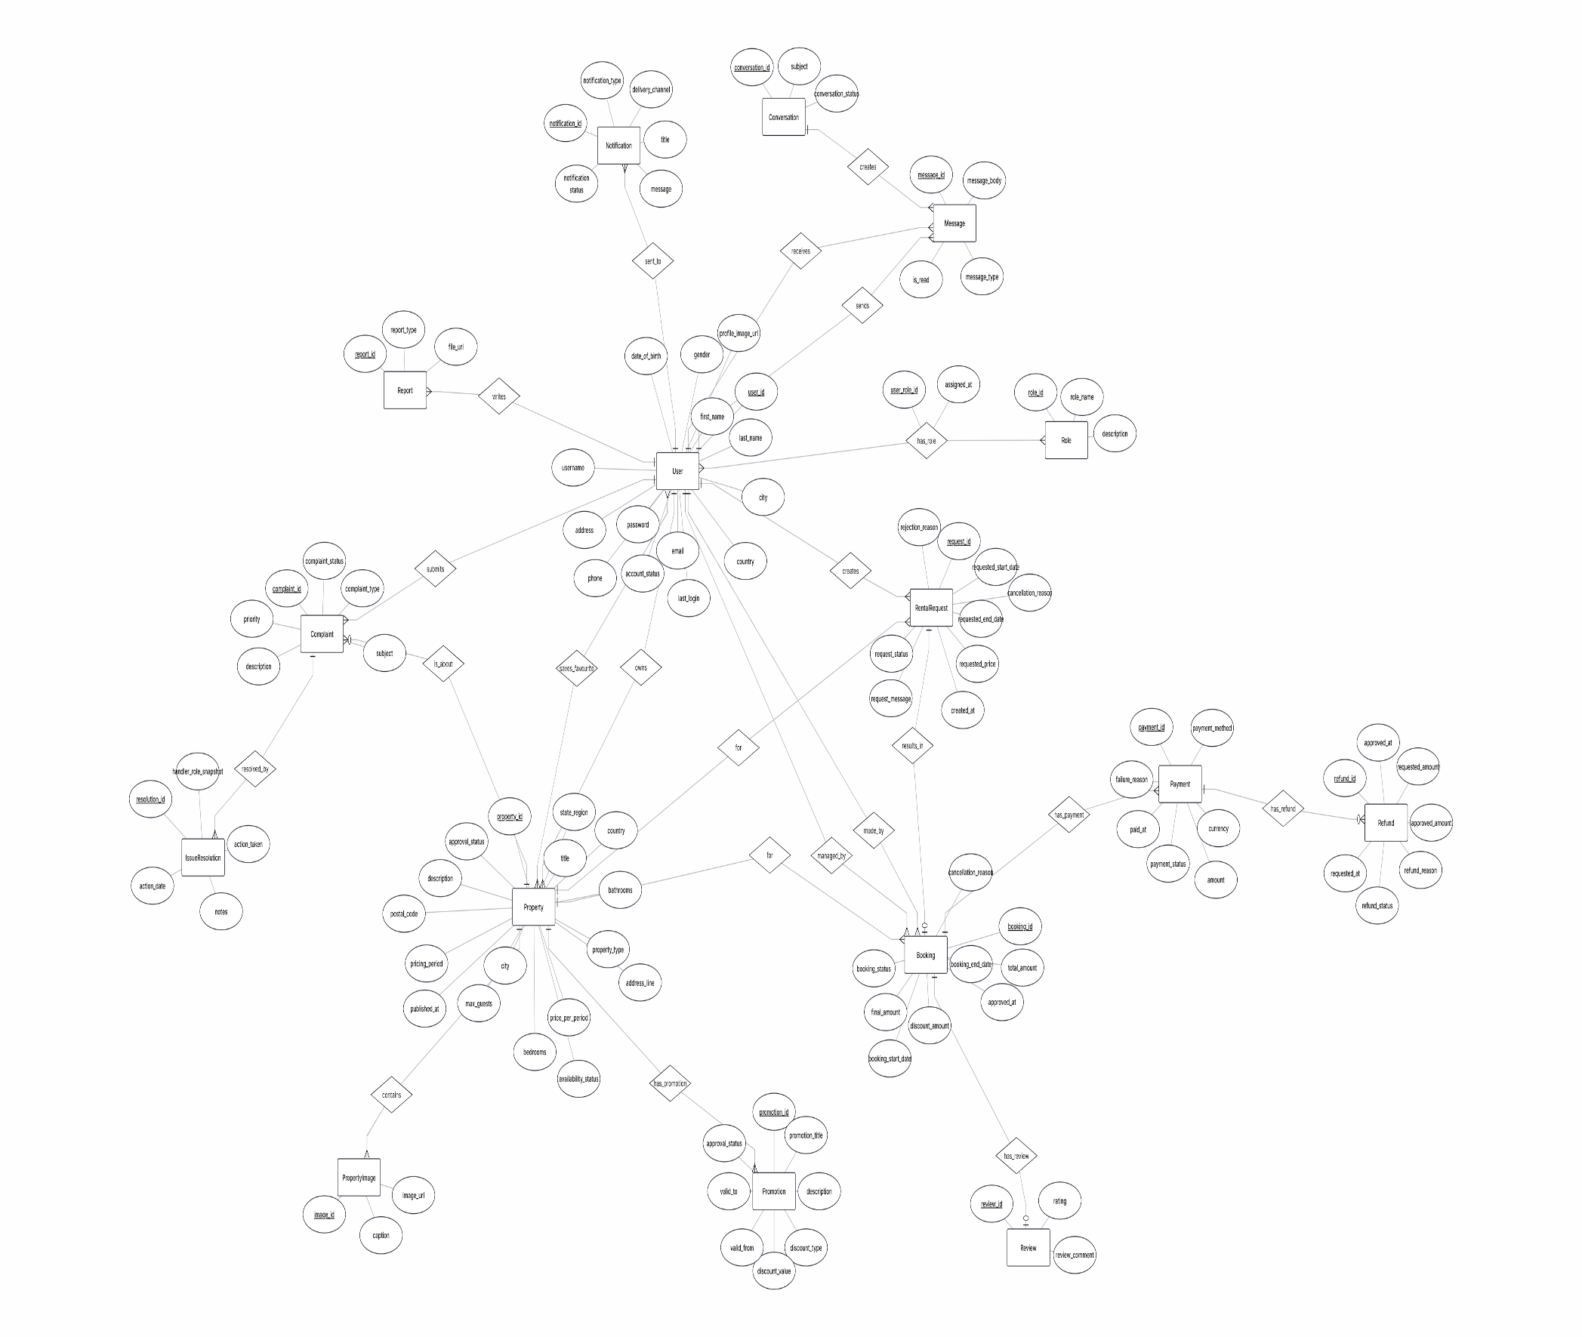
  - ER Diagram

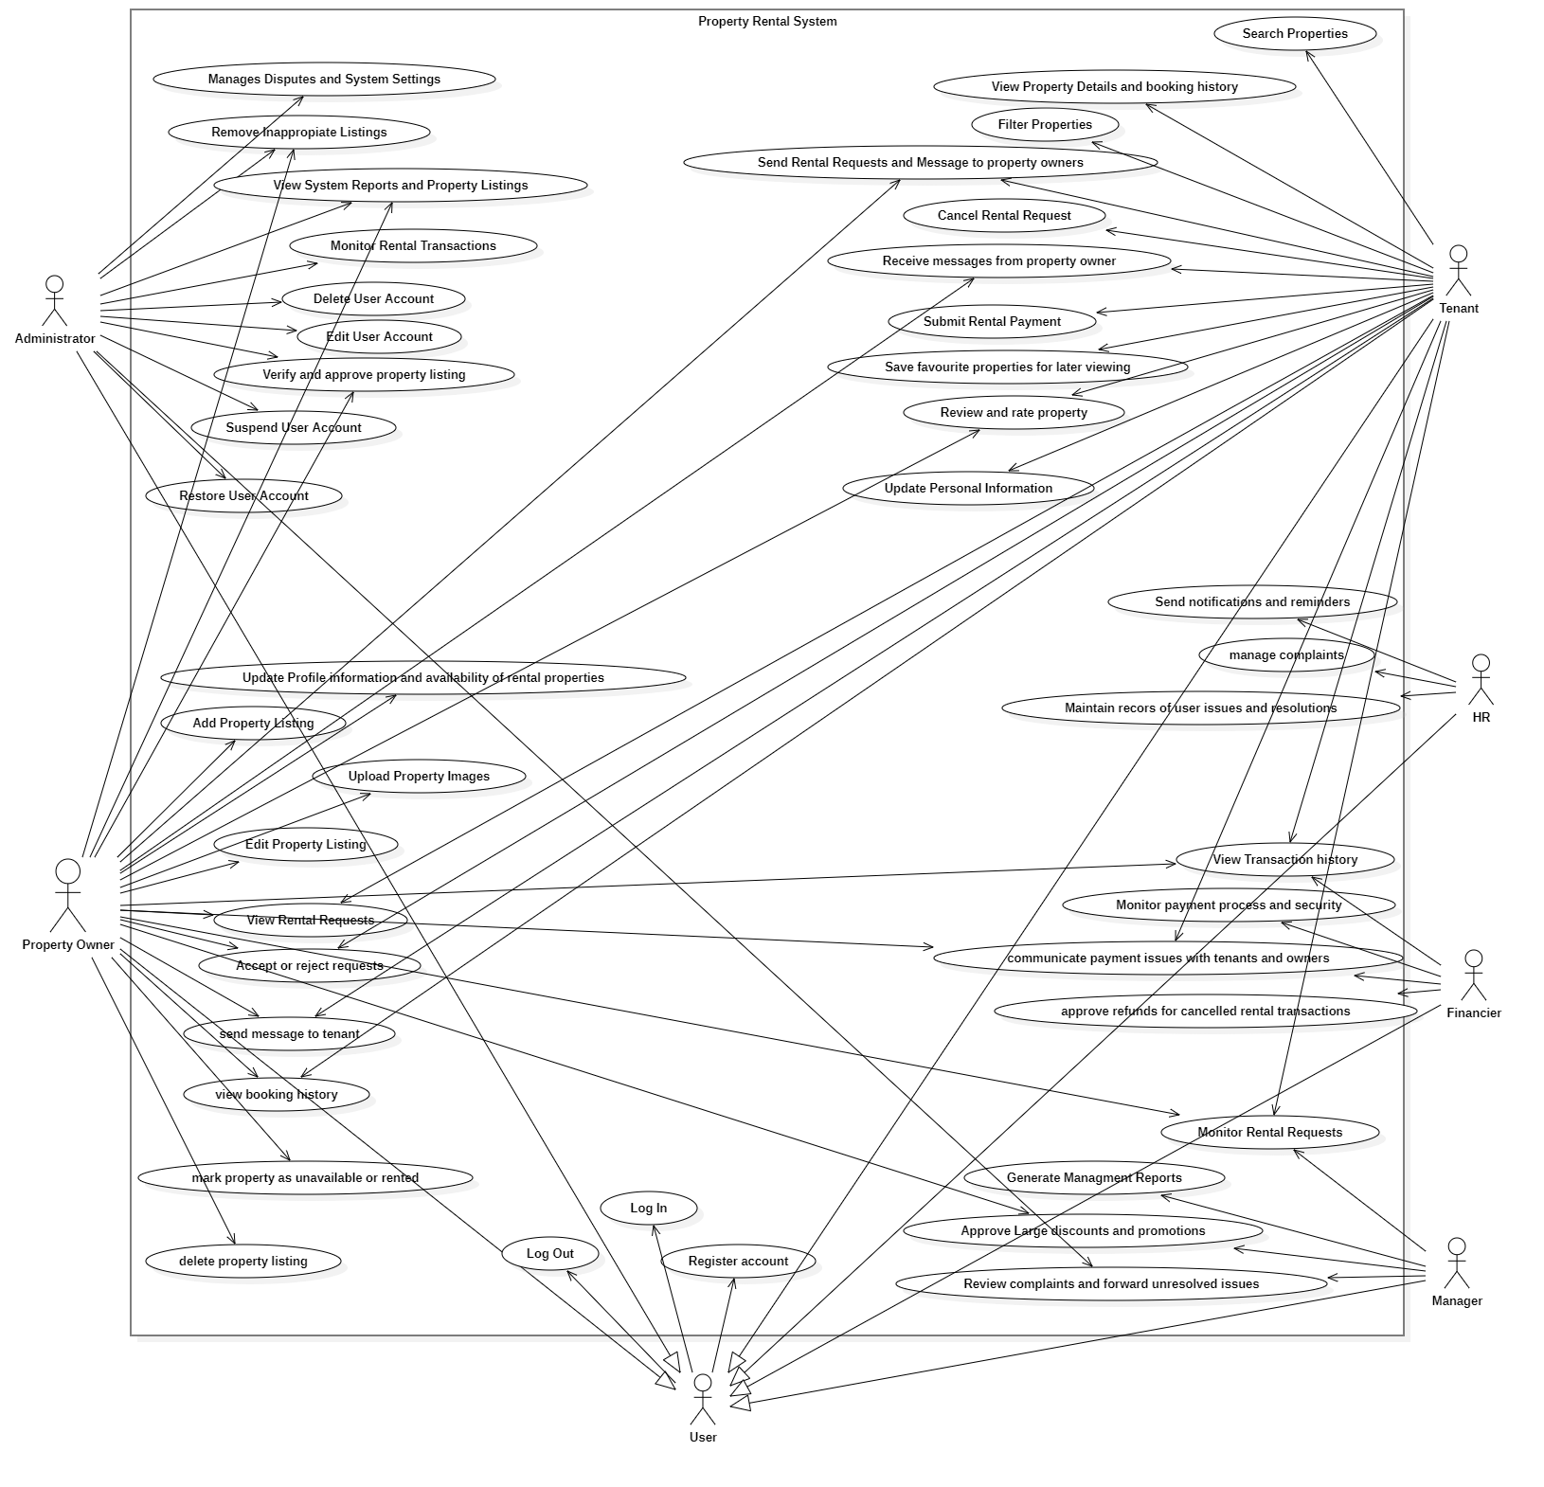
5.2 Use Case Diagram

  - Activity Diagram

AC_PRS_1- Update personal information (Done by: Anisa Domi)
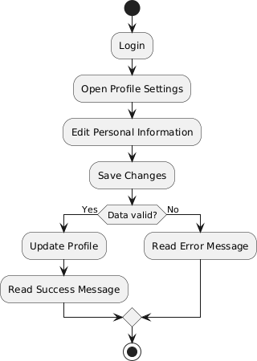

AC_PRS_2 - Search properties (Done by: Anisa Domi)
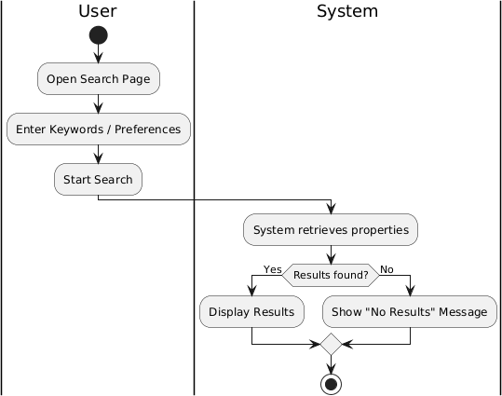

AC_PRS_3 - Filter properties (Done by: Anisa Domi)

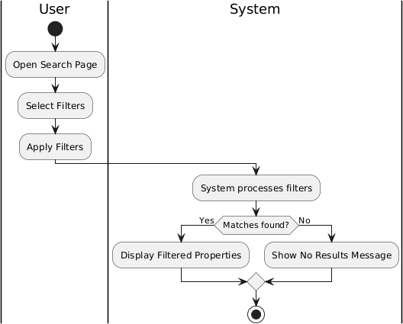

AC_PRS_4 - View property details and booking history. (Done by: Anisa Domi)

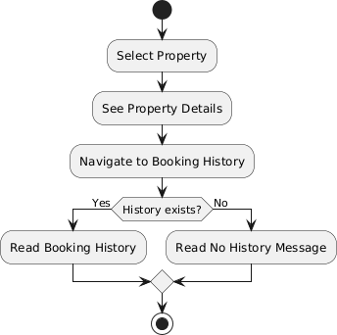

AC_PRS_5 - Send rental requests and message to property owners. (Done by: Anisa Domi)

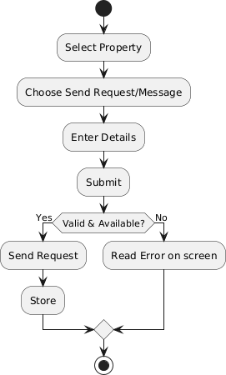

AC_PRS_6 - Cancel rental request (Done by: Anisa Domi)

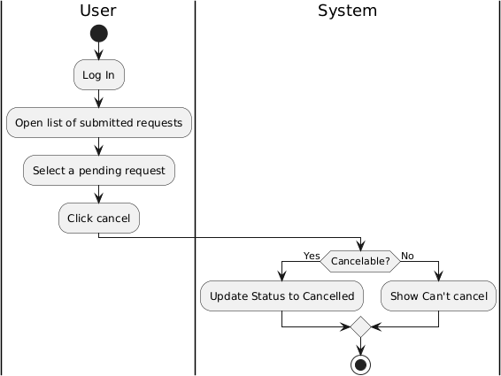

AC_PRS_7 - Receive messages from property owners. (Done by: Haidi Toto)

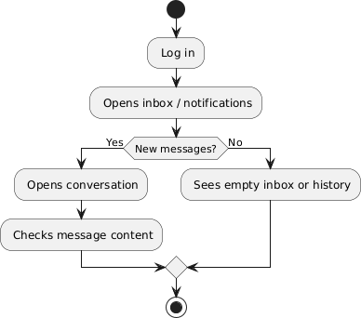

AC_PRS_8 – Submit rental payments. (Done by: Haidi Toto)
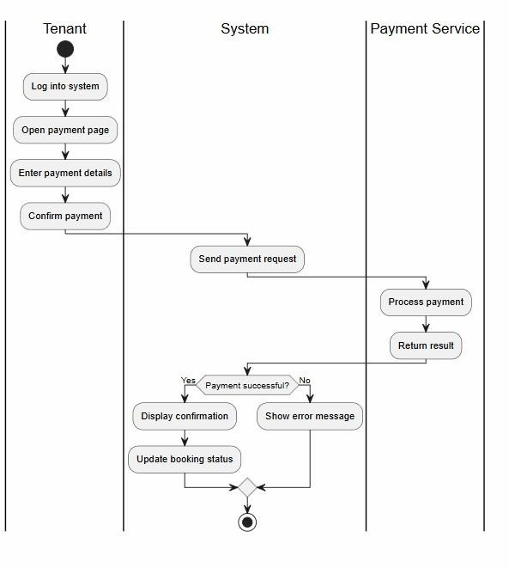

AC_PRS_9 - Save favourite properties for later viewing. (Done by: Haidi Toto)
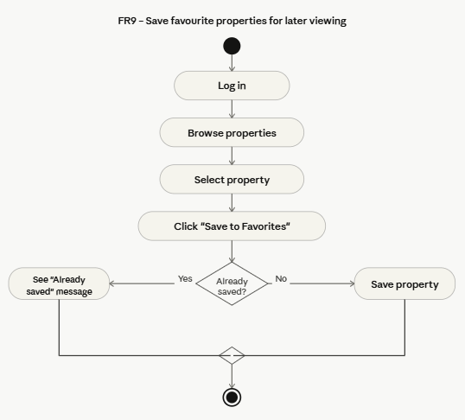

AC_PRS_10 – Review and Rate property (Done by: Haidi Toto)
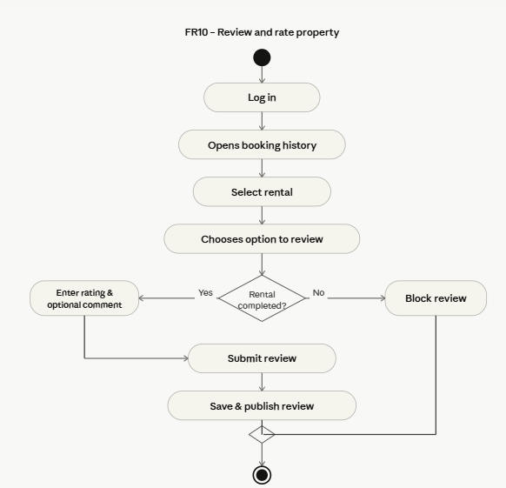

AC_PRS_11 - Update Profile Information and availability of rental properties (Done by: Haidi Toto)
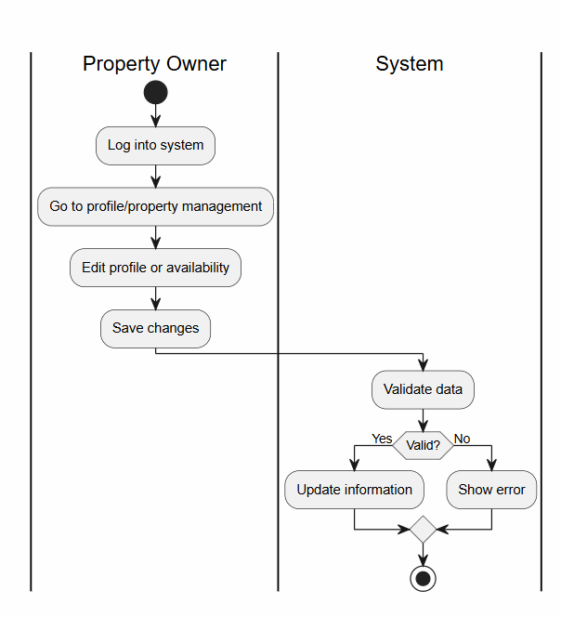
AC_PRS_12 - Add Property Listing (Done by: Haidi Toto)
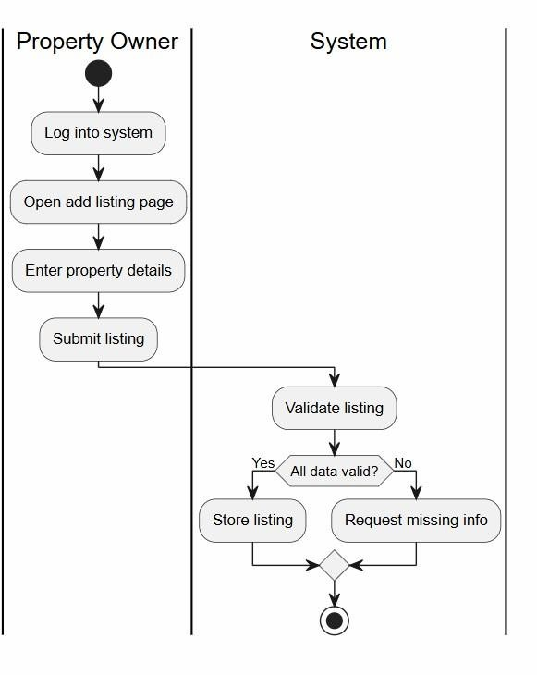
AC_PRS_13 - Upload Property Images (Done by: Ledio Tafciu)
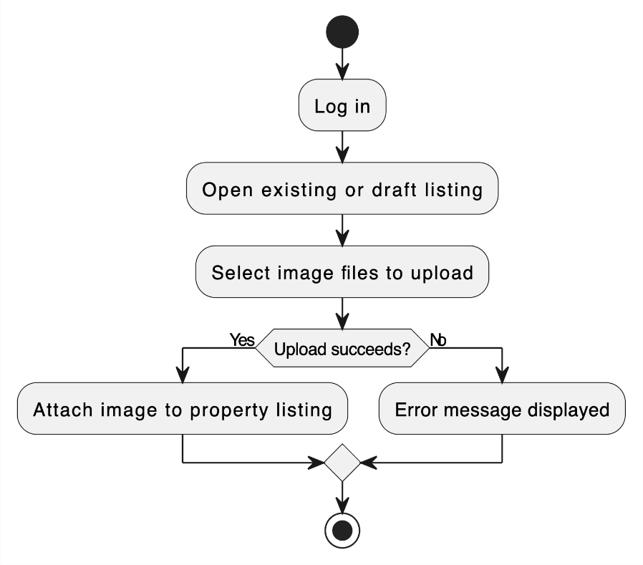

AC_PRS_14 - Edit Property Listing (Done by: Ledio Tafciu)

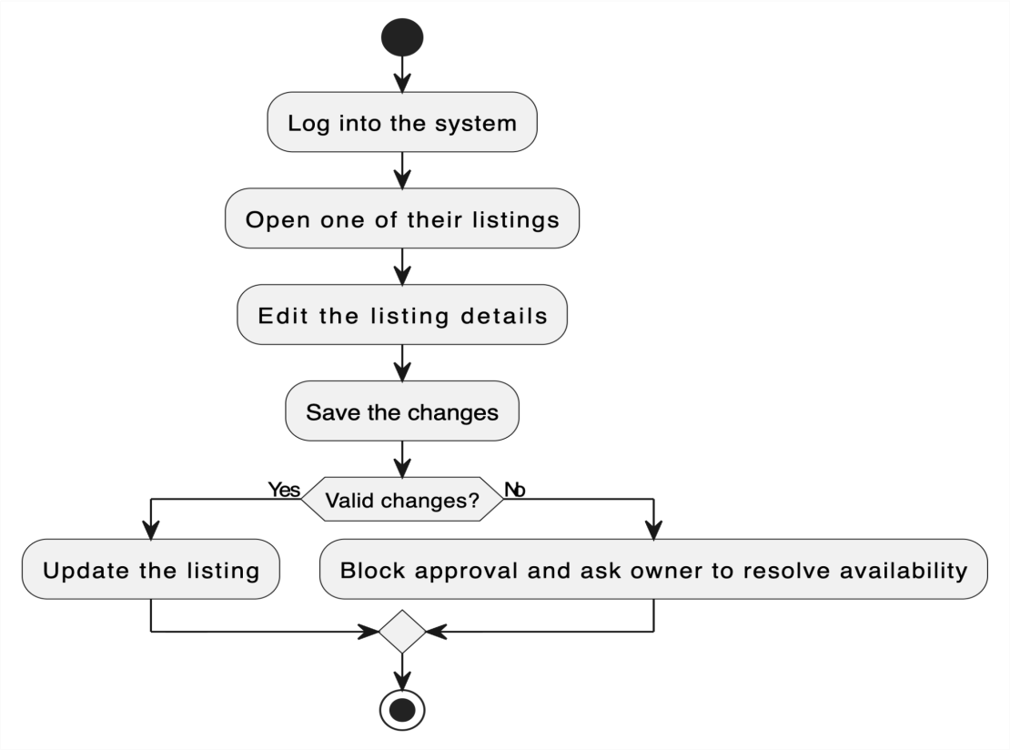

AC_PRS_15 - Delete Property Listing (Done by: Ledio Tafciu)
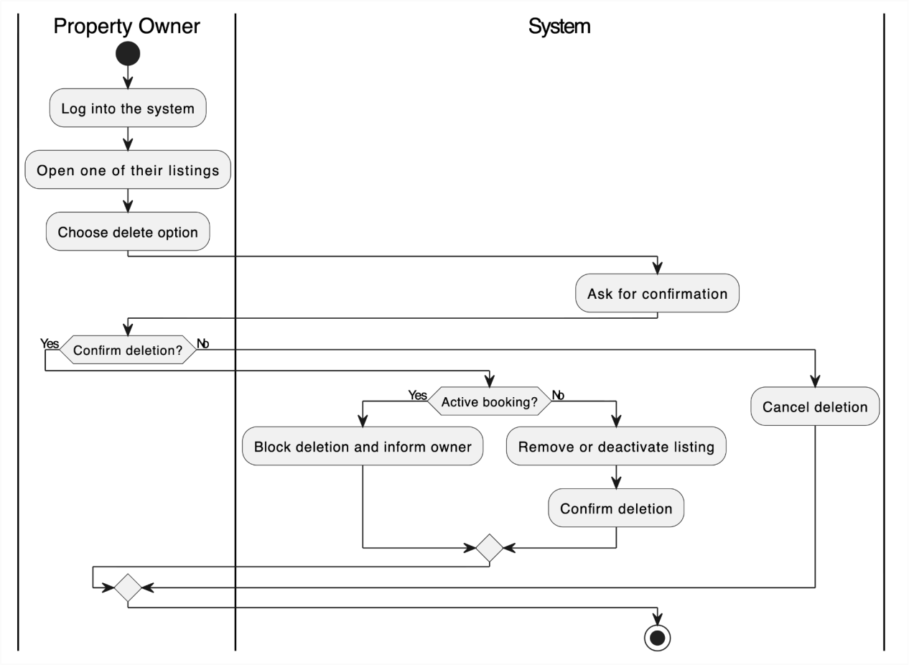
AC_PRS_16 - View Rental Requests (Done by: Ledio Tafciu)
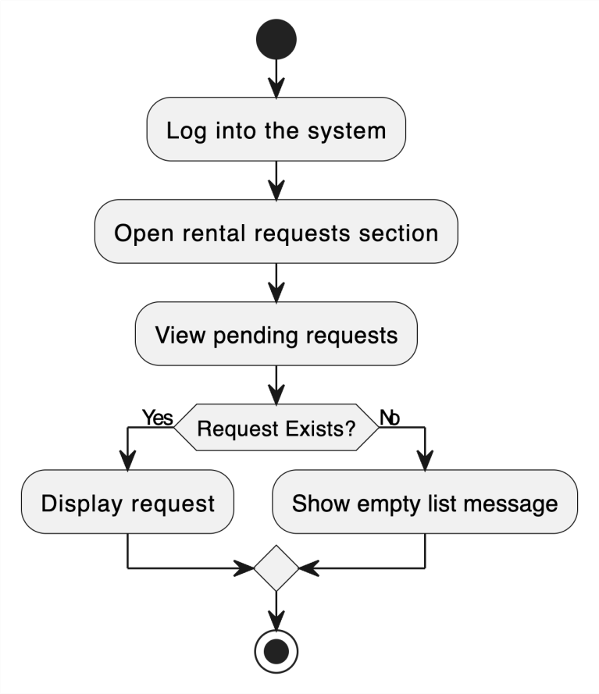
AC_PRS_17 - Accept or Reject Rental Request (Done by: Ledio Tafciu)
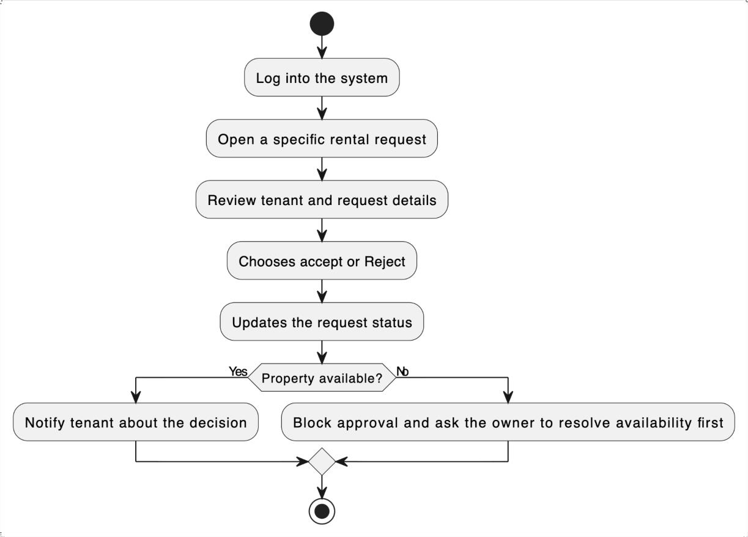
AC_PRS_18 - Send Message to Tenant (Done by: Ledio Tafciu)
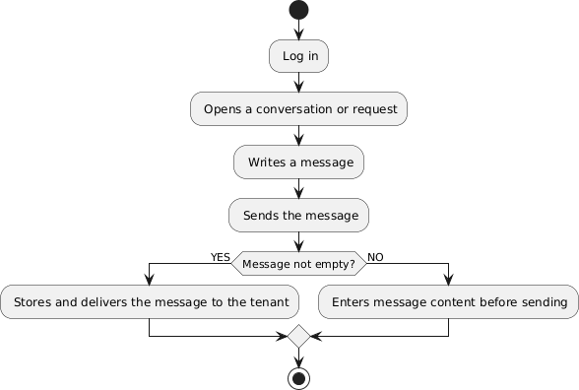

AC_PRS_19 - View Booking History (Done by: Desard Lybeshari)

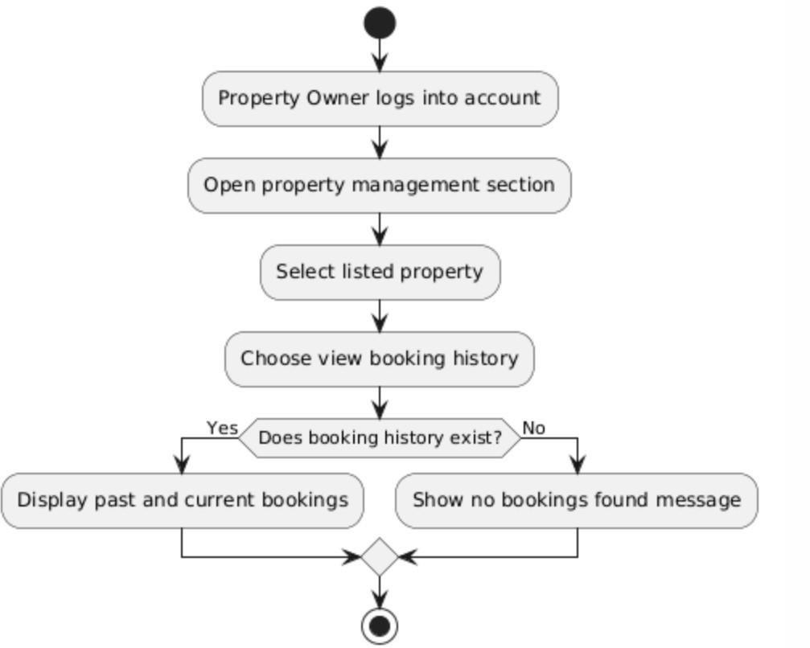

AC_PRS_20 - Mark Property as Unavailable or Rented (Done by: Desard Lybeshari)

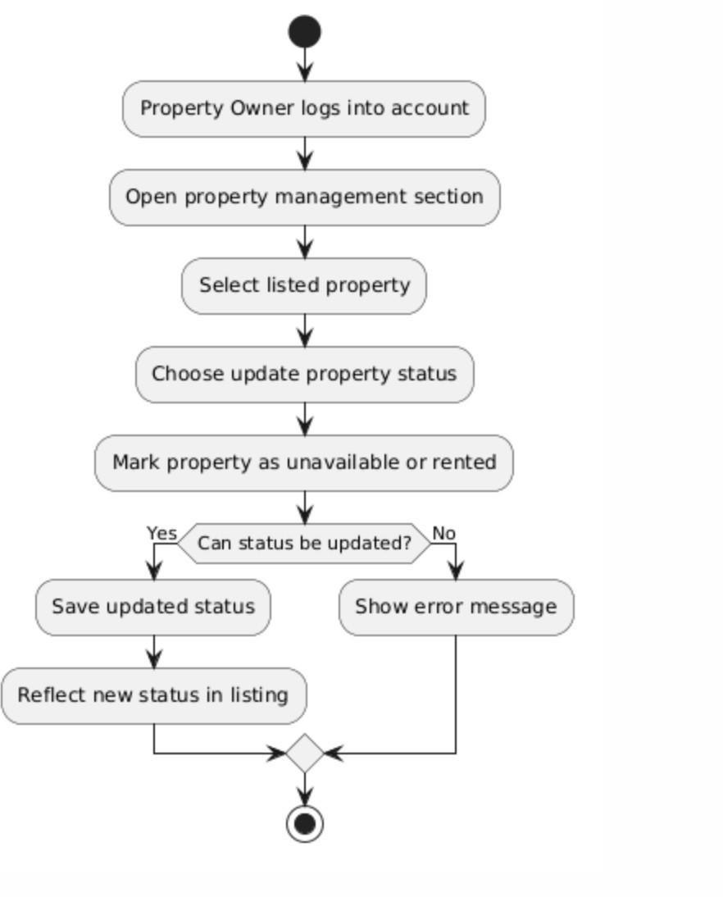

AC_PRS_21 - Edit User Accounts (Done by: Desard Lybeshari)
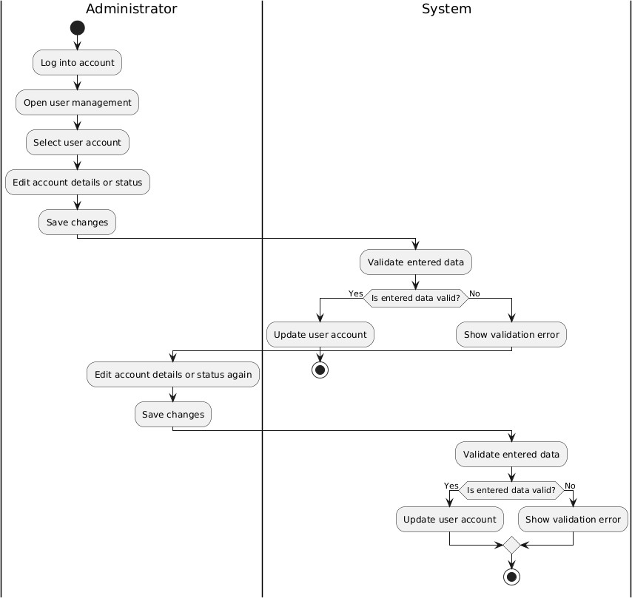
AC_PRS_22 - Delete User Accounts (Done by: Desard Lybeshari)

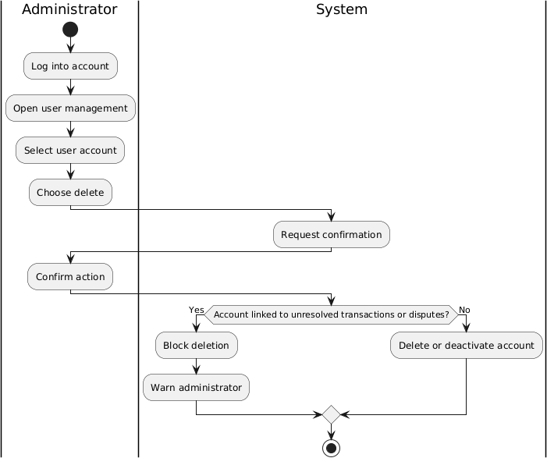

AC_PRS_23 - Monitor Rental Transactions (Done by: Desard Lybeshari)

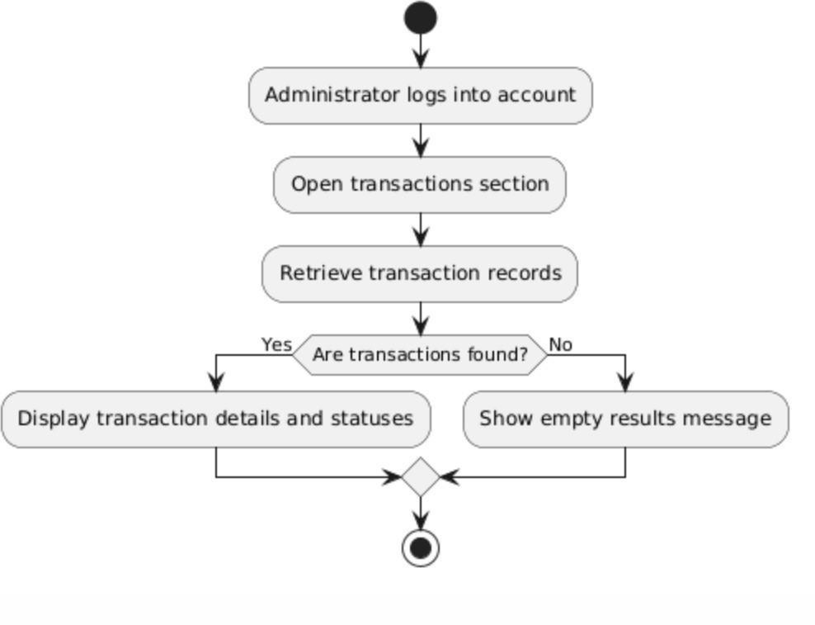

AC_PRS_24 - View System Reports and Property Listings (Done by: Desard Lybeshari)

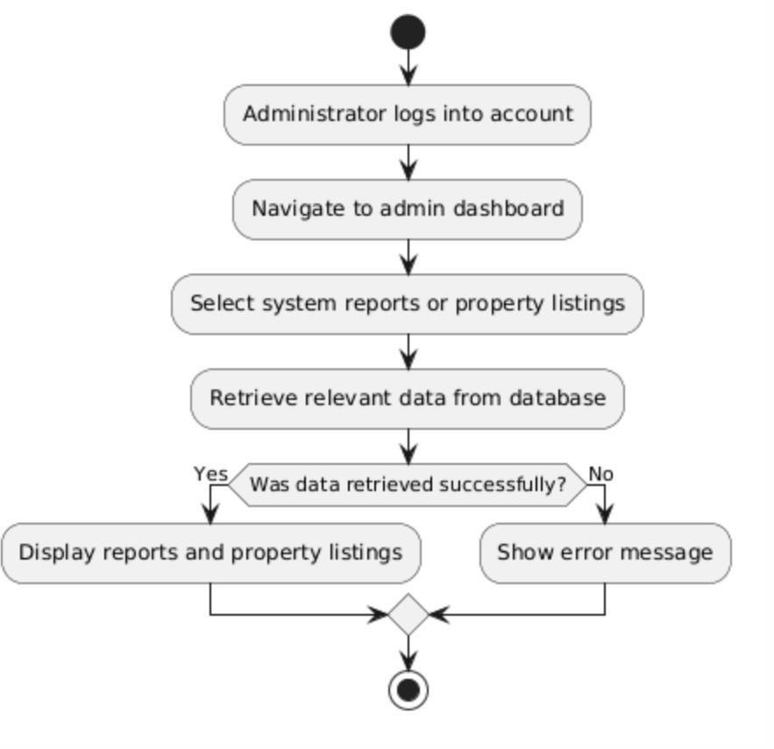

AC_PRS_25 - Remove Inappropriate Listings (Done by: Matias Bali)

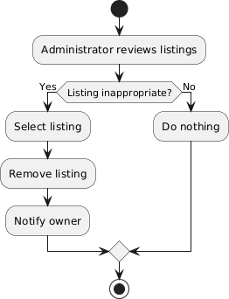

AC_PRS_26 - Manage Disputes and System Settings (Done by: Matias Bali)
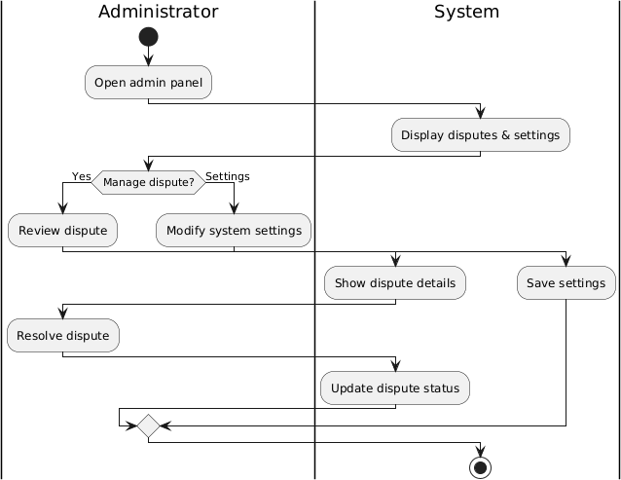
AC_PRS_27 - Restore User Accounts (Done by: Matias Bali)
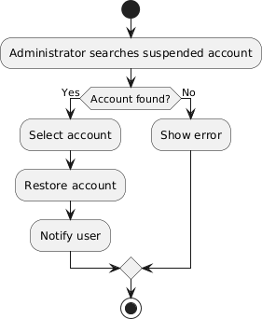

AC_PRS_28 - Suspend User Accounts (Done by: Matias Bali)
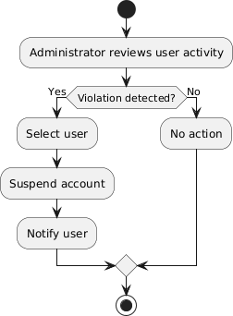
AC_PRS_29 - Verify and Approve property listings (Done by: Matias Bali)
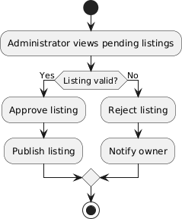

AC_PRS_30 - Monitor Rental Requests (Done by: Matias Bali)

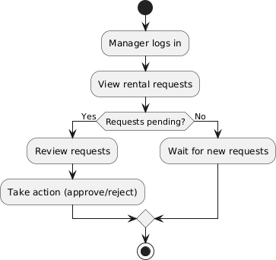
AC_PRS_31 - Generate Management Reports (Done by: Ornelt Lemellari)

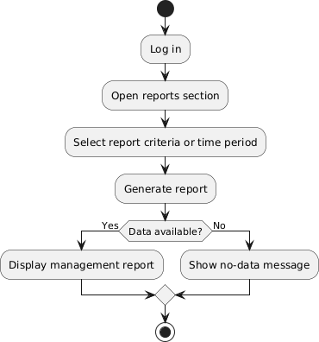

AC_PRS_32 - Approve Large Discounts and Promotions (Done by: Ornelt Lemellari)

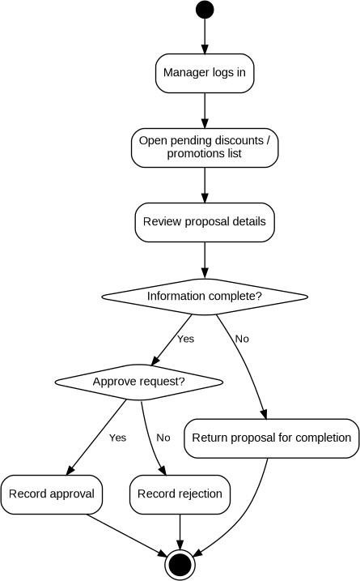

AC_PRS_33 - Review Complaints and Forward Unresolved Issues (Done by: Ornelt Lemellari)

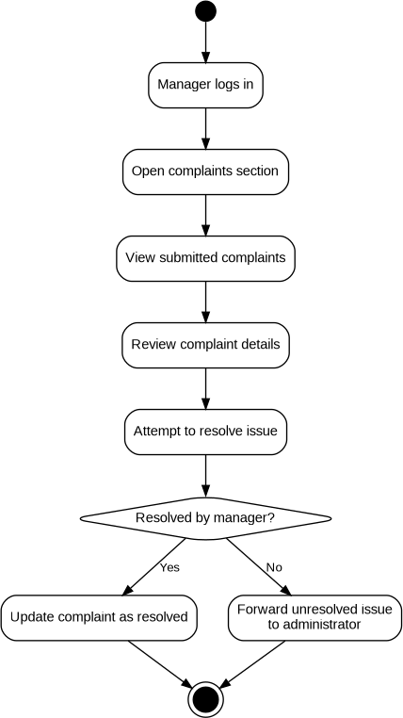

AC_PRS_34 - View Transaction History (Done by: Ornelt Lemellari)

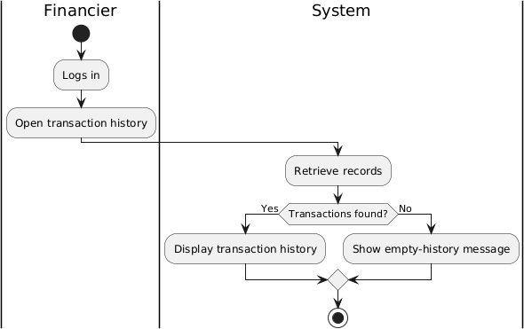

AC_PRS_35 - Monitor Payment Process and Security (Done by: Ornelt Lemellari)
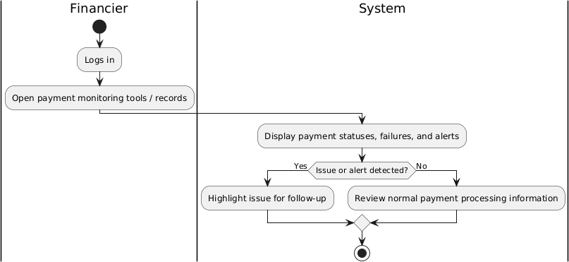

AC_PRS_36 - Communicate Payment Issues with Tenants and Owners (Done by: Ornelt Lemellari)

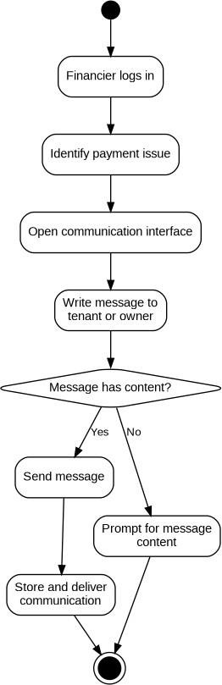

AC_PRS_37 - Approve Refunds for cancelled Rental Transactions (Done by: Kevin Muho)

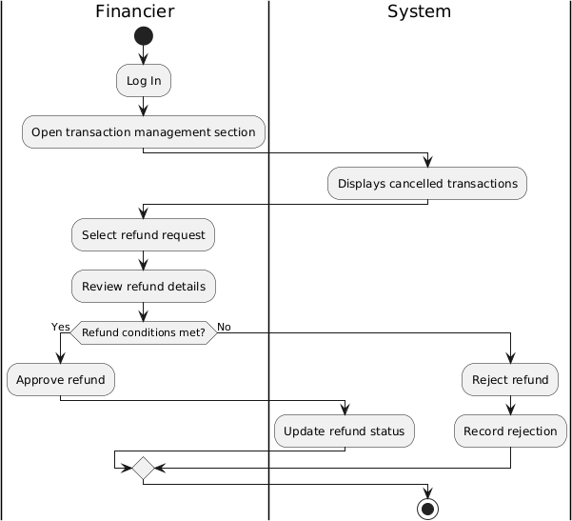

AC_PRS_38 - Manage Complaints (Done by: Kevin Muho)

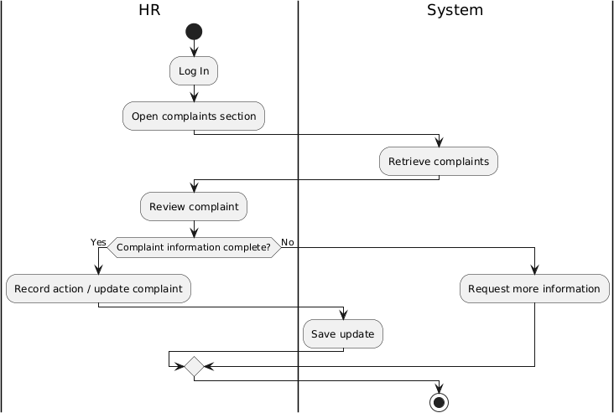
AC_PRS_39 - Send Notifications and Reminders (Done by: Kevin Muho)

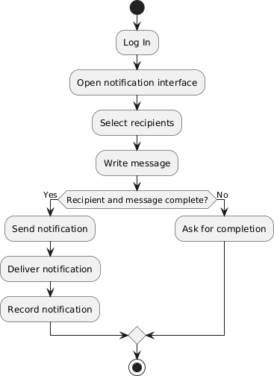

AC_PRS_40 - Maintain Records of User Issues and Resolutions (Done by: Kevin Muho)

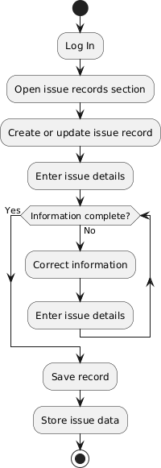

AC_PRS_41 - Register Account (Done by: Kevin Muho)

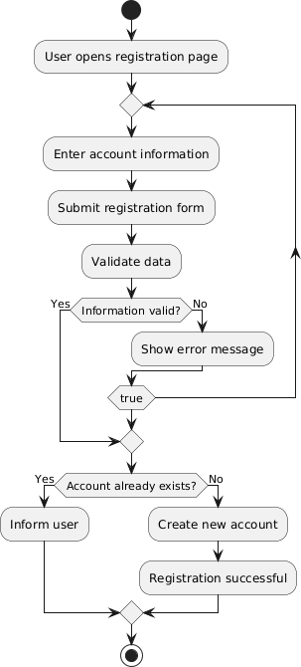

AC_PRS_42 - Log In (Done by: Kevin Muho)

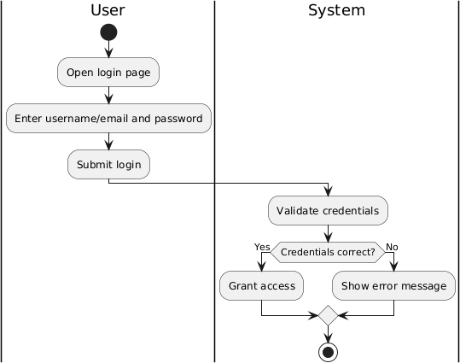

AC_PRS_43 – Log Out (Done by: Kevin Muho)

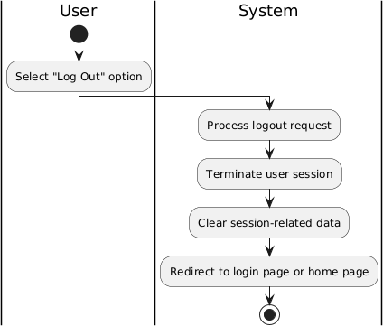

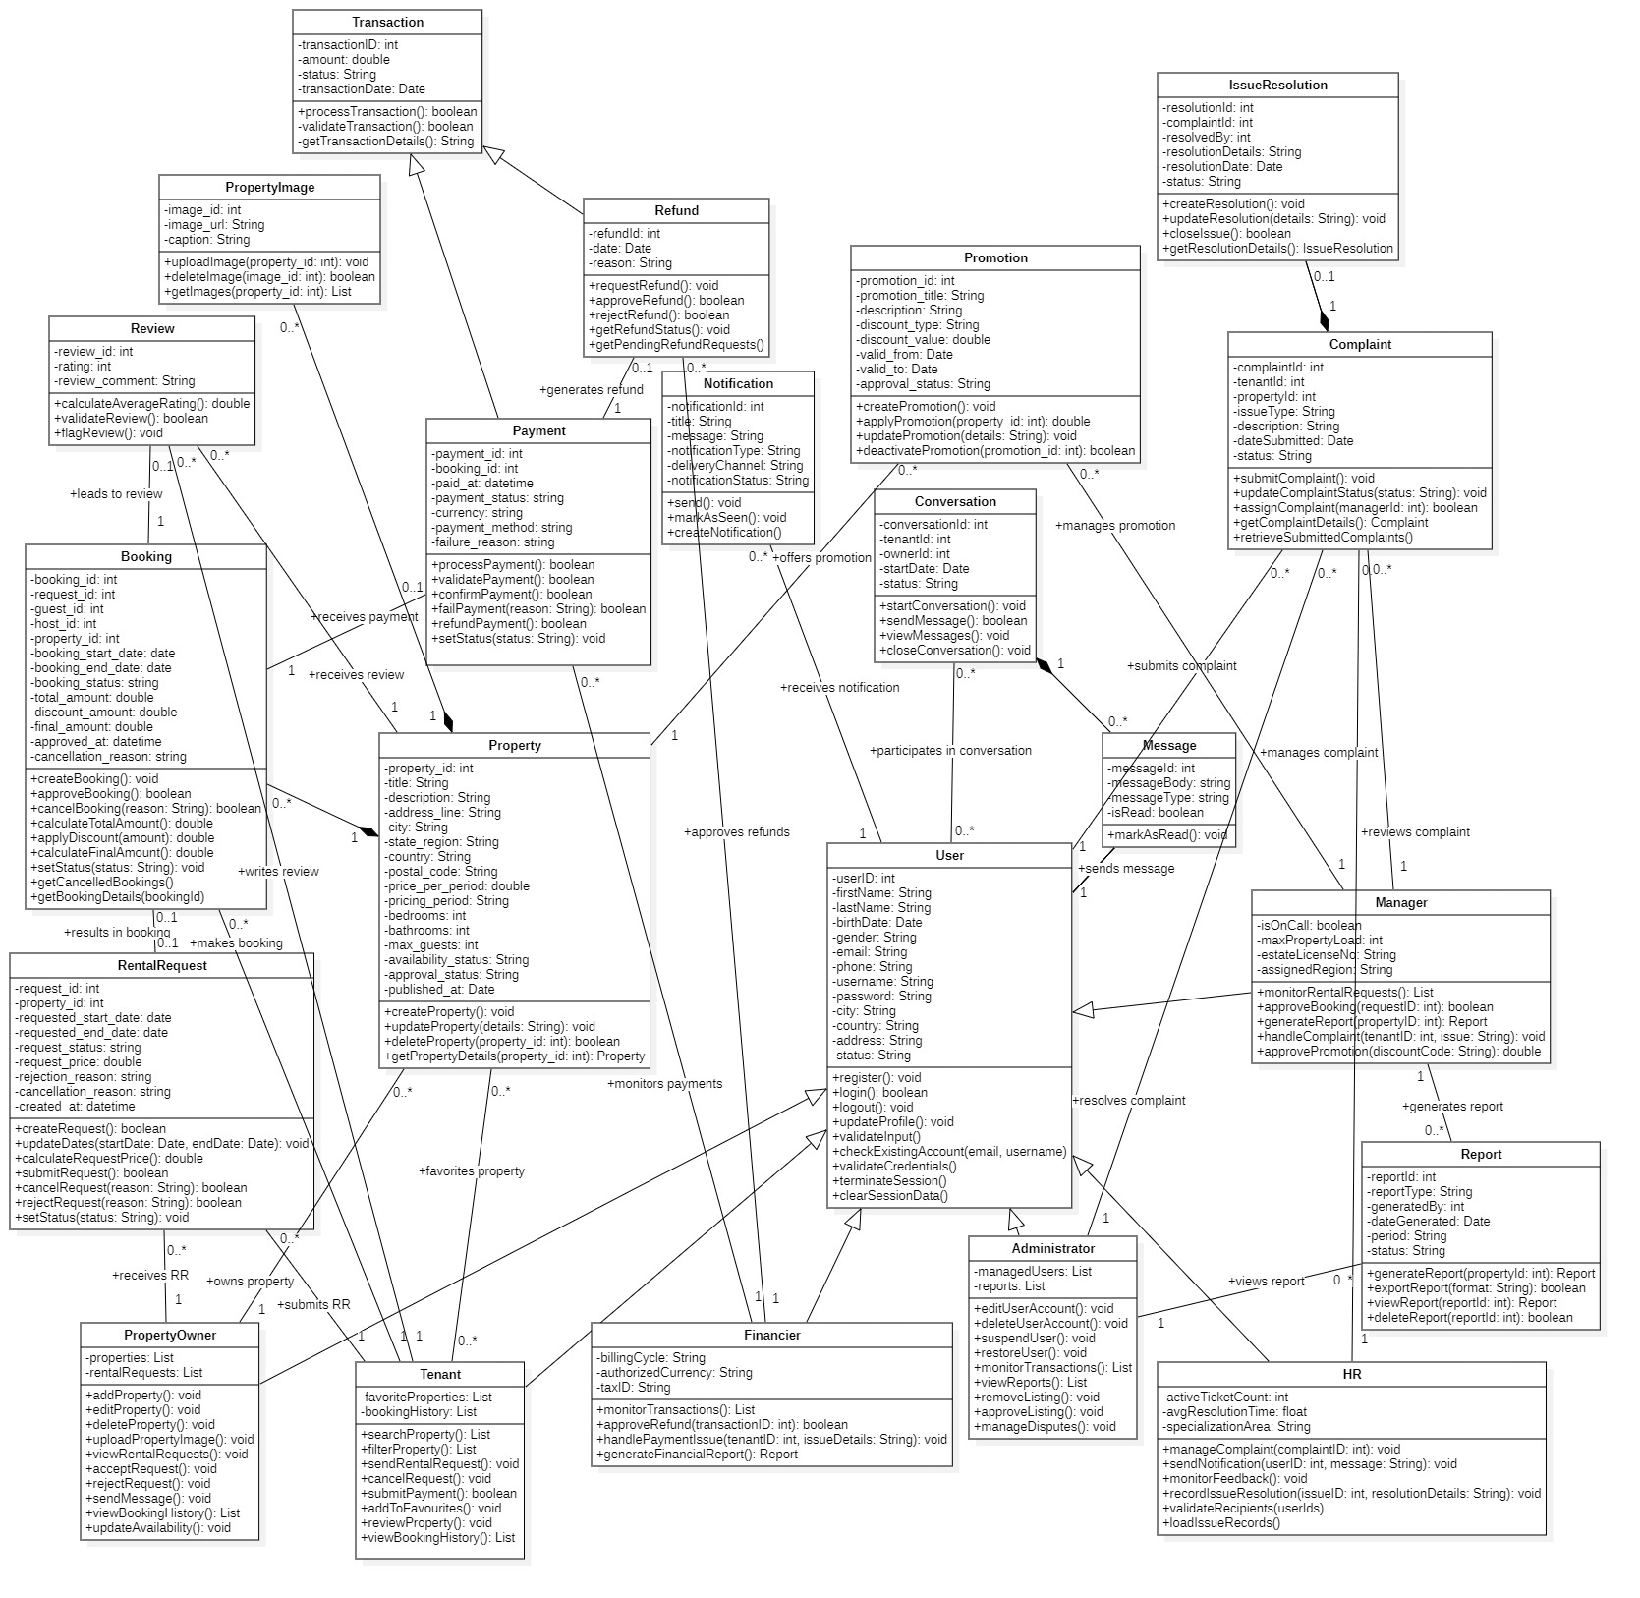
5.4. Class diagram.
  - State diagram

State Diagram – Tenant (Done by:Anisa Domi)
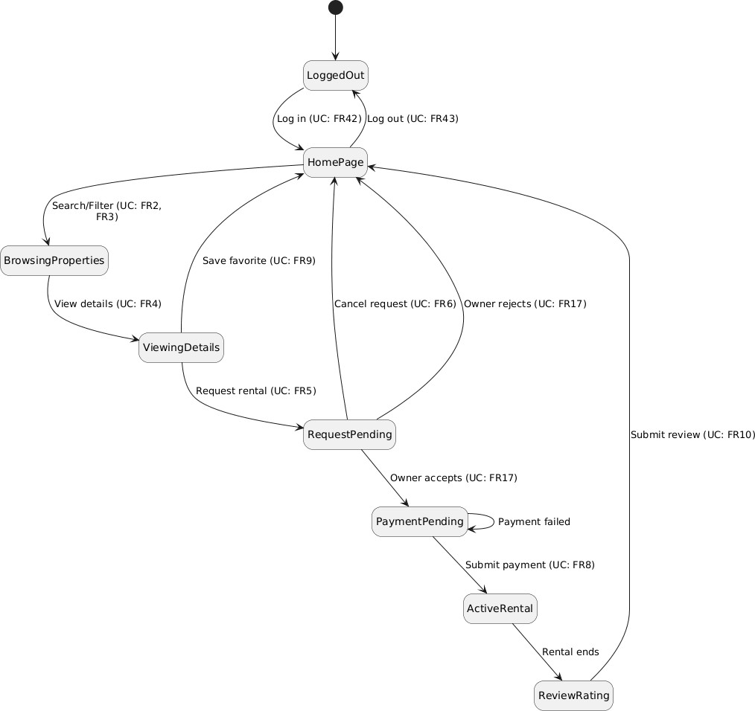

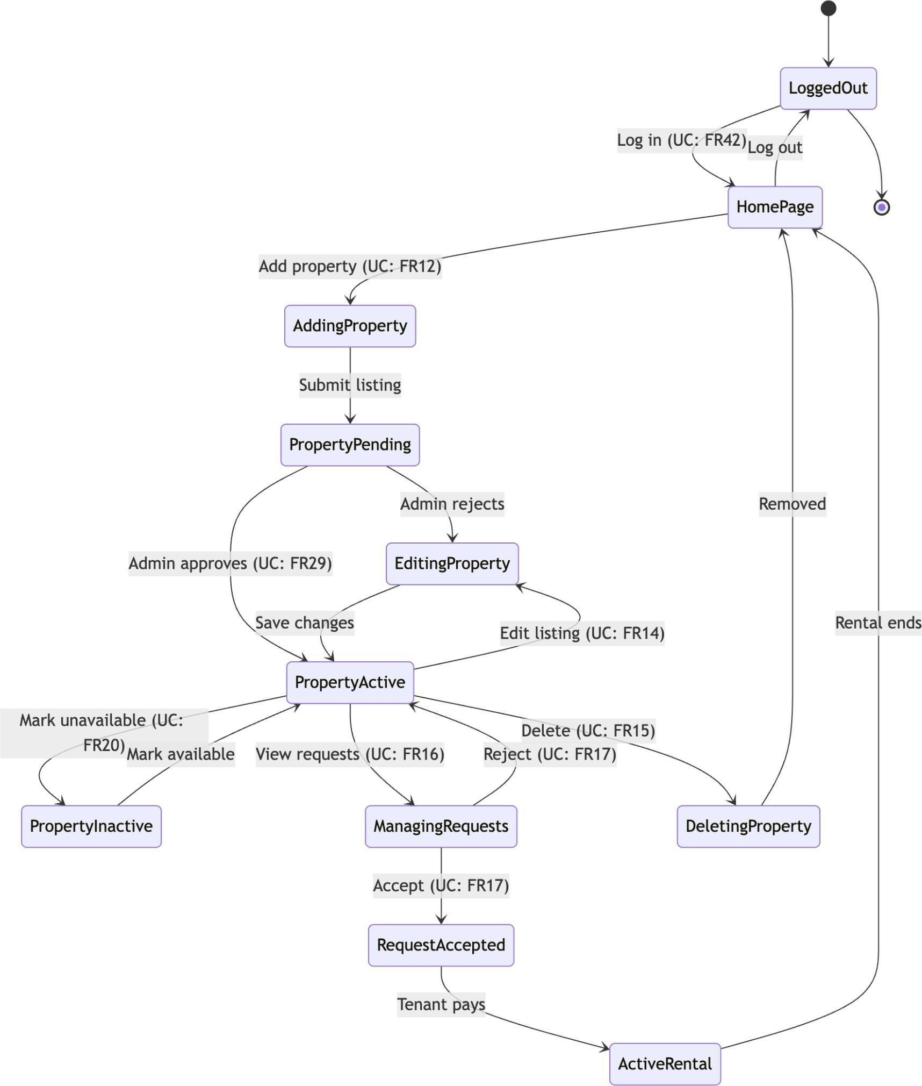
State Diagram - Property Owner (Done by:Haidi Toto)

State Diagram – Administrator (Done by:Ledio Tafciu)

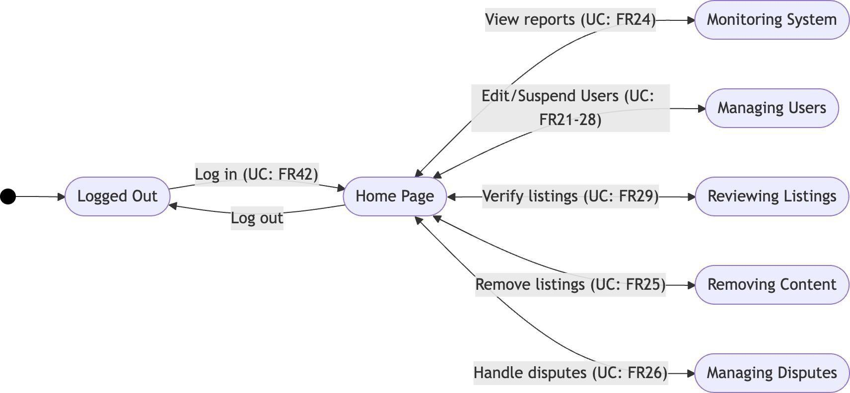

State Diagram – Manager (Done by:Matias Bali)
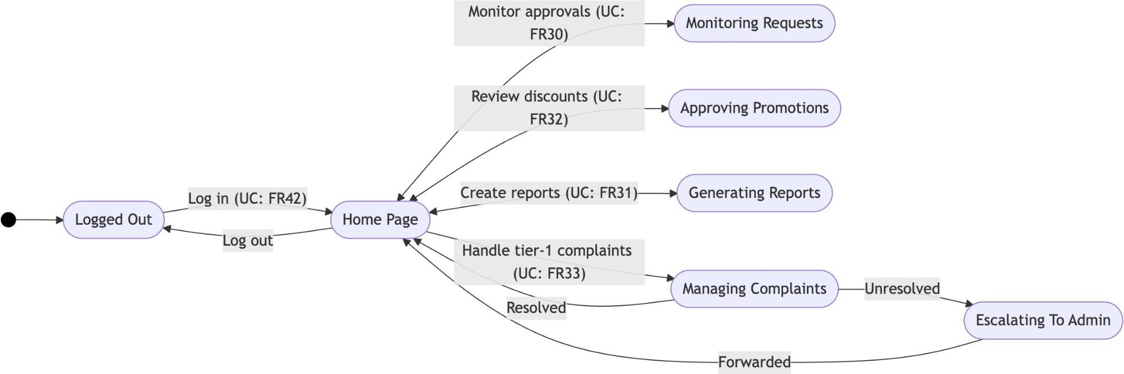

State Diagram – Financier (Done by:Ornelt Lemellari)
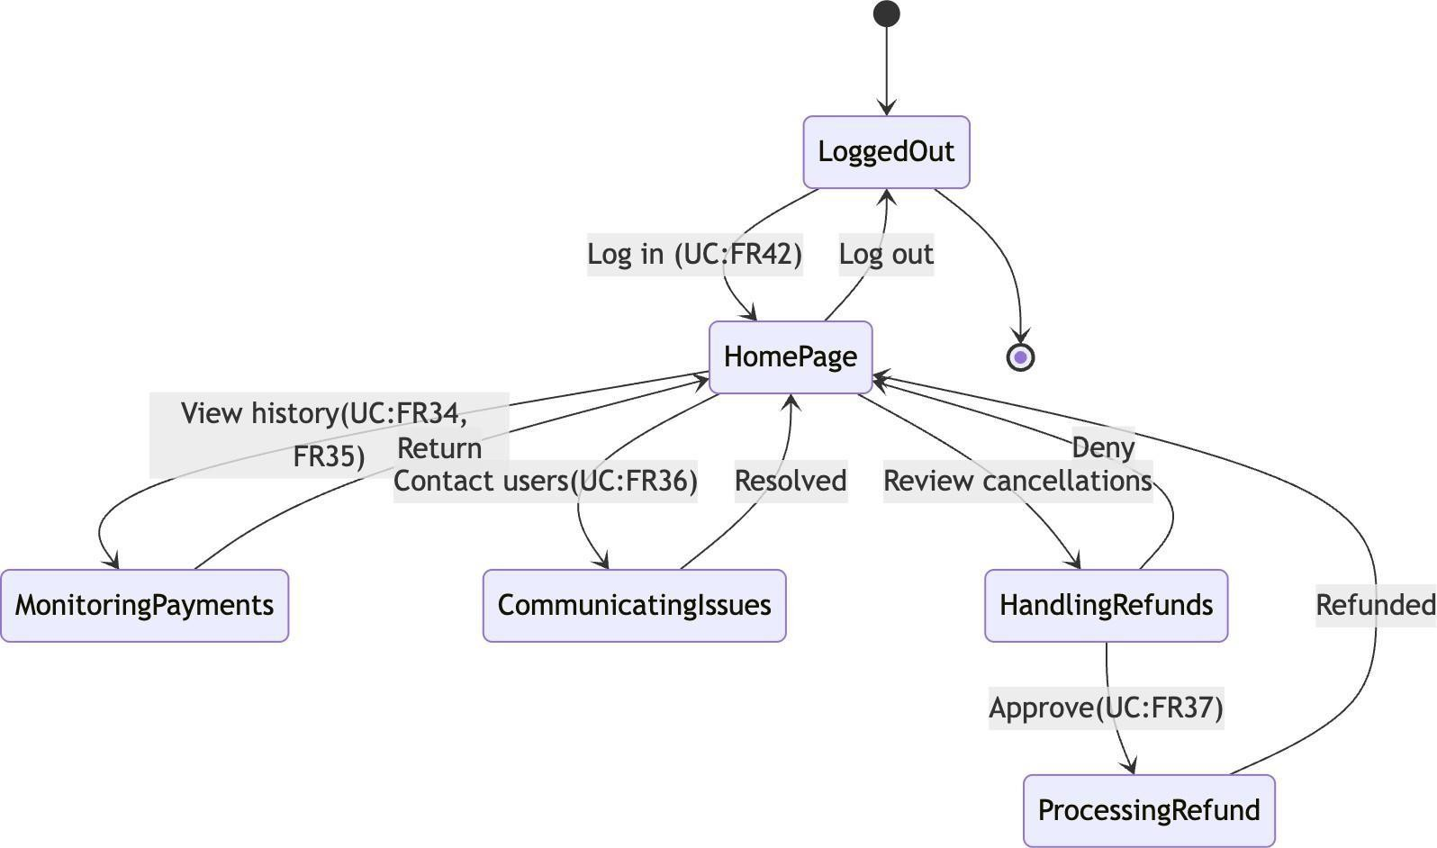

State Diagram – HR (Done by:Desard Lybeshari)
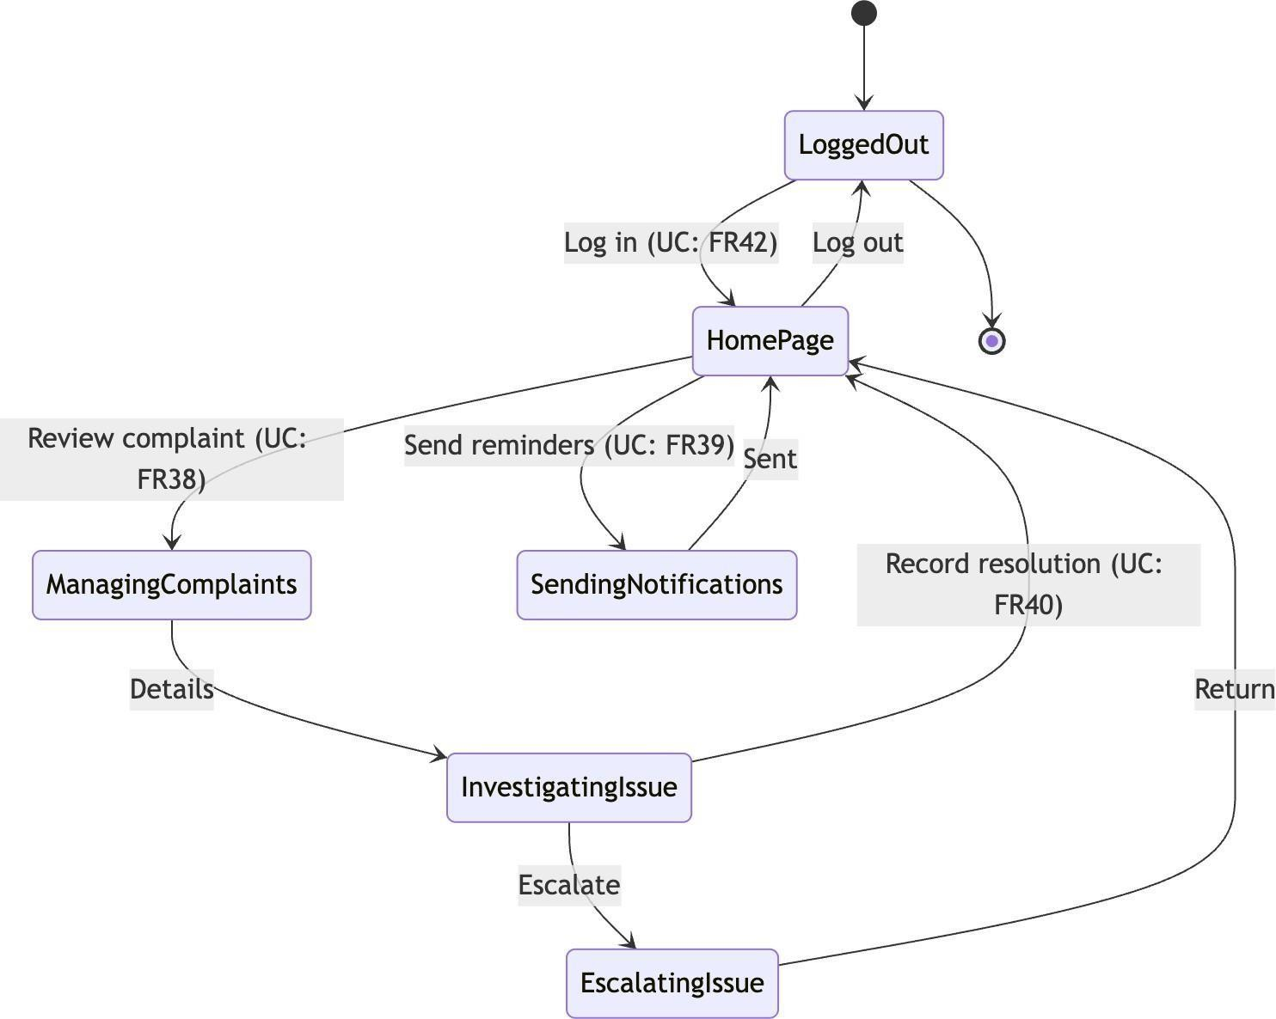

  - Sequence diagram.
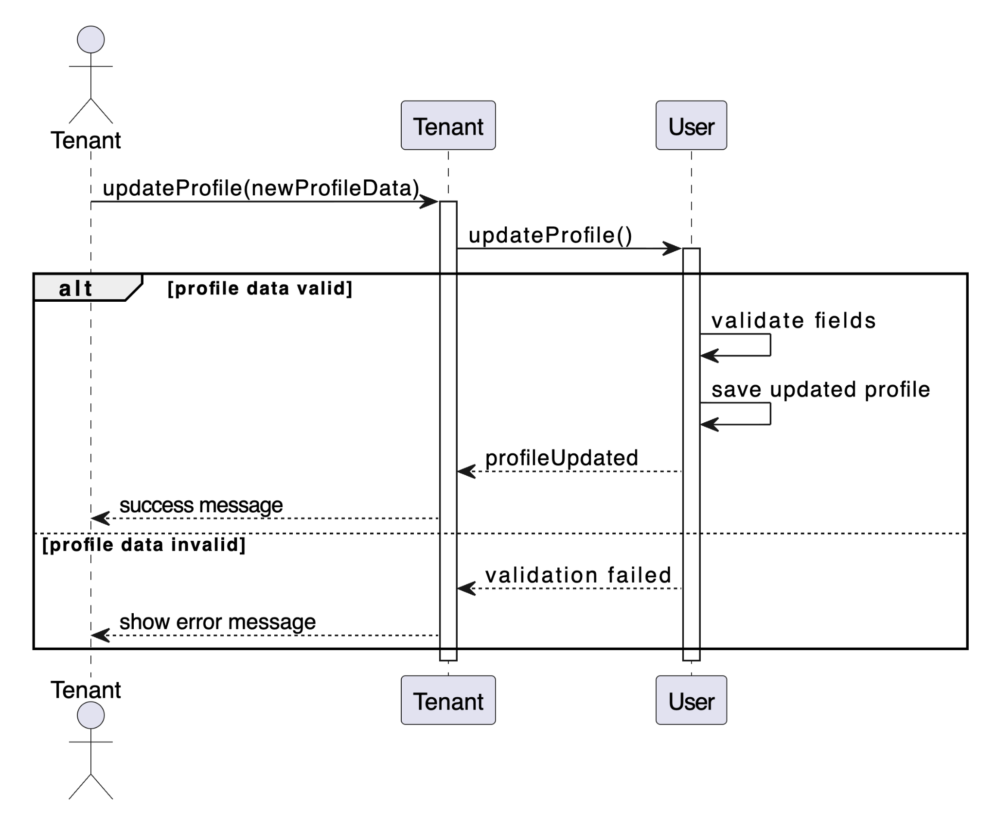
SC_PRS_1 – Update Personal Information (Done by: Anisa Domi)

SC_PRS_2 – Search Properties (Done by: Anisa Domi)
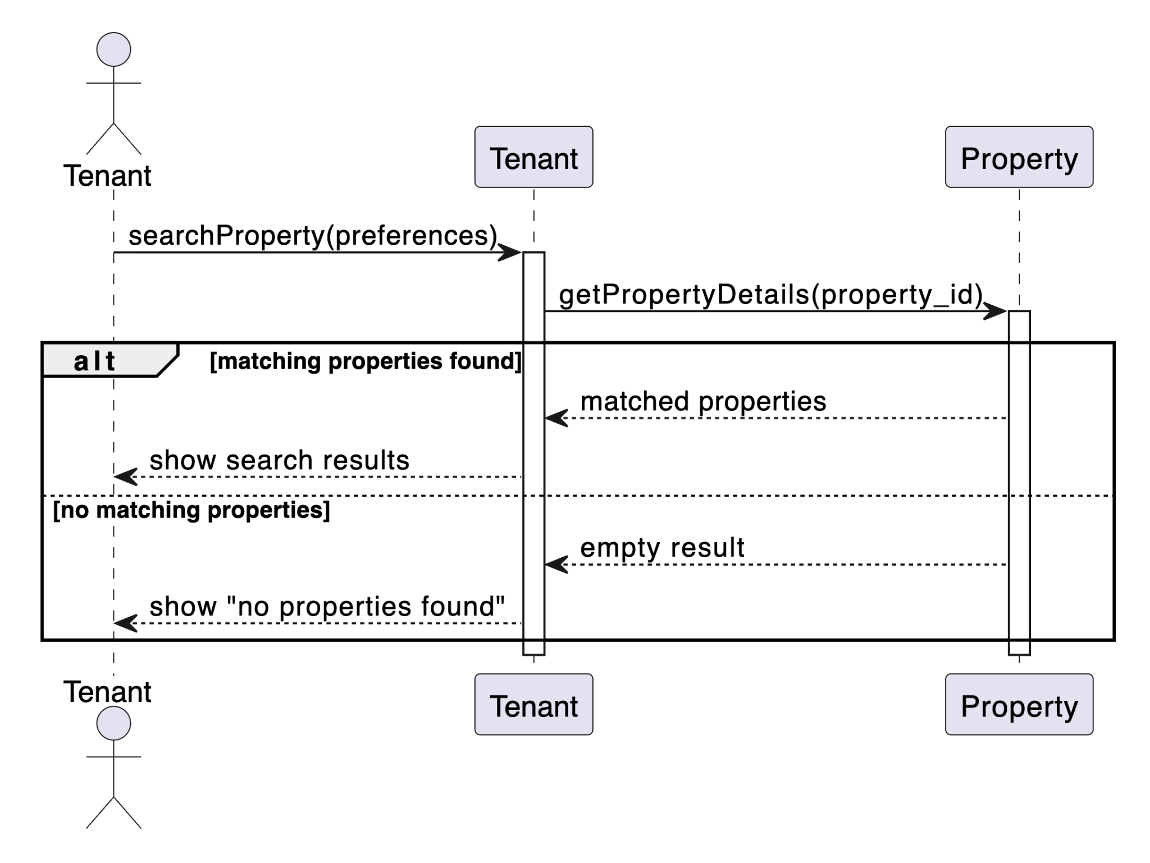

SC_PRS_3 – Filter Properties (Done by: Anisa Domi)
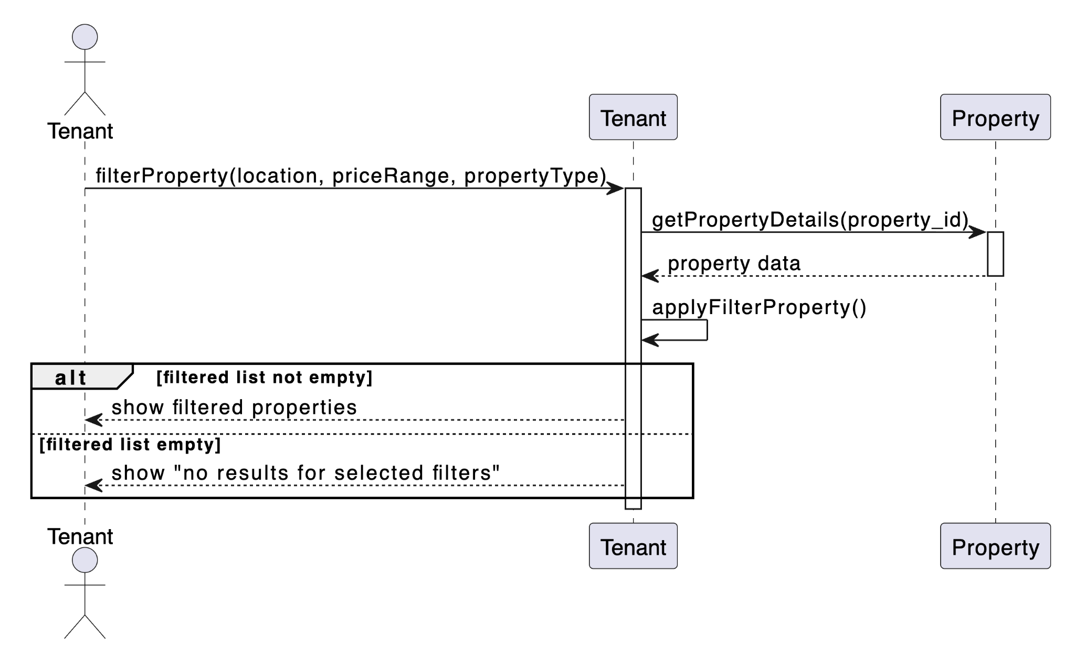

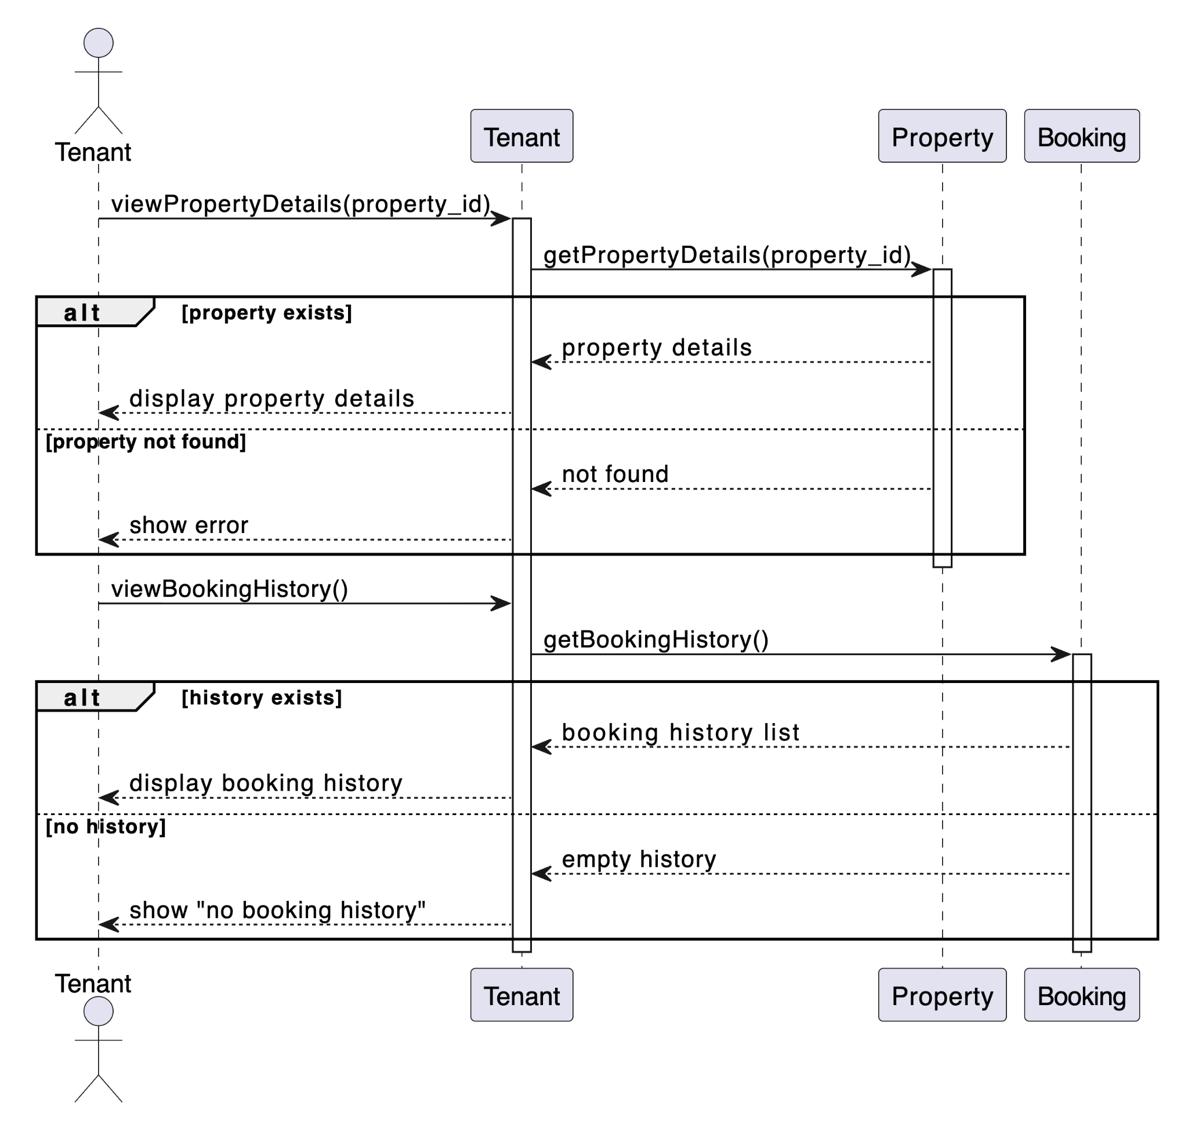
SC_PRS_4 – View Property Details and Booking History (Done by:Anisa Domi)

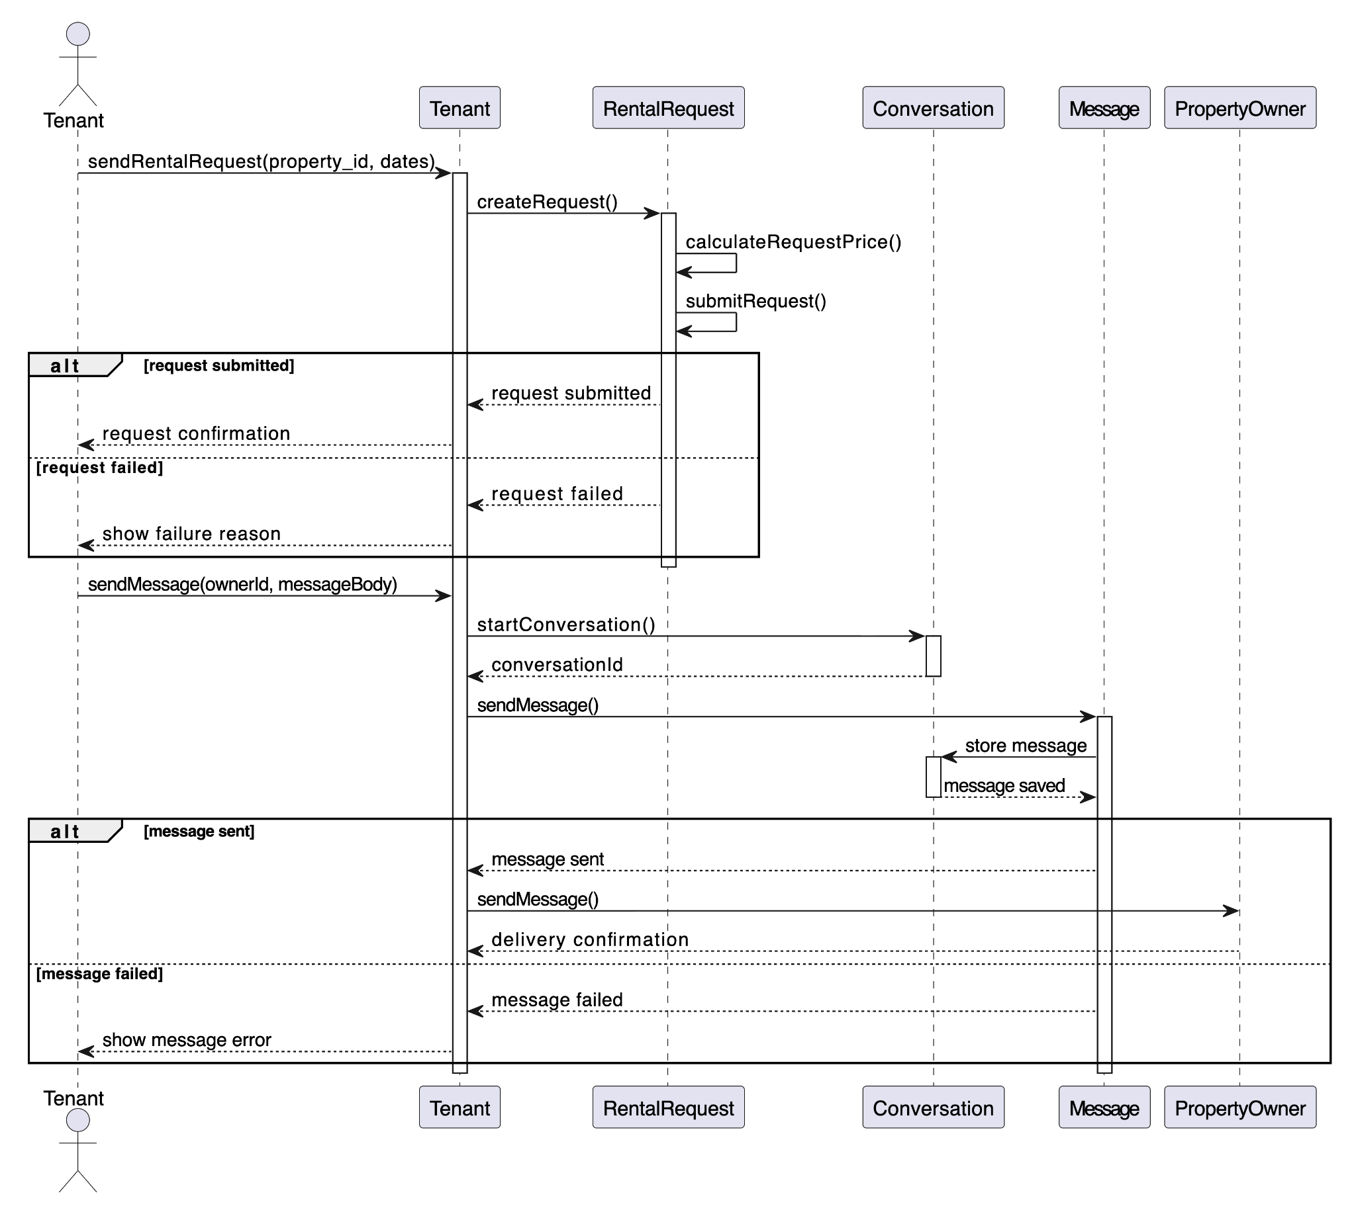
SC_PRS_5 – Send Rental Requests and Message to Property Owners (Done by: Anisa Domi)

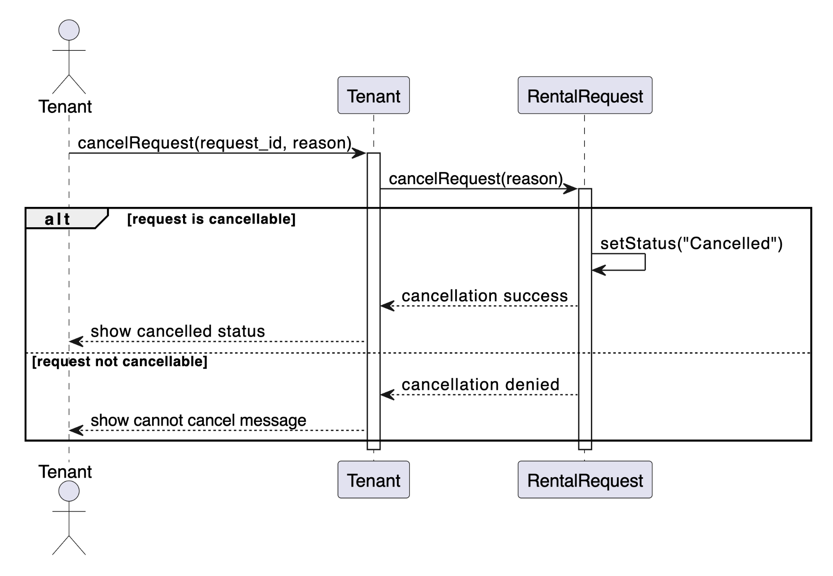
SC_PRS_6 – Cancel Rental Request (Done by: Anisa Domi)

SC_PRS_7 – Receive Messages from Property Owners (Done by: Haidi Toto)
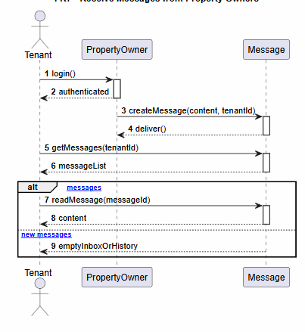

SC_PRS_8 – Submit Rental Payments (Done by: Haidi Toto)
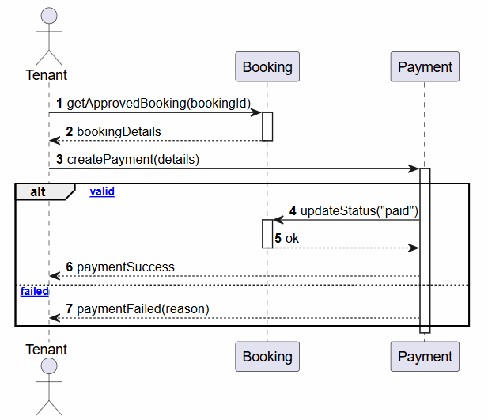

SC_PRS_9 – Save Favourite Properties for Later Viewing (Done by: Haidi Toto)
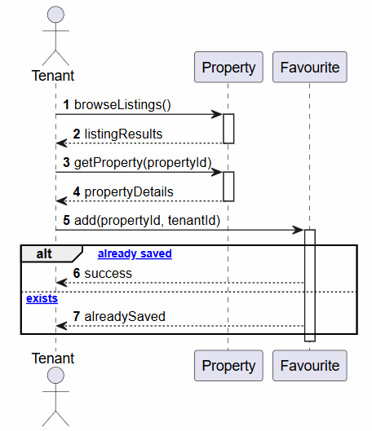

SC_PRS_10 – Review and Rate Property (Done by: Haidi Toto)
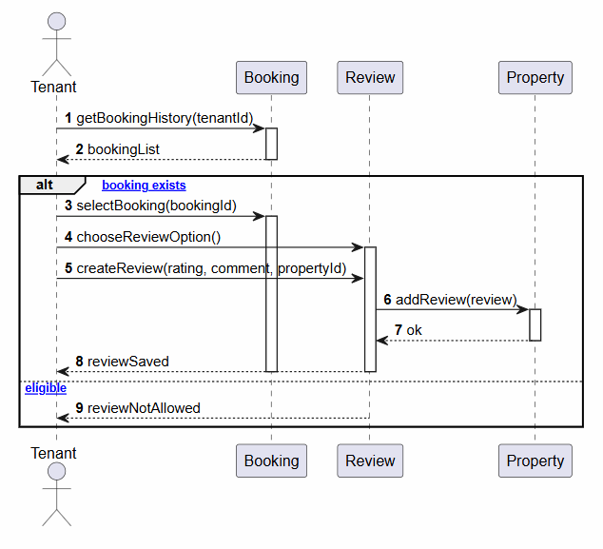

SC_PRS_11 – Update Profile Information and Availability of Rental Properties (Done by: Haidi Toto)
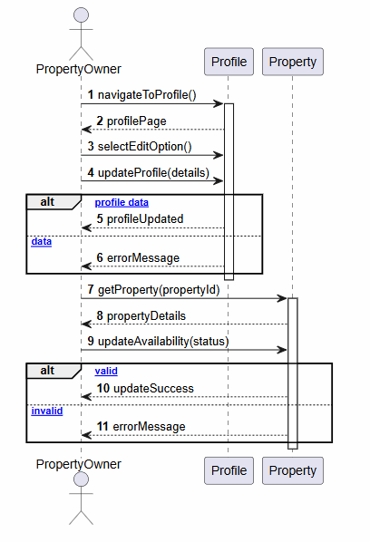

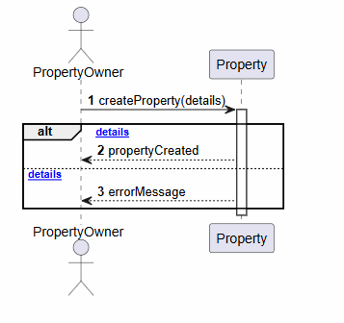
SC_PRS_12 – Add Property Listing (Done by: Haidi Toto)

SC_PRS_13 – Upload Property Images (Done by: Ledio Tafciu)
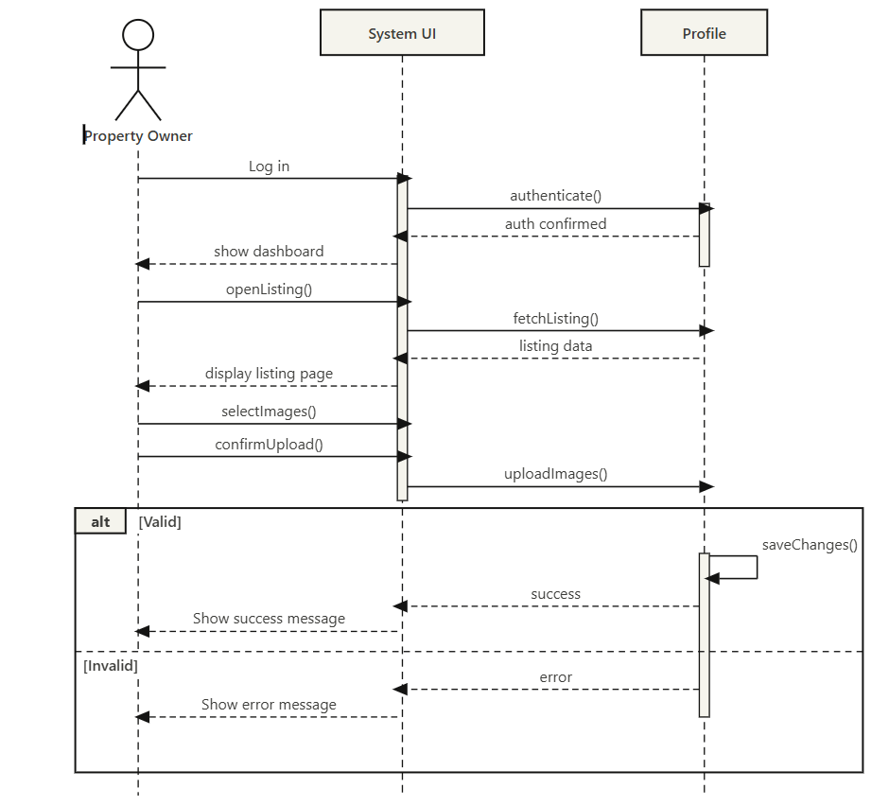

SC_PRS_14 – Edit Property Listing (Done by: Ledio Tafciu)
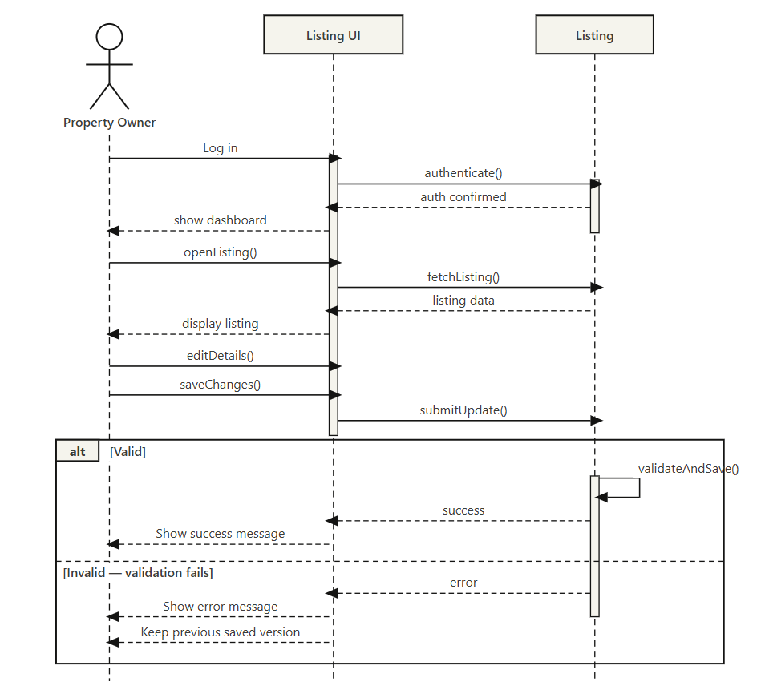

SC_PRS_15 – Delete Property Listing (Done by: Ledio Tafciu)
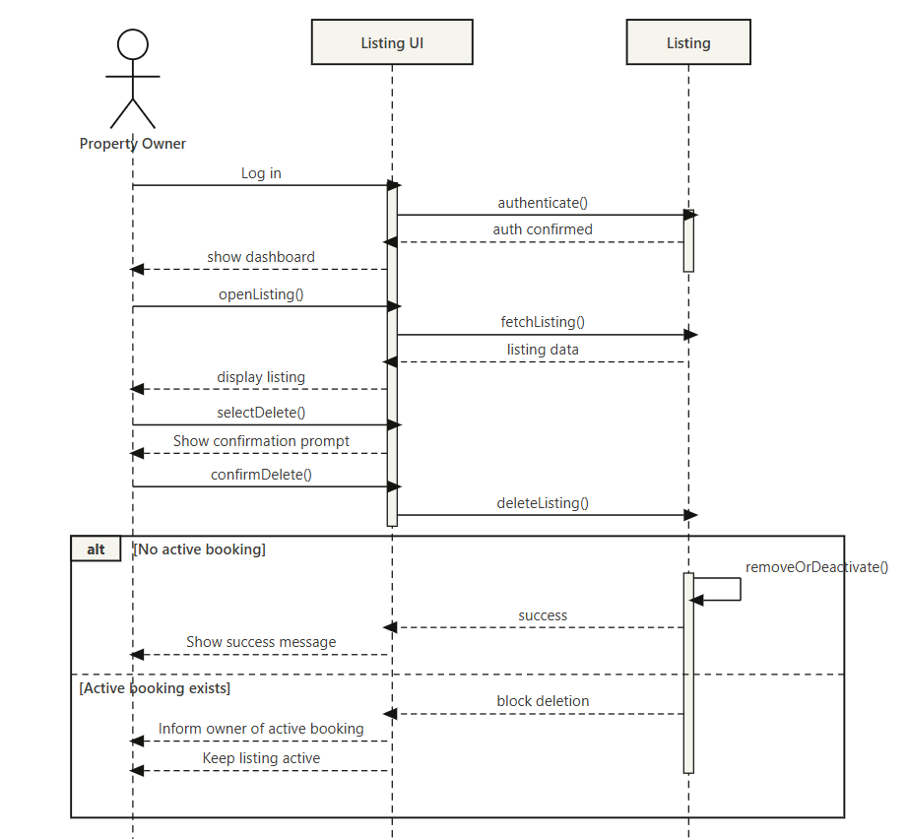

SC_PRS_16 – View Rental Requests (Done by: Ledio Tafciu)
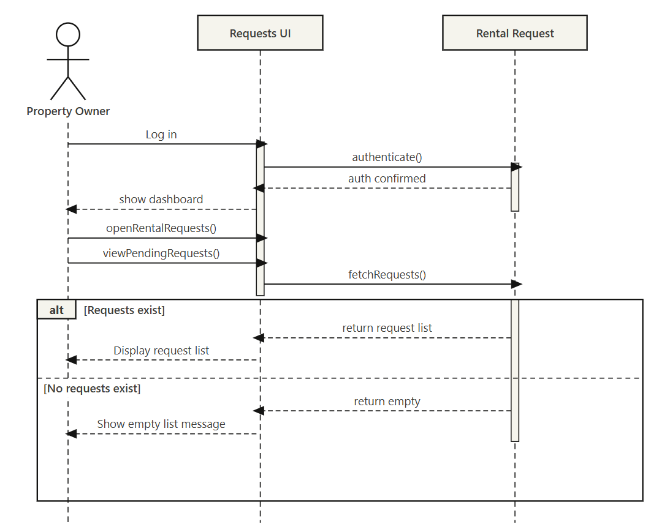

SC_PRS_17 – Accept or Reject Rental Request (Done by: Ledio Tafciu)
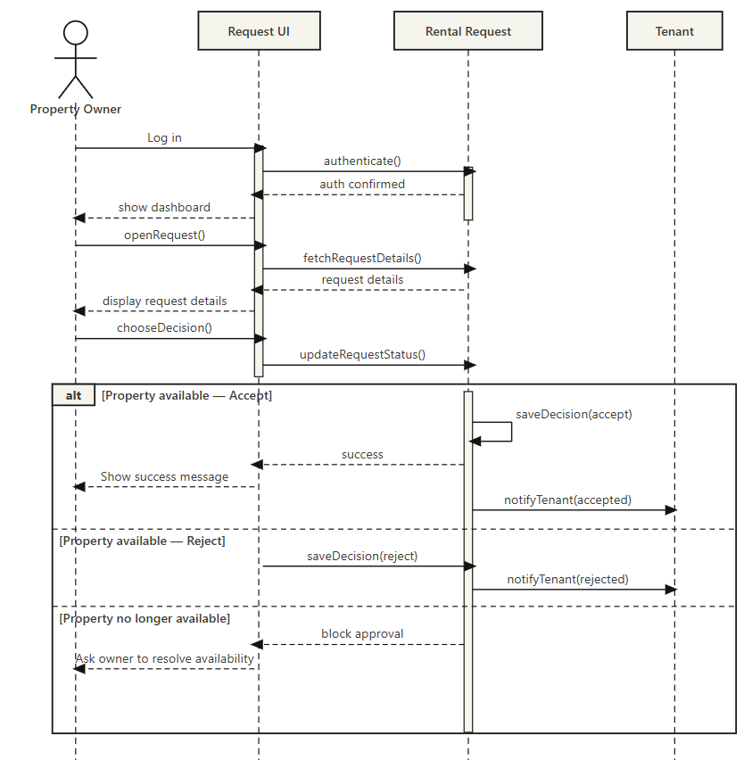

SC_PRS_18 – Send Message to Tenant (Done by: Ledio Tafciu)
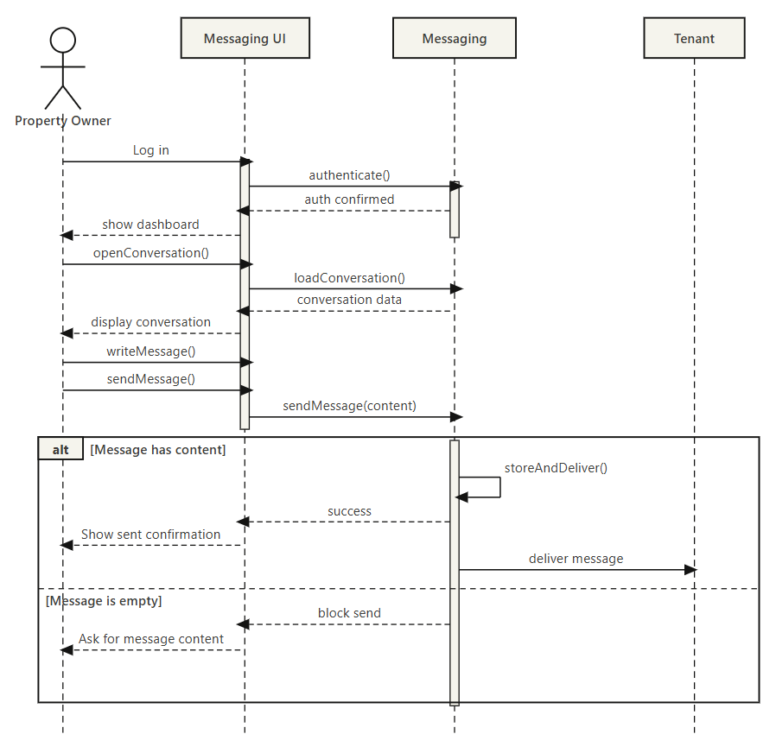

SC_PRS_19 – View Booking History (Done by: Desard Lybeshari)
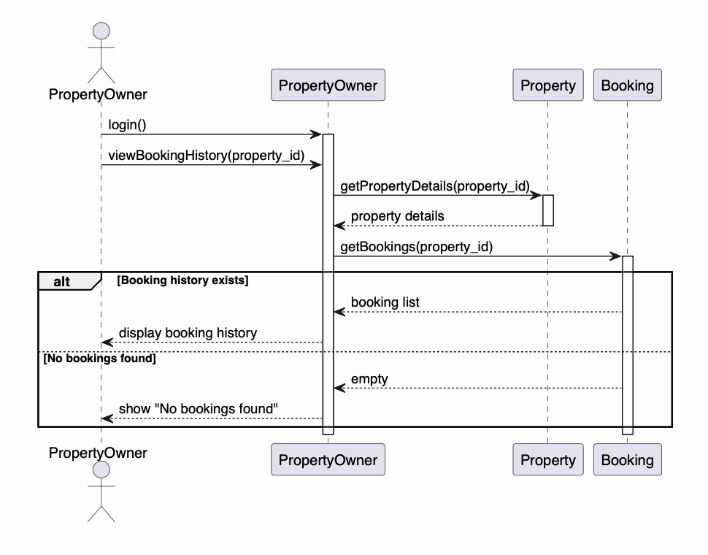

SC_PRS_20 – Mark Property as Unavailable or Rented (Done by: Desard Lybeshari)
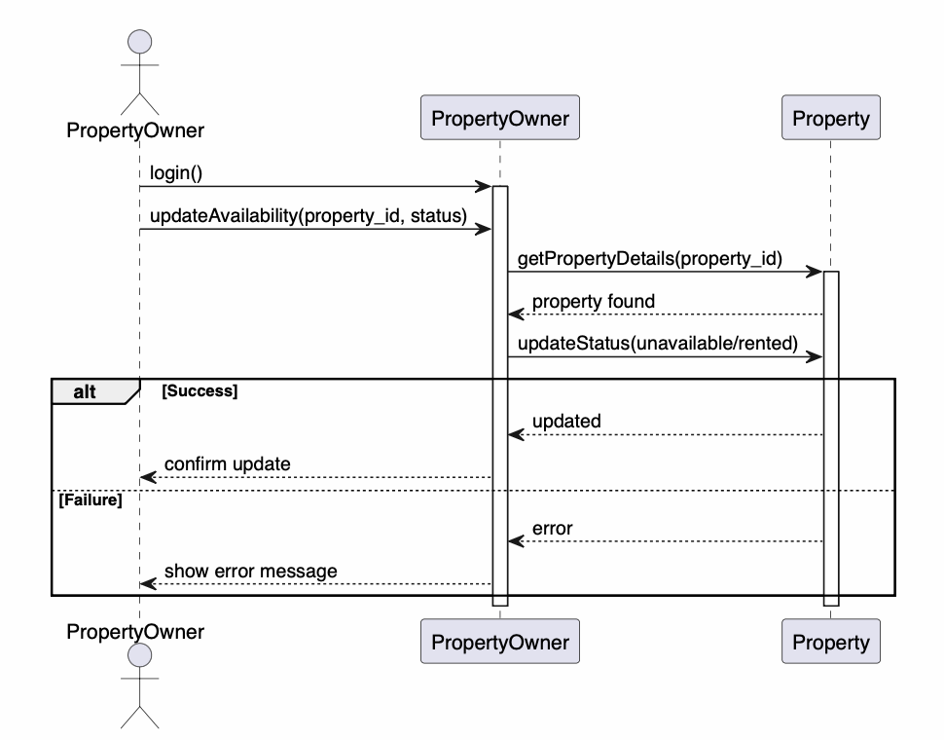
SC_PRS_21 – Edit User Accounts (Done by: Desard Lybeshari)
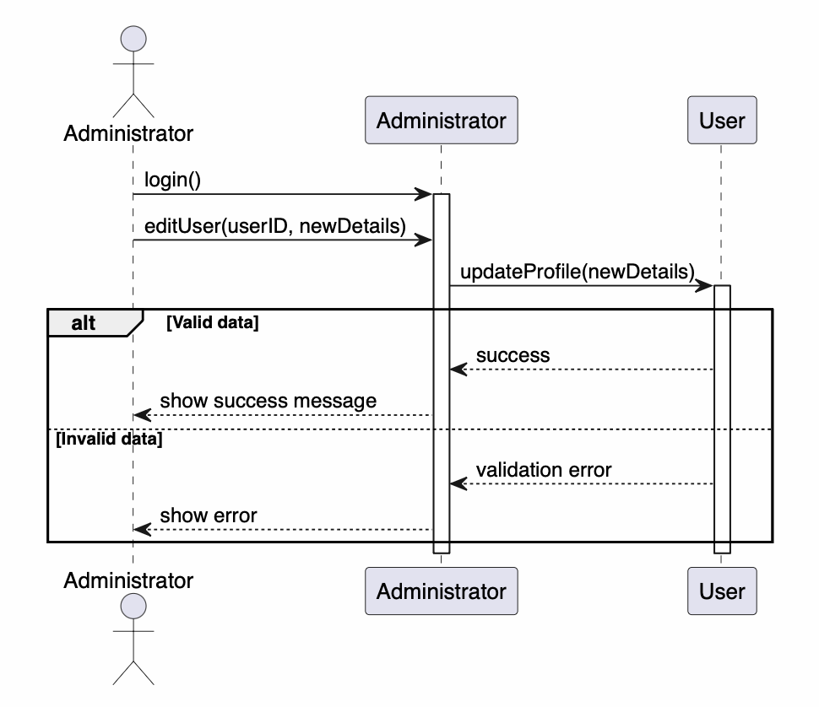

SC_PRS_22 – Delete User Accounts (Done by: Desard Lybeshari)
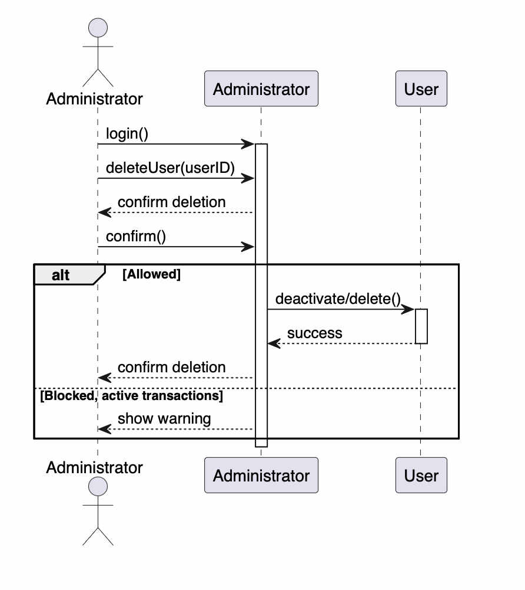

SC_PRS_23 – Monitor Rental Transactions (Done by: Desard Lybeshari)
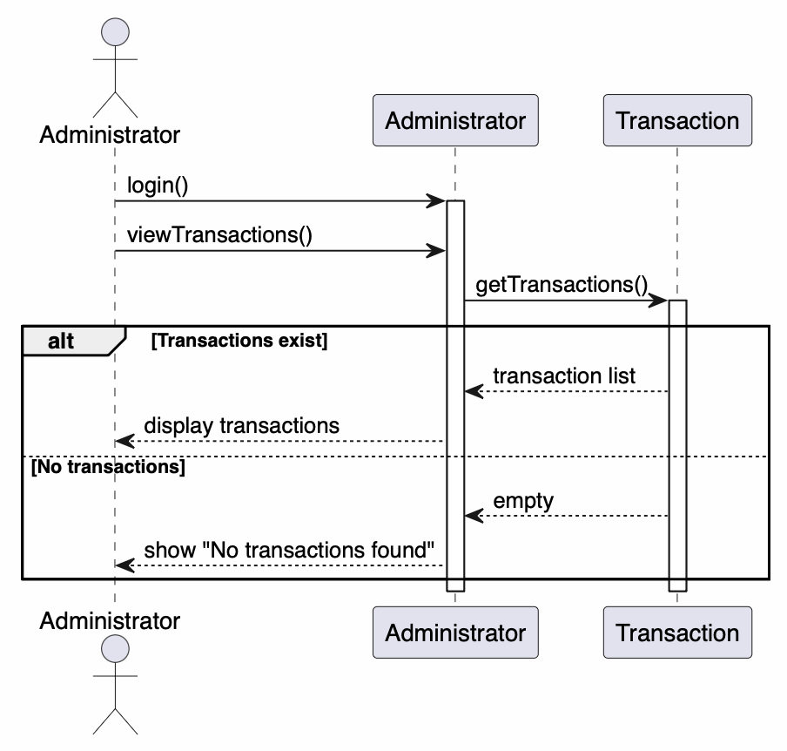

SC_PRS_24 – View System Reports and Property Listings (Done by: Desard Lybeshari)

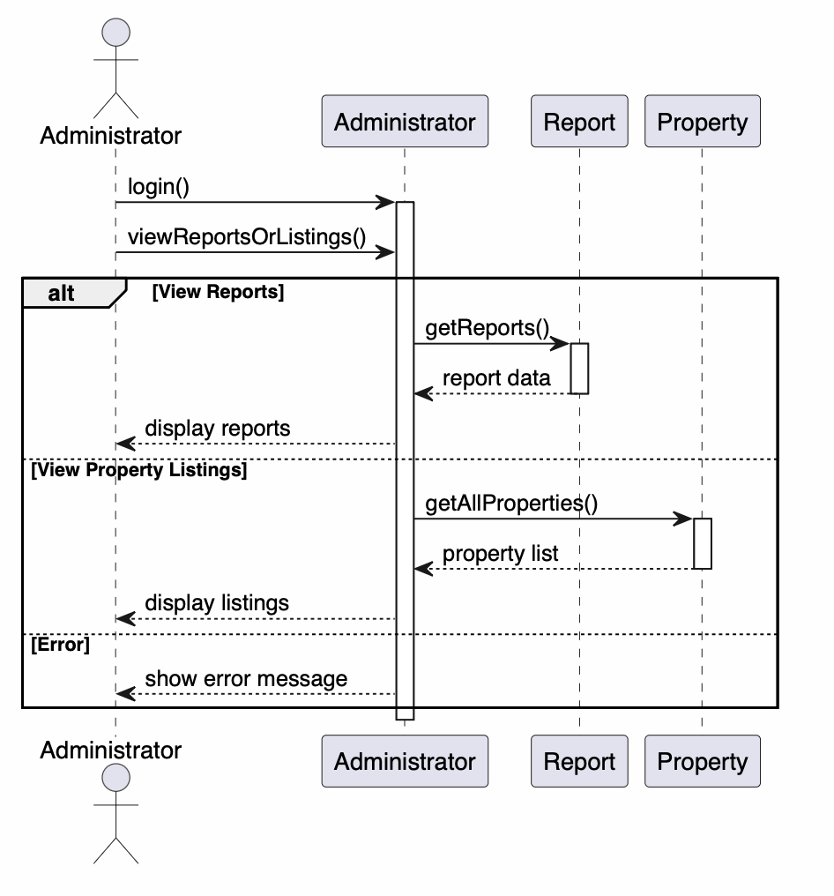

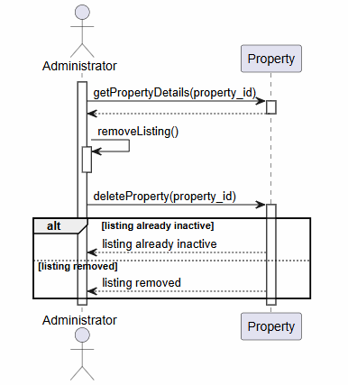
SC_PRS_25 – Remove Inappropriate Listings (Done by: Matias Bali)

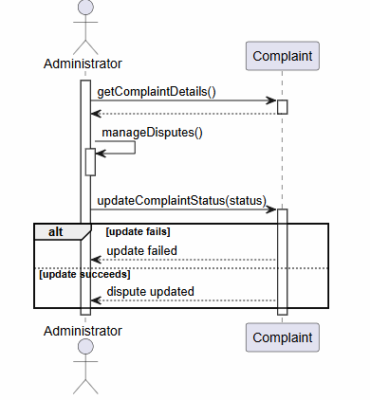
SC_PRS_26 – Manage Disputes and System Settings (Done by: Matias Bali)

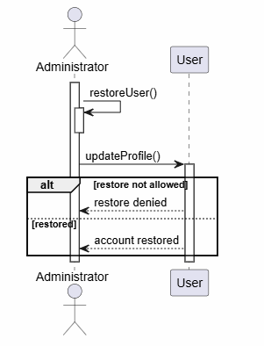
SC_PRS_27 – Restore User Account (Done by: Matias Bali)

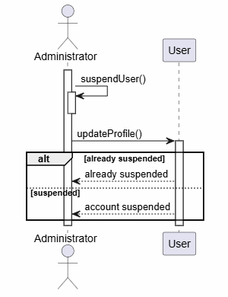
SC_PRS_28 – Suspend User Account (Done by: Matias Bali)

SC_PRS_29 – Verify and Approve Property Listings (Done by: Matias Bali)
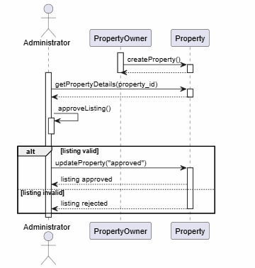

SC_PRS_30 – Monitor Rental Requests (Done by: Matias Bali)
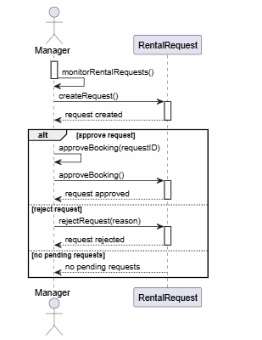

SC_PRS_31 – Generate Management Reports (Done by: Ornelt Lemellari)
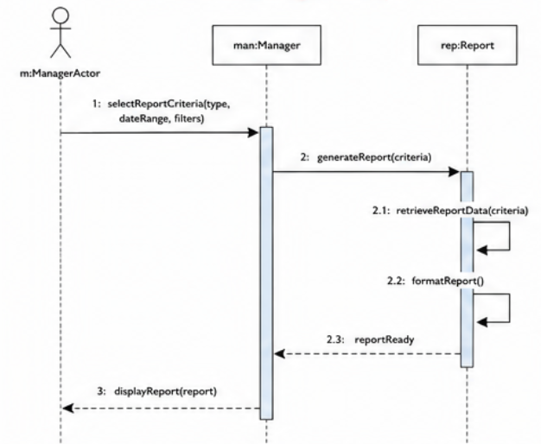

SC_PRS_32 – Approve Large Discounts and Promotions (Done by: Ornelt Lemellari)
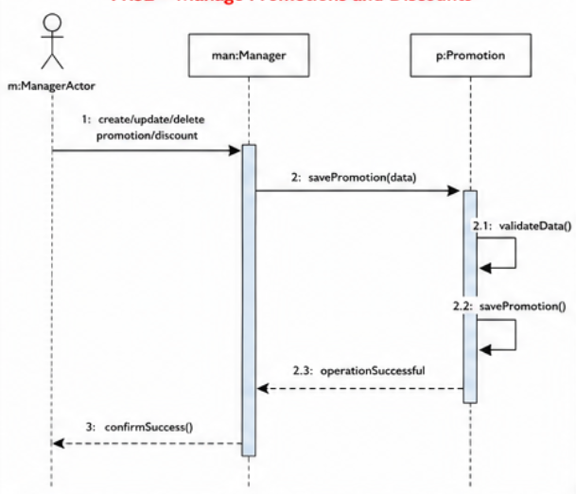

SC_PRS_33 – Review Complaints and Forward Unresolved Issues (Done by: Ornelt Lemellari)
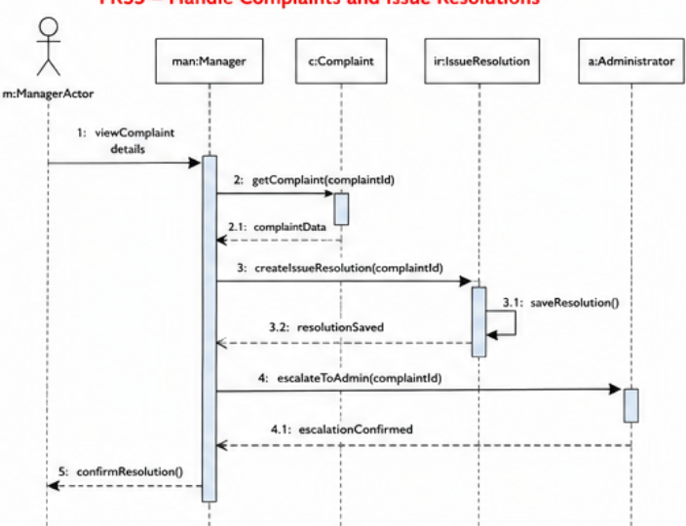

SC_PRS_34 – View Transaction History (Done by: Ornelt Lemellari)
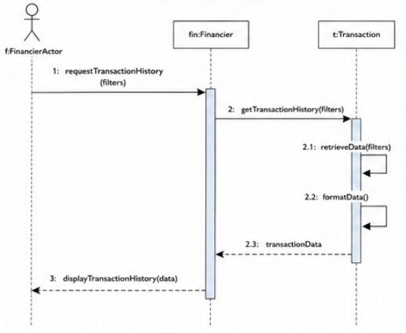

SC_PRS_35 – Monitor Payment Process and Security (Done by: Ornelt Lemellari)
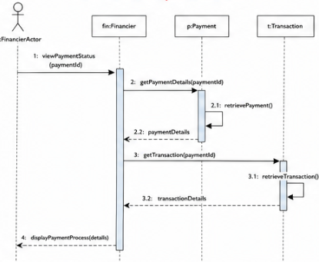

SC_PRS_36 – Communicate Payment Issues with Tenants and Owners (Done by: Ornelt Lemellari)
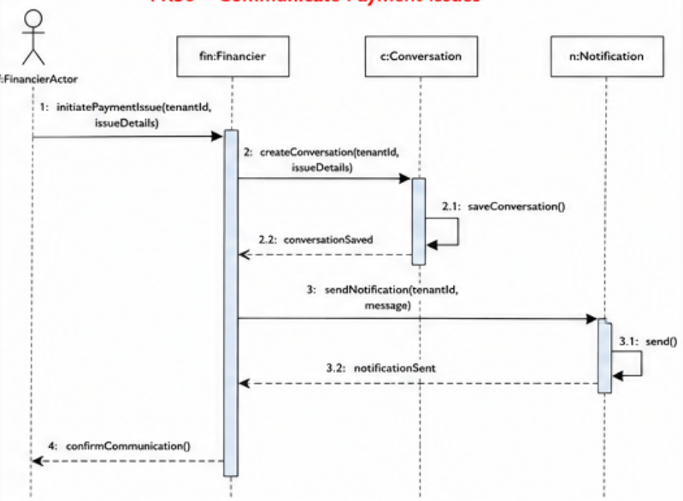

SC_PRS_37 – Approve Refunds for Cancelled Rental Transactions (Done by: Kevin Muho)
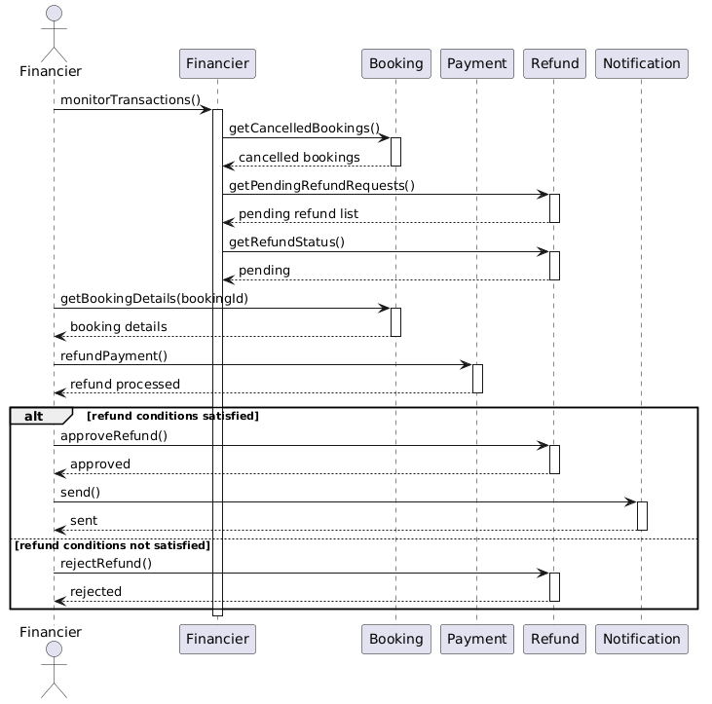

SC_PRS_38 – Manage Complaints (Done by: Kevin Muho)
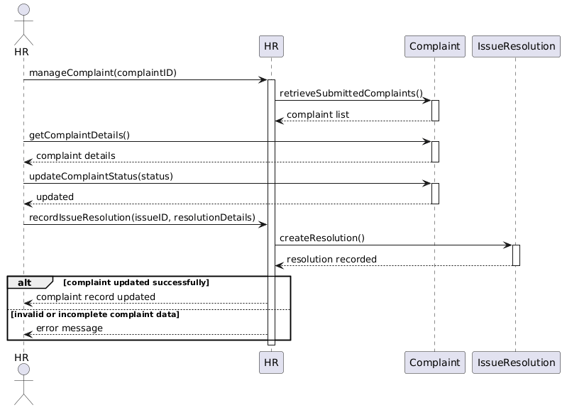

SC_PRS_39 – Send Notifications and Reminders (Done by: Kevin Muho)
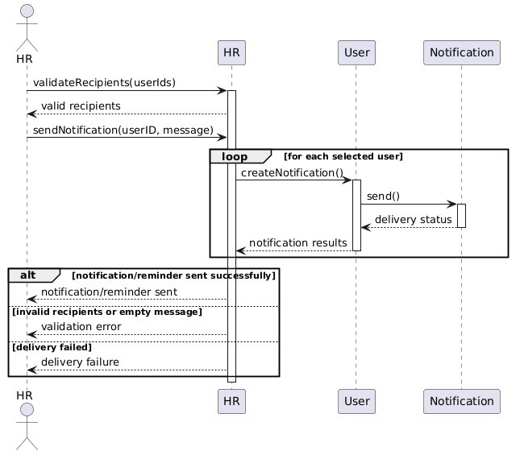

SC_PRS_40 – Maintain Records of User Issues and Resolutions (Done by: Kevin Muho)
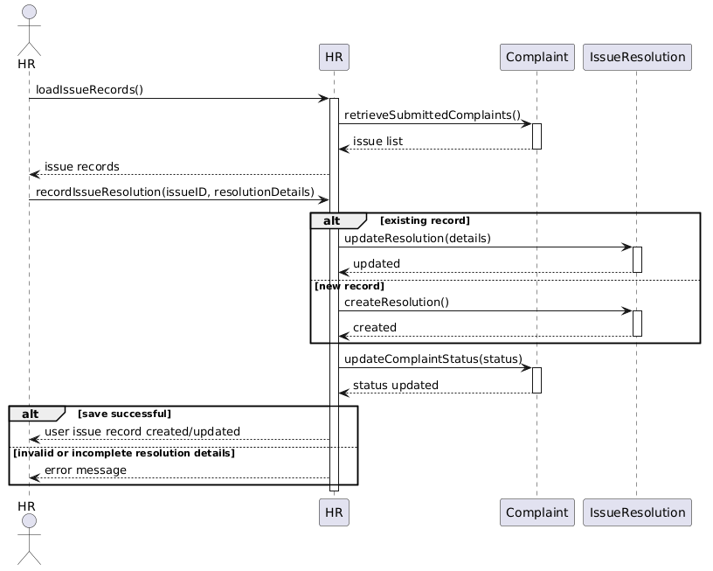

SC_PRS_41 – Register Account (Done by: Kevin Muho)
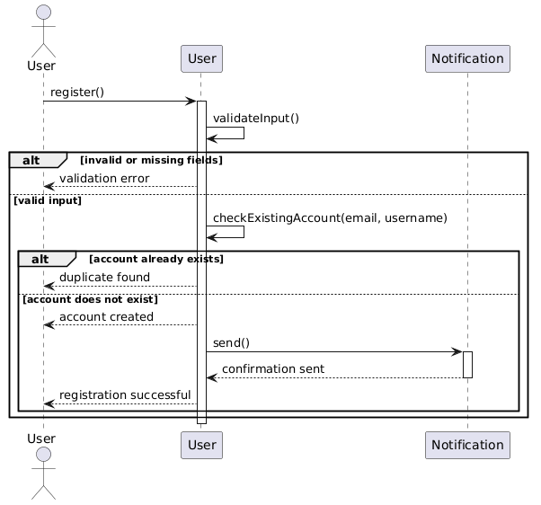

SC_PRS_42 – Log In (Done by: Kevin Muho)
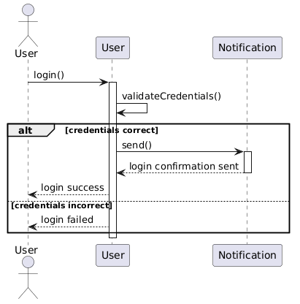

SC_PRS_43 – Log Out (Done by: Kevin Muho)
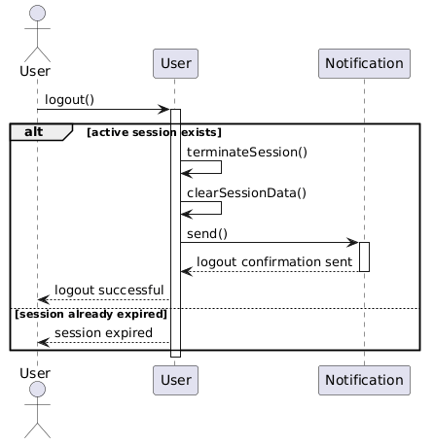

5.7. Collaboration diagram
CC_PRS_1 - Update personal information (Done by:Anisa Domi)
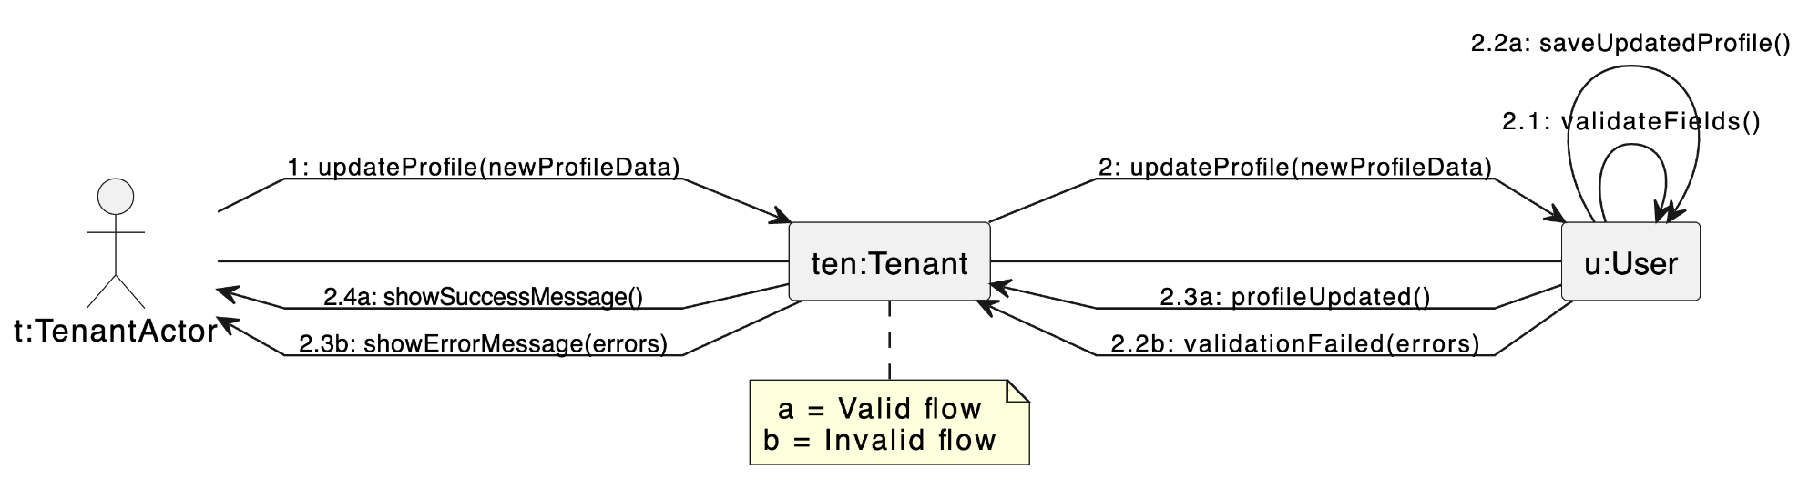

CC_PRS_2 - Search properties (Done by:Anisa Domi)

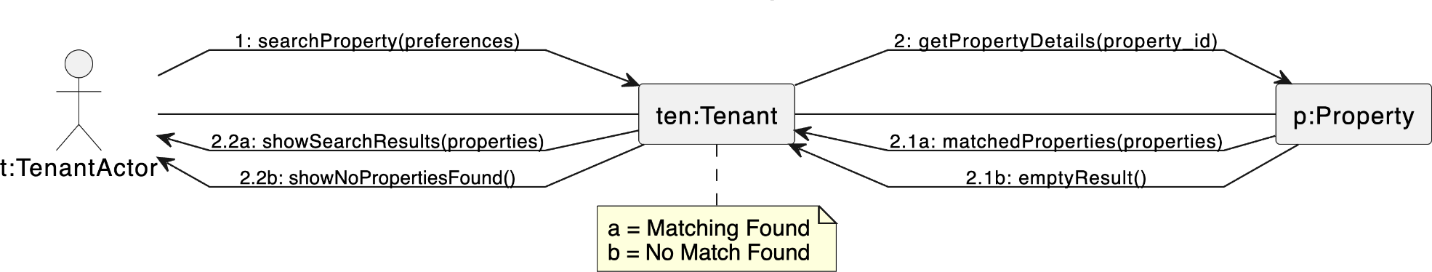

CC_PRS_3 - Filter properties (Done by:Anisa Domi)

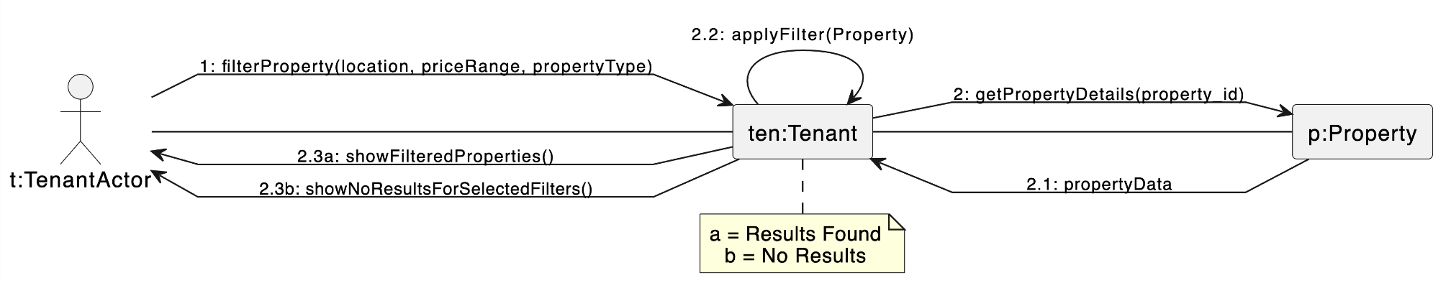

CC_PRS_4 - View property details and booking history (Done by:Anisa Domi)
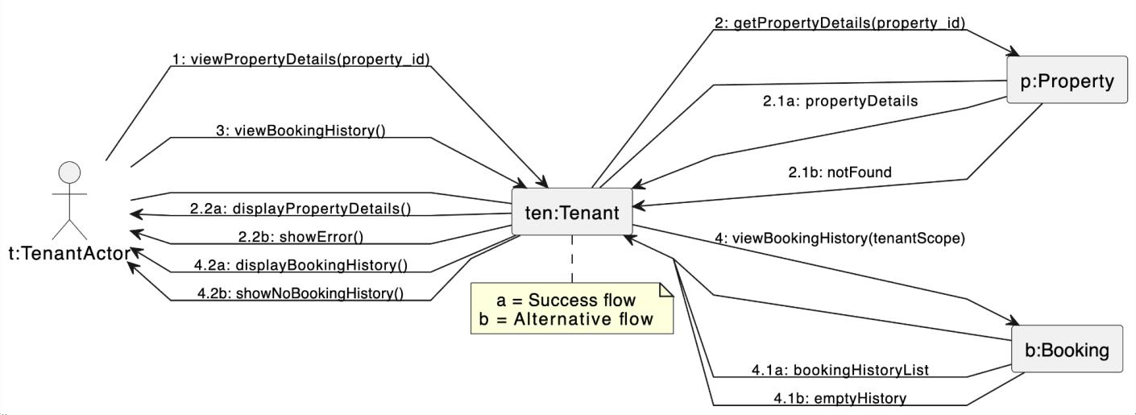

CC_PRS_5 - Send rental requests and message to property owners (Done by:Anisa Domi)

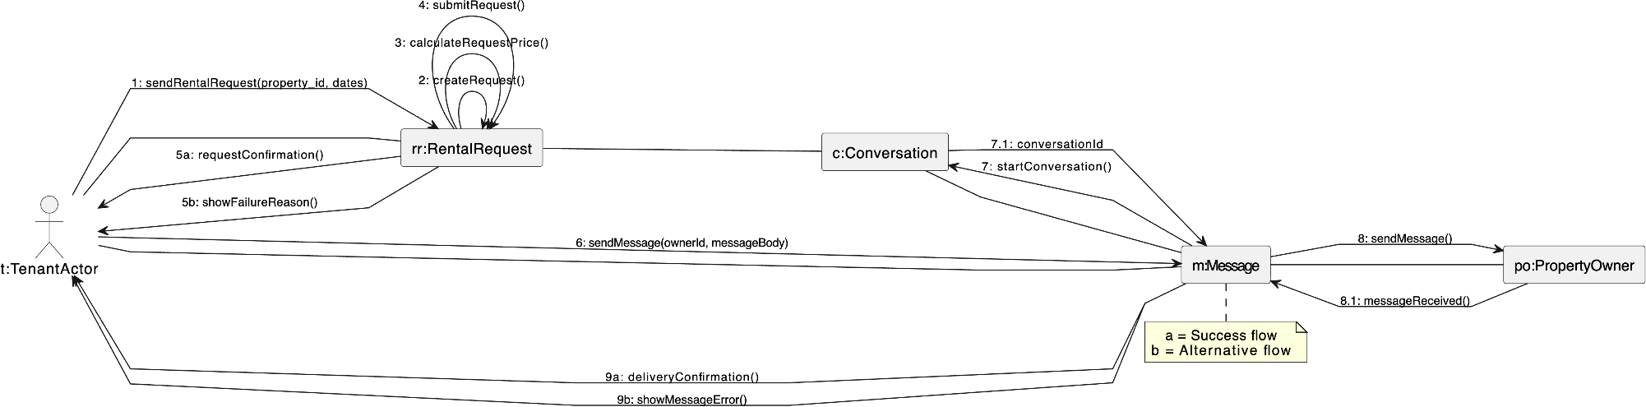

CC_PRS_6 - Cancel rental request (Done by:Anisa Domi)
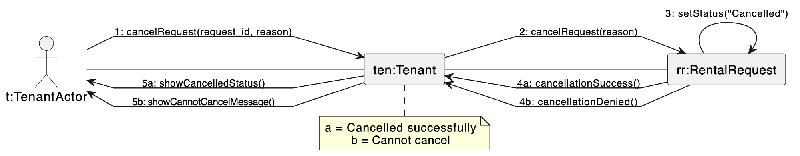

CC_PRS_7-Receive Messages from property owners (Done by: Haidi Toto)
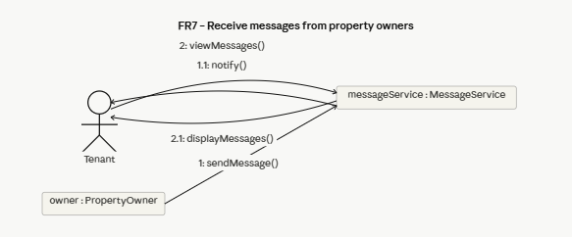

CC_PRS_8 – Submit Rental Payment (Done by: Haidi Toto)
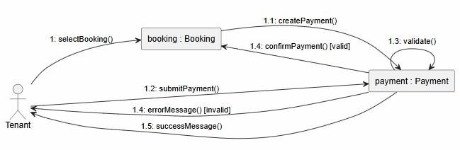
CC_PRS_9 – Save Favourite Properties for later viewing (Done by: Haidi Toto)
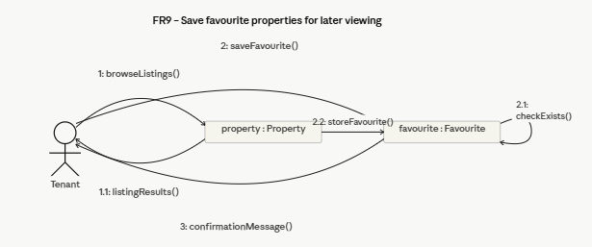

CC_PRS_10 – Review and Rate Property (Done by: Haidi Toto)
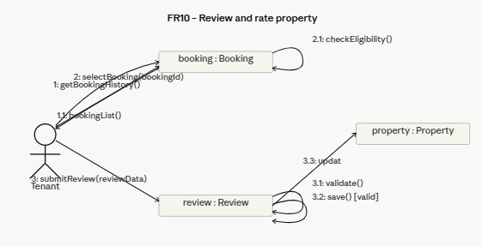
CC_PRS_11 – Update Profile information and Availability of Rental Properties (Done by: Haidi Toto)
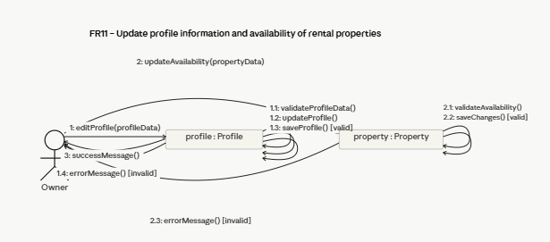
CC_PRS_12 – Add Property Listing (Done by: Haidi Toto)
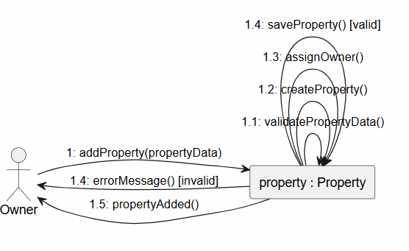

CC_PRS_13-Upload Property Images (Done by: Ledio Tafciu)
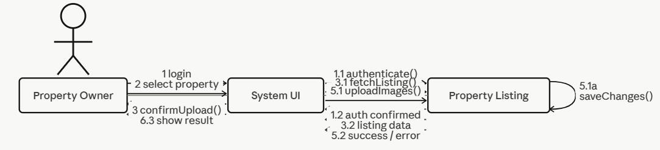
CC_PRS_14 - Edit Property Listing (Done by: Ledio Tafciu)
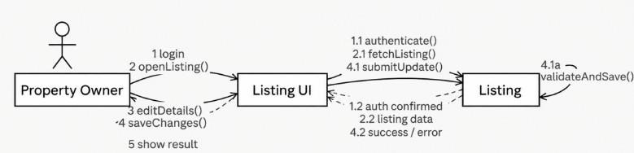
CC_PRS_15 - Delete Property Listing (Done by: Ledio Tafciu)
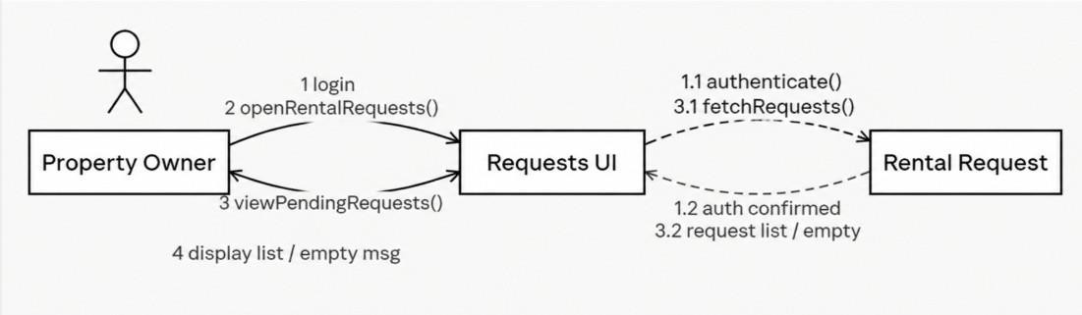
CC_PRS_16 - View Rental Requests (Done by: Ledio Tafciu)
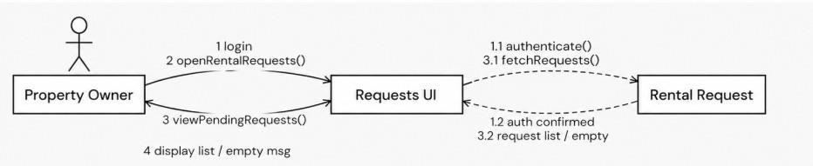

CC_PRS_17 - Accept or Reject Rental Request (Done by: Ledio Tafciu)
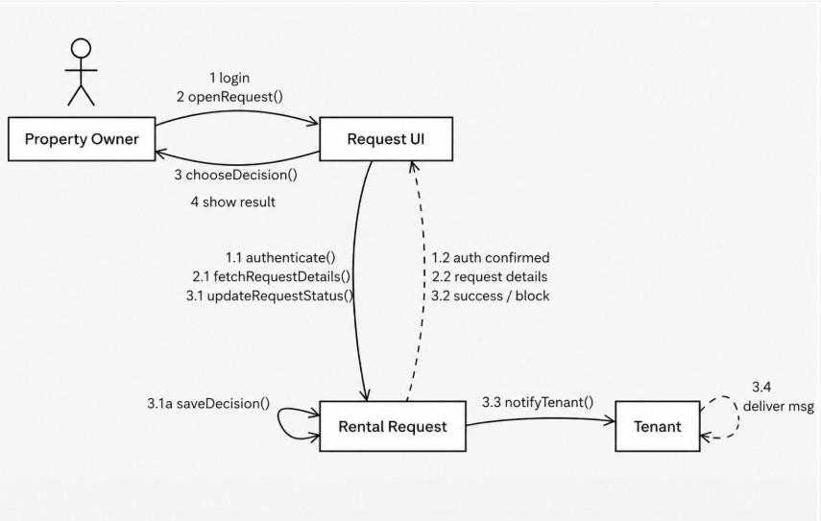
CC_PRS_18 - Send Message To Tenant (Done by: Ledio Tafciu)
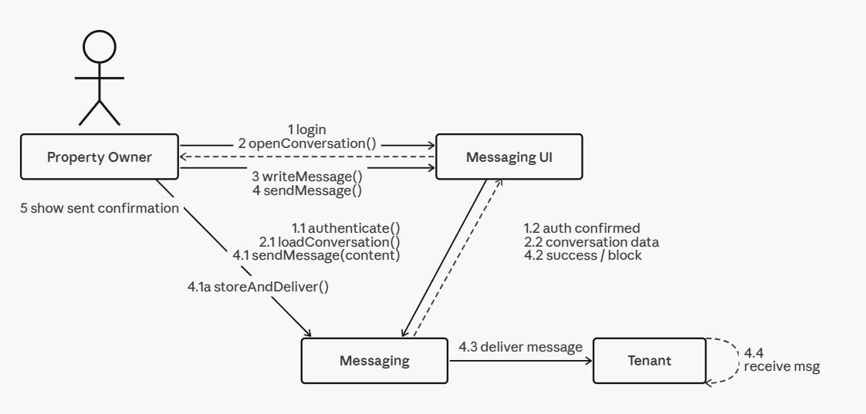

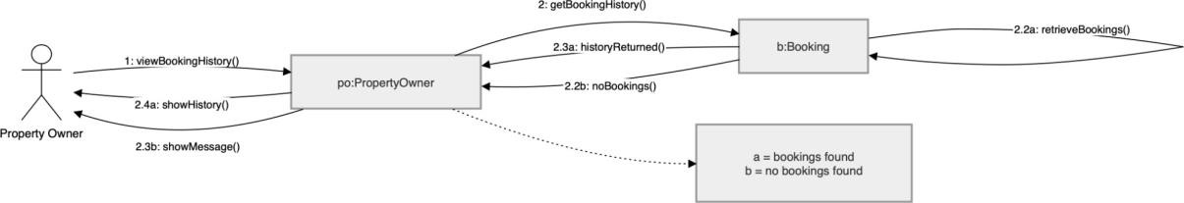
CC_PRS_19 - View Booking History (Done by:Desard Lybeshari)
CC_PRS_20 - Mark Property as Unavailable or Rented (Done by:Desard Lybeshari)

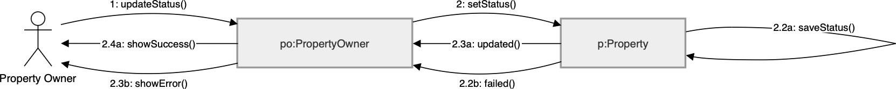

CC_PRS_21 - Edit User Accounts (Done by:Desard Lybeshari)
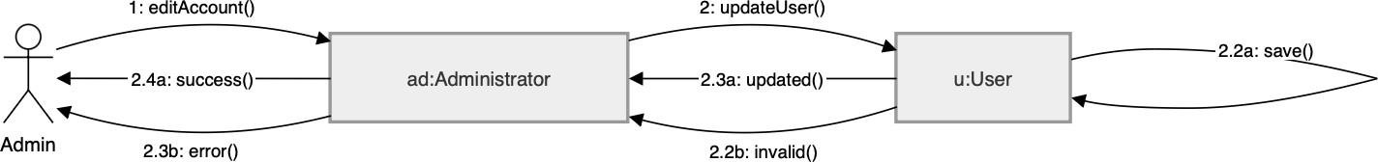

CC_PRS_22 - Delete User Accounts (Done by:Desard Lybeshari)
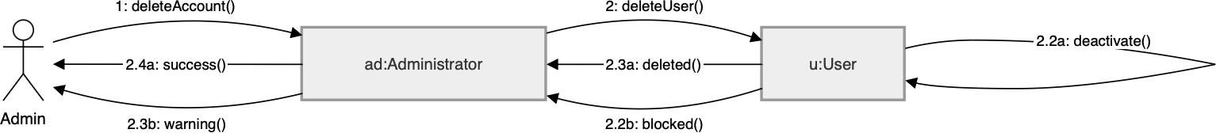

CC_PRS_23 - Monitor Rental Transactions (Done by:Desard Lybeshari)

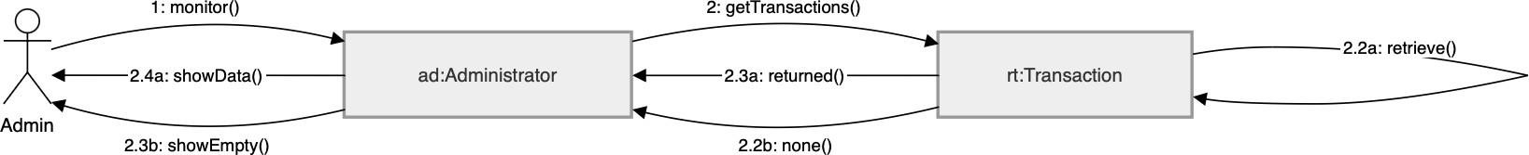

CC_PRS_24 - View System Reports and Property Listings (Done by:Desard Lybeshari)

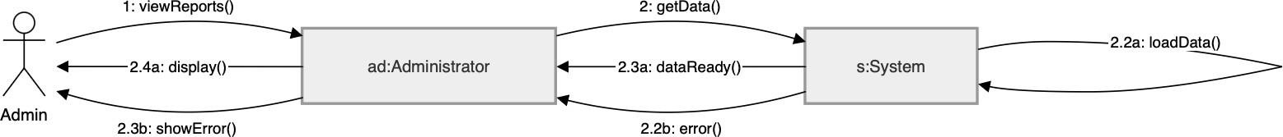

CC_PRS_25- Remove inappropriate listings (Done by:Matias Bali)
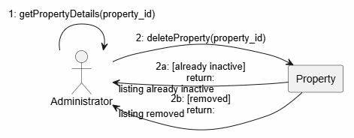

CC_PRS_26- Manage disputes & system settings (Done by:Matias Bali)
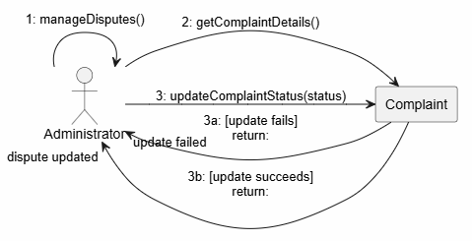

CC_PRS_27- Restore user accounts (Done by:Matias Bali)
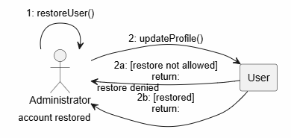

CC_PRS_28- Suspend user accounts (Done by:Matias Bali)
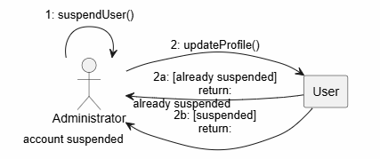

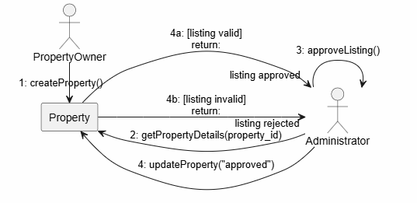
CC_PRS_29- Verify and Approve property listings (Done by:Matias Bali)

CC_PRS_30- Monitor rental requests (Done by:Matias Bali)
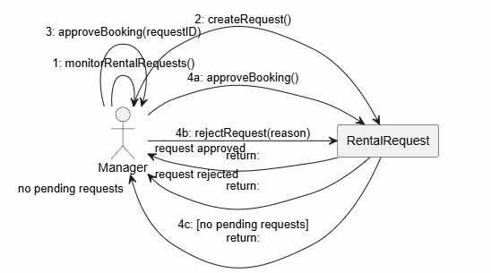
CC_PRS_31 – Generate Management Reports (Done by: Ornelt Lemellari)
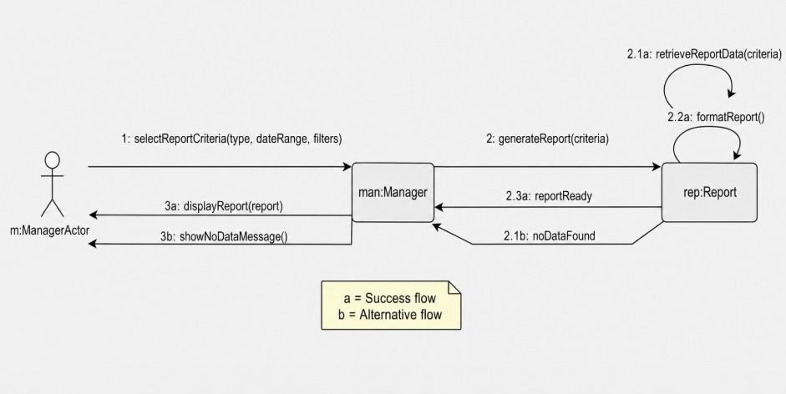

CC_PRS_32 – Approve Large Discounts (Done by: Ornelt Lemellari)
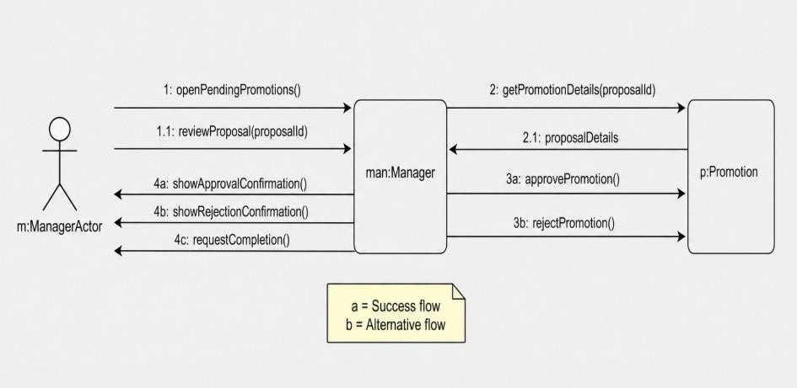

CC_PRS_33 – Review Complaints and forward unresolved issues (Done by: Ornelt Lemellari)
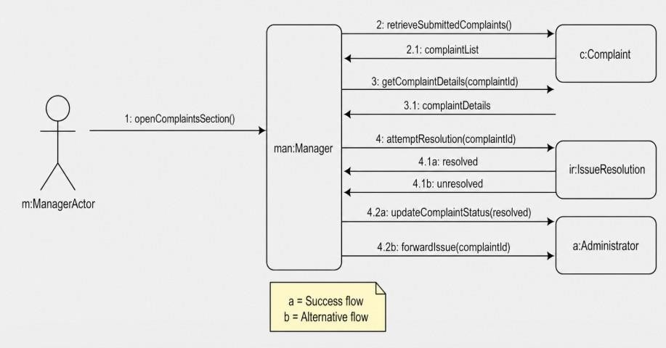

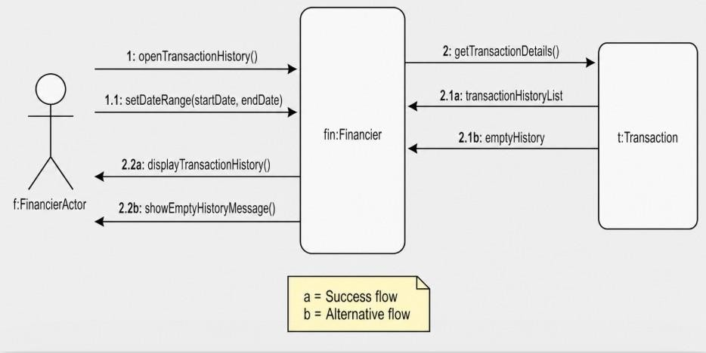
CC_PRS_34 – View Transaction History (Done by: Ornelt Lemellari)

CC_PRS_35 – Monitor Payment process and Security (Done by: Ornelt Lemellari)
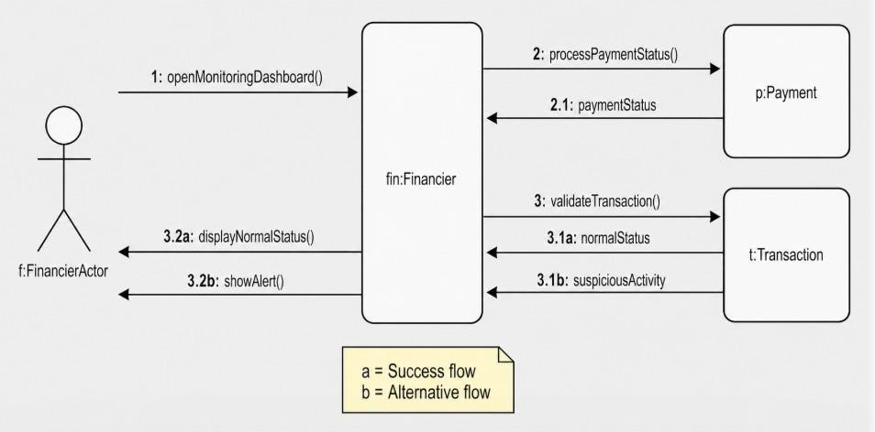

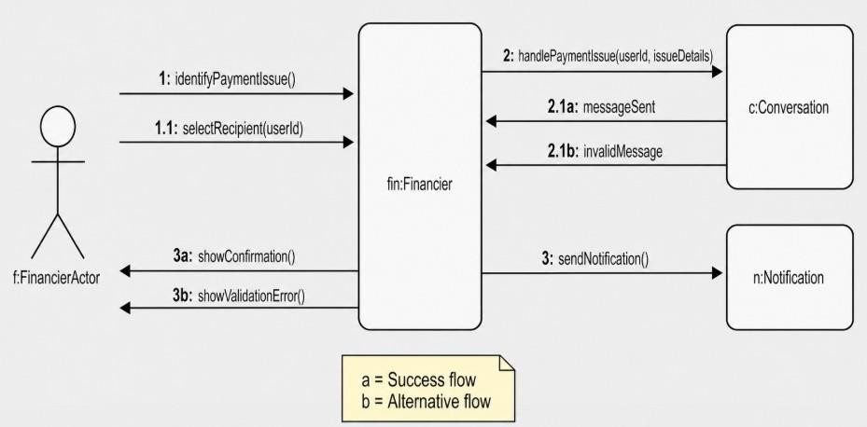
CC_PRS_36 – Communicate Payment Issues with tenants and owners (Done by: Ornelt Lemellari)

CC_PRS_37- Approve refunds for cancelled rental transactions (Done by:Kevin Muho)
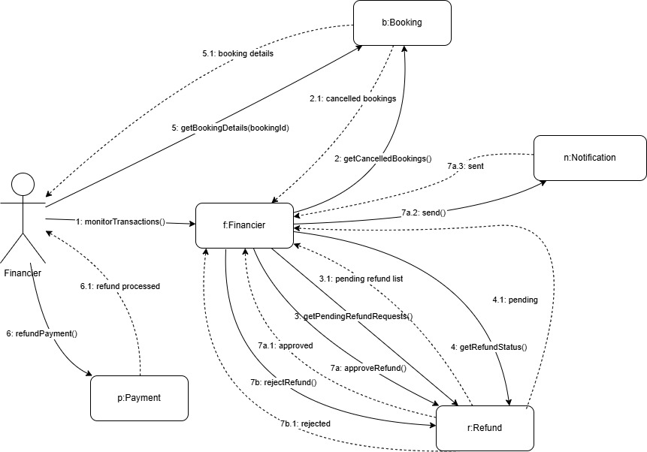

CC_PRS_38- Manage Complaints (Done by: Kevin Muho)
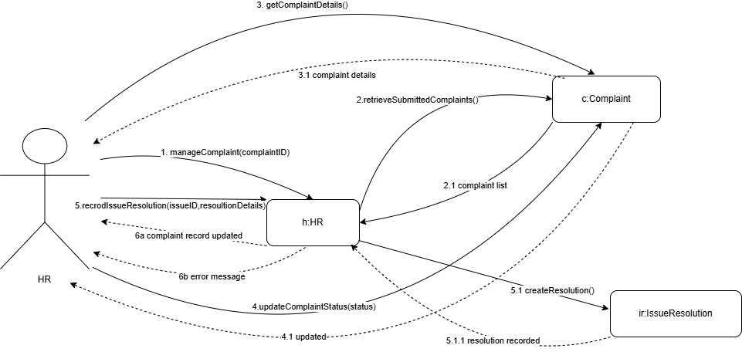

CC_PRS_39- Send notifications and reminders (Done by:Kevin Muho)
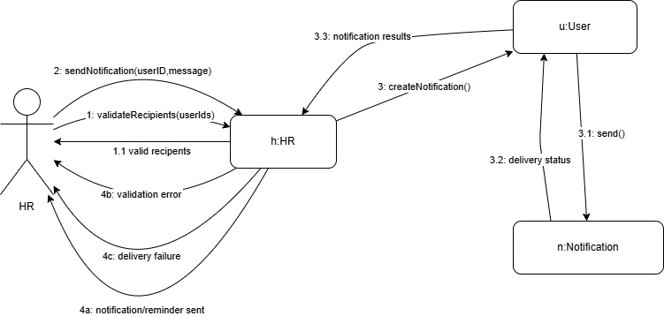

CC_PRS_40- Maintain Record of User Issues and Resolutions (Done by:Kevin Muho)
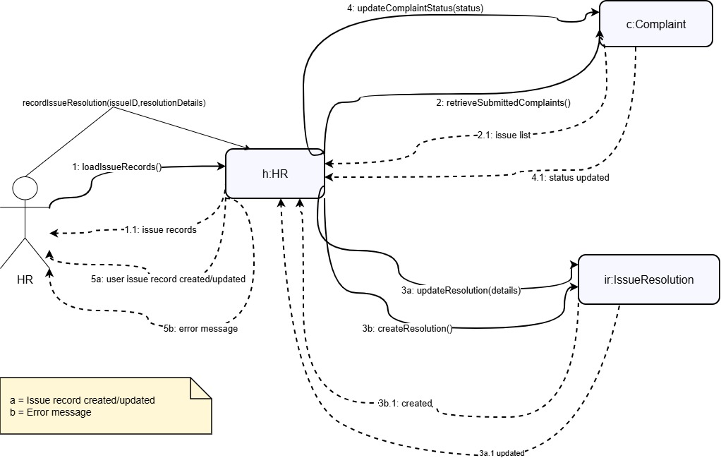

CC_PRS_41- Register Account (Done by:Kevin Muho)

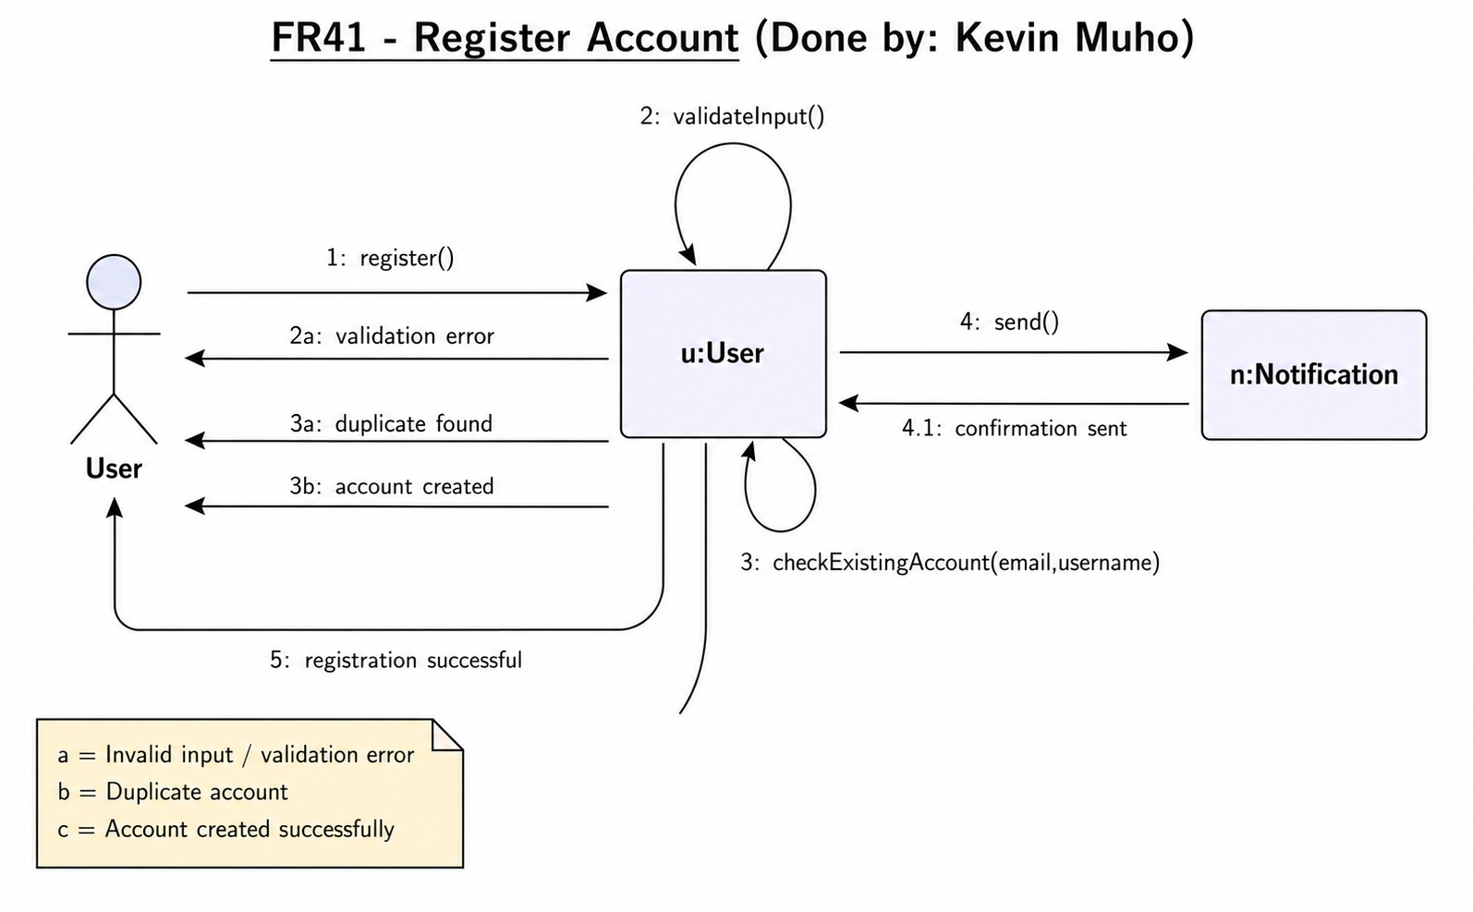

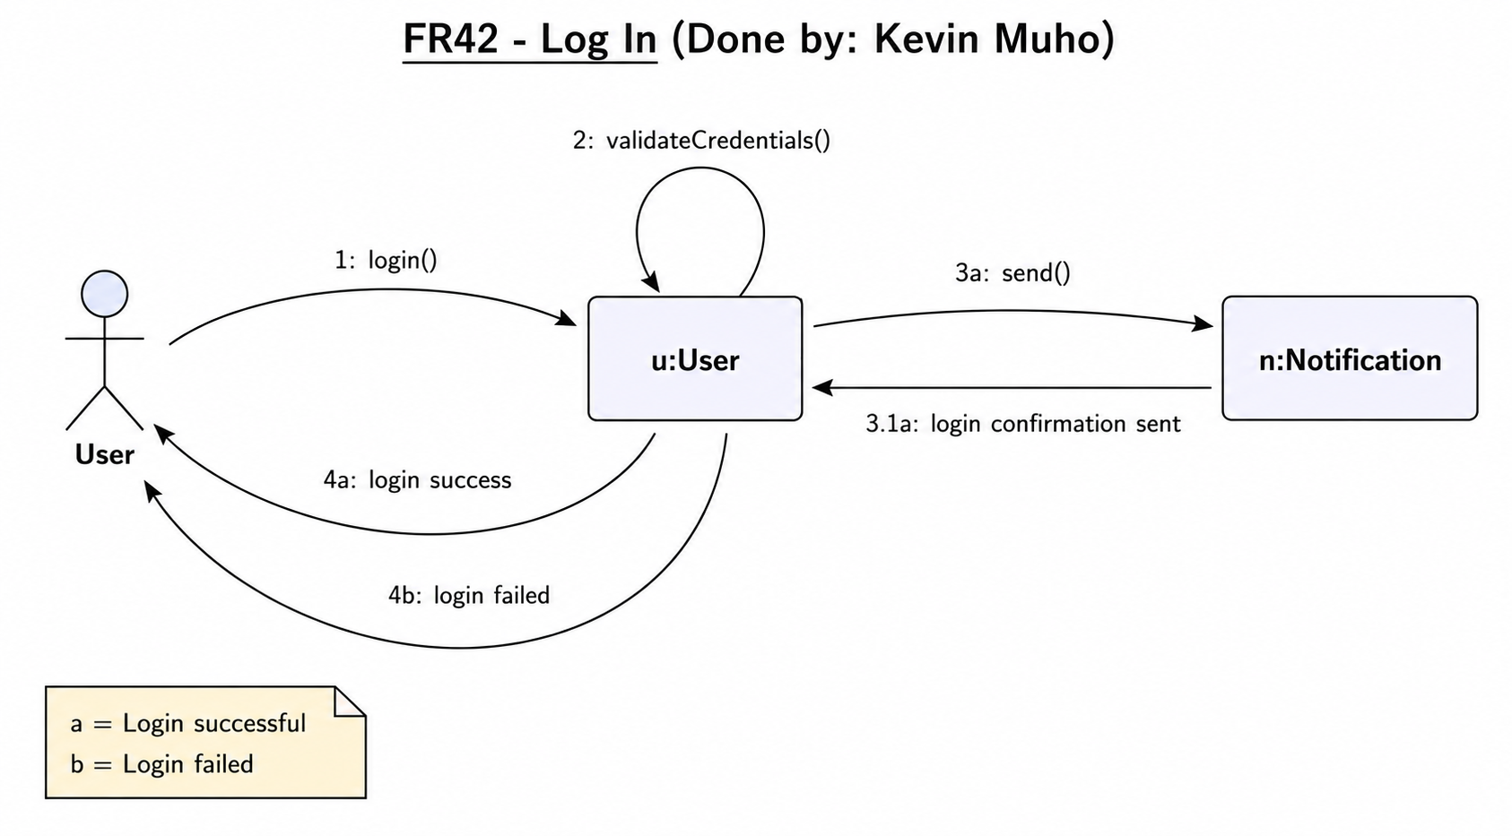
CC_PRS_42 - Log In (Done by:Kevin Muho)
CC_PRS_43 – Log Out (Done by:Kevin Muho)
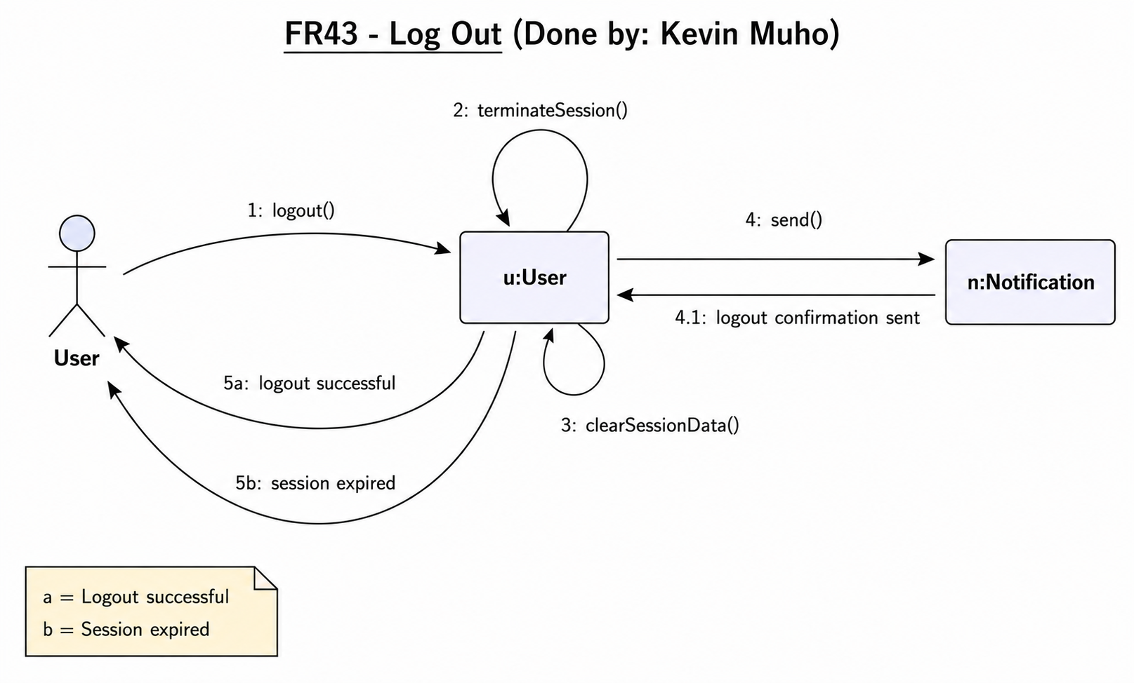

  - IOD

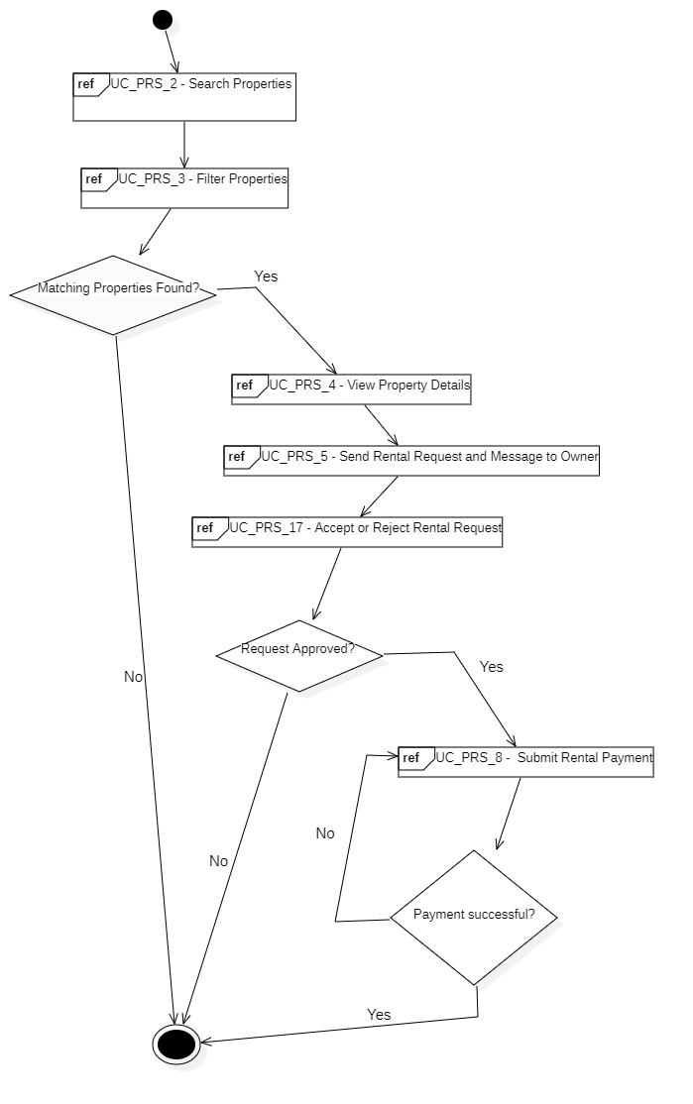
- Property Booking Process (Done by:Kevin Muho)

- Property Listing & Managment (Done by:Anisa Domi)
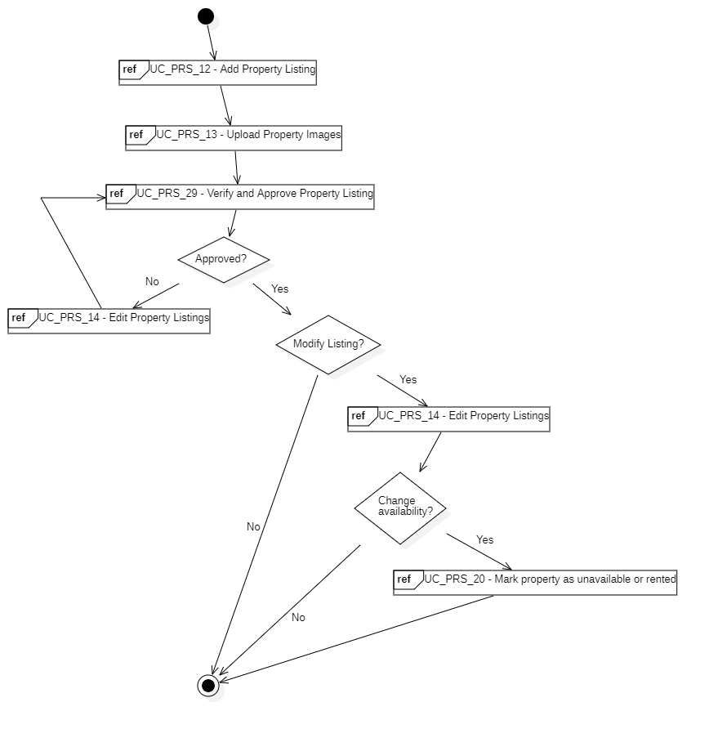

- Complaint & Issue Managment (Done by:Desard Lybeshari)
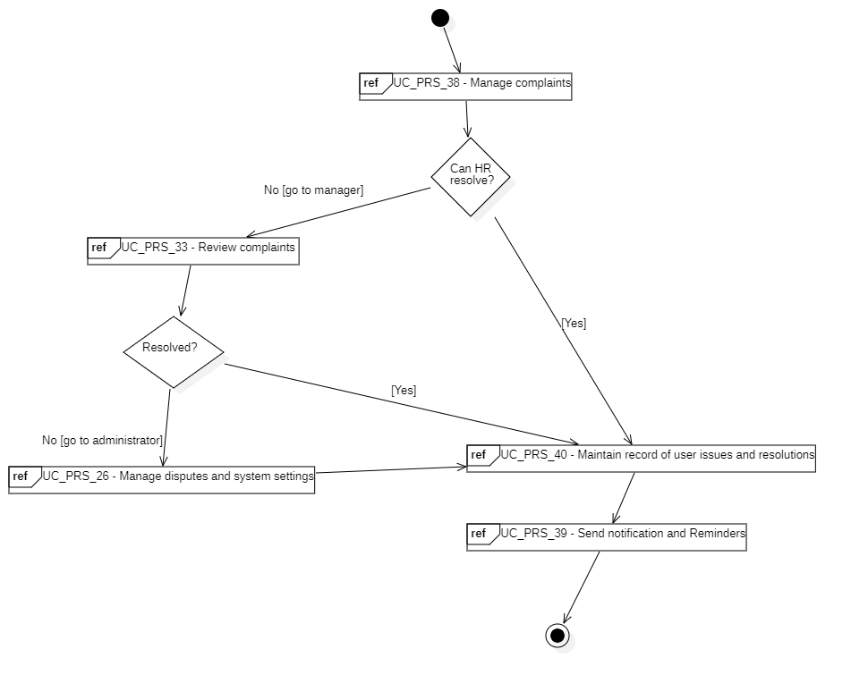

  - BPMN

BPMN - Property Listing & Management (Done by:Anisa Domi)

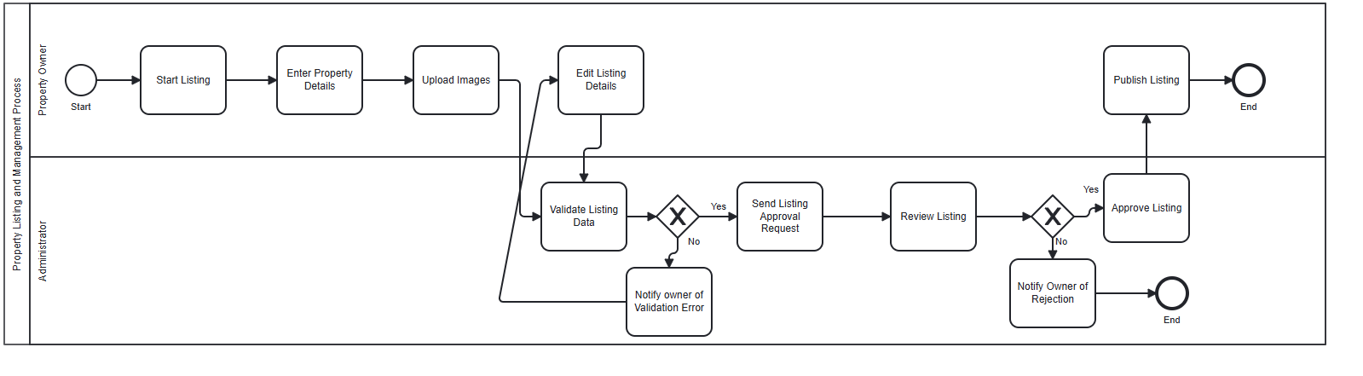

BPMN - Property Booking (Done by:Kevin Muho)
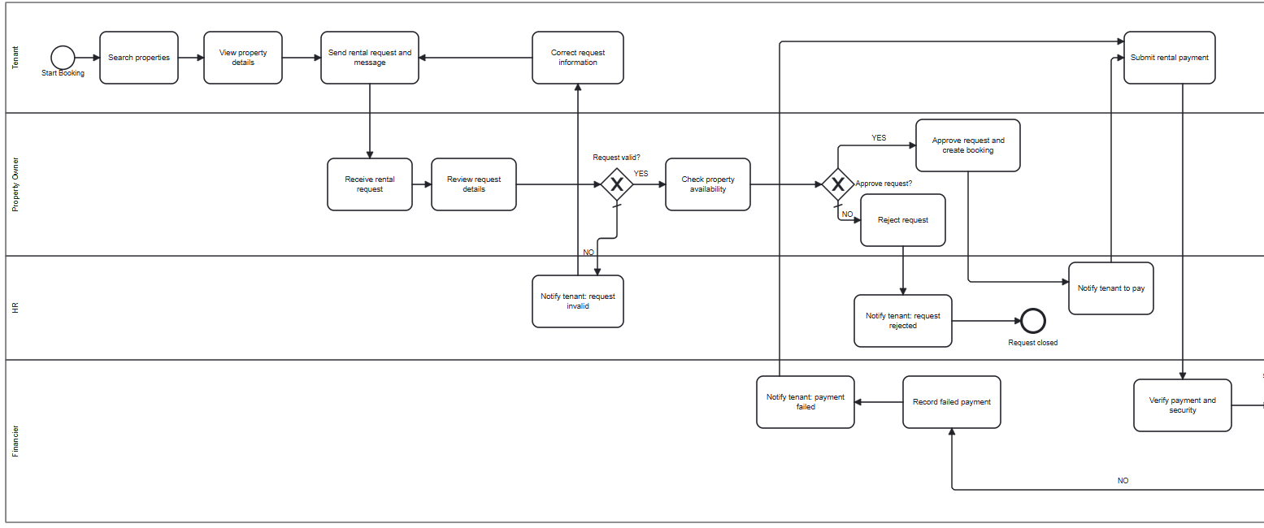

Continuation down here
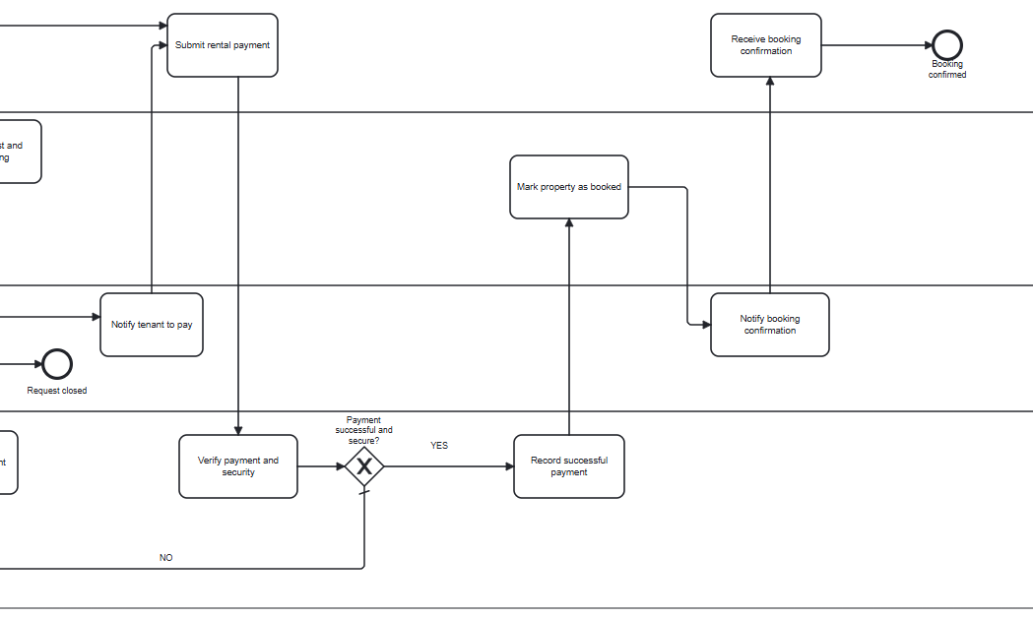

BPMN – Complaint & Issue Management (Done by:Desard Lybeshari)

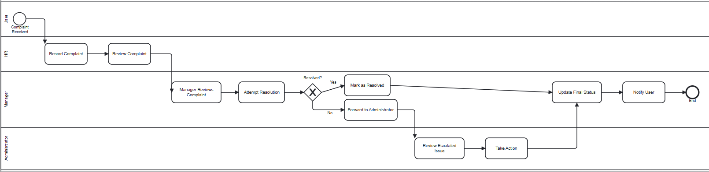

6.Design Patterns
Builder Pattern (Done by: Anisa Domi,Ledio Tafciu)

Justifying the design pattern presence → The Builder Pattern is used in the system to automatically construct different User objects during registration based on the selected role.
In this design:
The RegistrationSystem acts as the Director controlling the build sequence UserBuilder ddefines the construction steps, each concrete builder assembles role-specific data, and the User product is returned fully built by the system.
For example:
In FR41 when a user registers an account and system selects the correct builder for the chosen role, builds profile data, credentials, and role-specific details step by step and returns a complete User object without changing the registration flow.
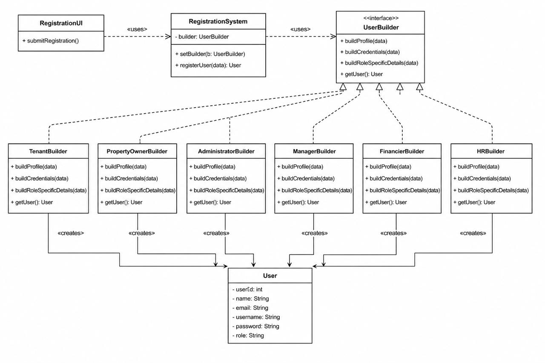

Chain of Responsibility Pattern (Done by:Kevin Muho,Ornelt Lemellari, Matias Bali)
Justifying the design pattern presenceThe Chain of Responsibility Pattern is used in the system to automatically process complaints through multiple handling stages without placing all complaint logic in one class.
In this design:
ComplaintHandler acts as the abstract handler and stores nextHandler.
ValidationHandler, PriorityHandler, DuplicateComplaintHandler, AutoResolutionHandler, and EscalationHandler act as concrete handlers.Complaint is the request object passed through the chain.IssueResolution stores the final resolution details.
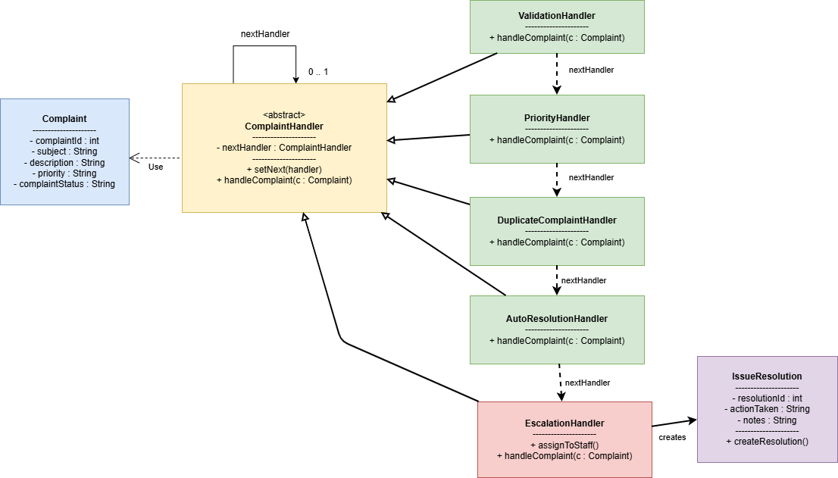
For example:
In FR38, when HR manages complaints, the system first validates and categorizes the complaint automatically.
In FR33, if the complaint cannot be resolved automatically, it is escalated for manager review.
In FR26, unresolved or serious complaints can be escalated to the administrator as a dispute/system issue.

Observer Pattern (Done by:Desard Lybeshari,Haidi Toto)
Justifying the design pattern presenceThe Observer Pattern is used in the system to automatically notify users when important events occur, such as rental request updates or payment completion.
In this design:
RentalRequest and Payment act as Subjects because their status can
change.
NotificationSystem acts as the Observer, listening for these changes.
Tenant and PropertyOwner receive notifications about approvals, rejections, payments, and reminders.
For example:
-In FR17, when a property owner accepts or rejects a rental request, the tenant is notified.
-In FR8 and FR39, payment updates and reminders are also sent automatically.
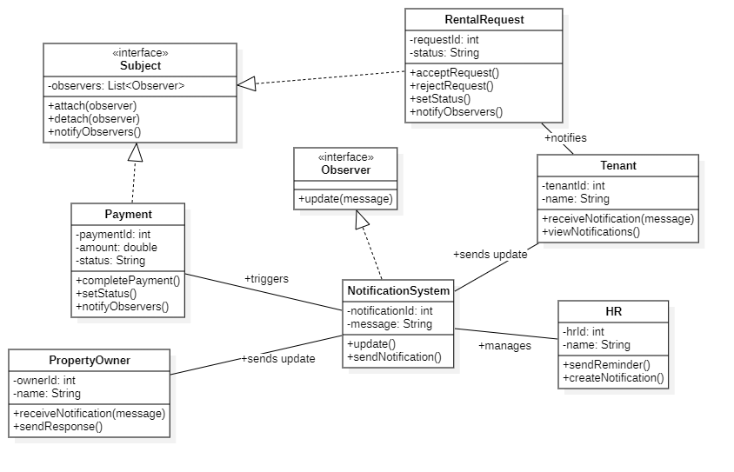

Facade Pattern (Done by:Kevin Muho,Ornelt Lemellari,Matias Bali)
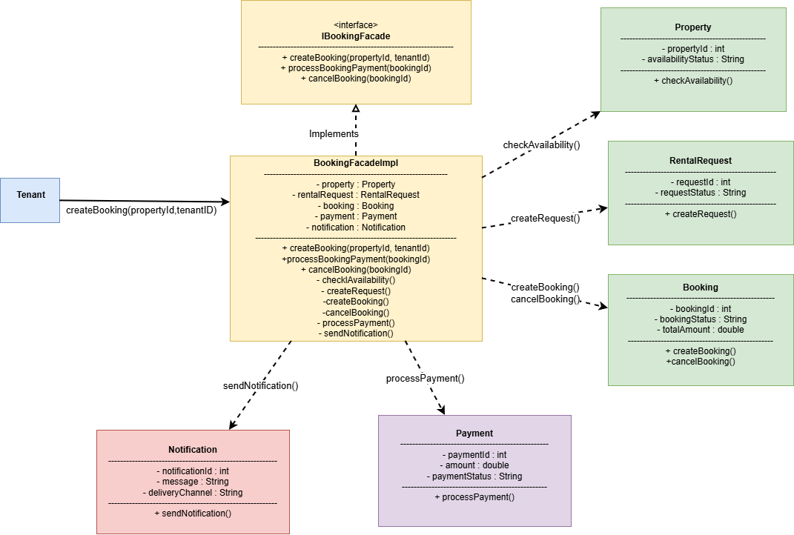
Justifying the design pattern presenceThe Facade Pattern is used in the system to simplify the property booking workflow by providing a unified interface for handling multiple booking-related operations through a single facade class.
In this design:
IBookingFacade acts as the facade interface that defines the booking operations.
BookingFacadeImpl acts as the concrete facade implementation that coordinates the subsystem classes.
Property, RentalRequest, Booking, Payment, and Notification act as subsystem classes responsible for specific booking operations.
Tenant acts as the client that interacts with the facade instead of directly communicating with all subsystem classes.
For example:
In FR2 and FR3, the system checks property availability before creating a booking request.
In FR5, the system automatically creates a rental request through the facade.
In FR17, the system manages booking creation and status updates after request approval.
The facade also sends notifications automatically after important booking and payment events occur.

Adapter Pattern (Done by:Desard Lybeshari,Haidi Toto)

Justifying the design pattern presenceThe Adapter Pattern is used to connect the rental system with an external payment service without changing the internal system structure.
In this design:
PaymentServiceAdapter acts as a bridge between the system and ExternalPaymentService. The system sends payment data using the PaymentProcessor interface, while the adapter converts the request and response formats required by the external service.
This pattern focuses on *software structure and object collaboration*, since it shows how objects inside the system communicate during payment processing.
For example:
On FR8 – Submit Rental Payment, the system sends the payment request to the payment service.Also, the system receives the payment result and displays confirmation.
